Aim: Why is it important for Leaders to Resolve Conflicts?
Learning Objectives, Swbat:

SWBAT OBJECTIVES:
▪ Relate situations in books and short stories by Dr. Seuss to situations and events in their own lives
▪ Prepare critical thinking questions and lead class discussions
▪ Classify questions as critical thinking questions or literal questions
▪ Identify the conflict presented in texts by Dr. Seuss
▪ Define Terms
▪ Read for understanding
▪ Provided written responses
▪ Participate in discussion

Do Now: Answer the following questions:
Who is Dr. Seuss?

What do you remember about his stories?

Which was your favorite? Why?

Task A: Log onto www.Dictionary.com and define the following terms

1. | Stubborn | _________________________________
2. | Rigid | _________________________________
3. | Inflexible | _________________________________
4. | Flexible | _________________________________
5. | Open-Minded | _________________________________
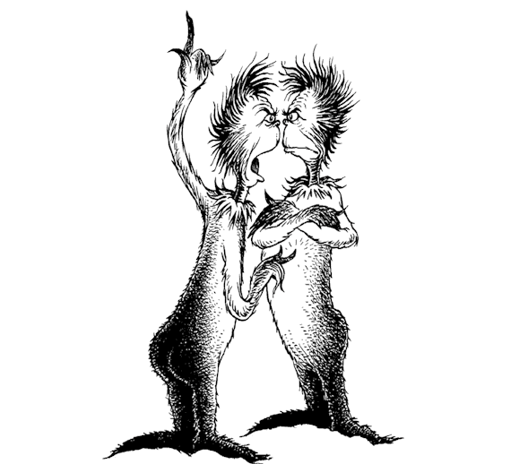

Task B: Watch “The Zax” -Dr. Suess” on Youtube
1. Identify the message of the story.

2. Why did Dr. Seuss write this story?

3. What lesson was he trying to teach?

4. Do you agree with the actions of the Zax?

Task C: Search the internet to find the full text “The Zax” -Dr. Suess” Read the short story on screen before answering the questions
The Zax – Dr. Seuss

The day before today, One day, making tracks
In the prairie of Prax,
Came a North-Going Zax
And a South-Going Zax.
And it happened that both of them came to a place
Where they bumped. There they stood.
Foot to foot. Face to face.

“Look here, now!” the North-Going Zax said, “I say!
You are blocking my path. You are right in my way.
I’m a North-Going Zax and I always go north.
Get out of my way, now, and let me go forth!”
“Who’s in whose way?” snapped the South-Going Zax.
“I always go south, making south-going tracks.
So you’re in MY way! And I ask you to move
And let me go south in my south-going groove.”
Then the North-Going Zax puffed his chest up with pride.
“I never,” he said, “take a step to one side.
And I’ll prove to you that I won’t change my ways
If I have to keep standing here fifty-nine days!”
“And I’ll prove to YOU,” yelled the South-Going Zax,
“That I can stand here in the prairie of Prax
For fifty-nine years! For I live by a rule
That I learned as a boy back in South-Going School.
Never budge! That’s my rule. Never budge in the least!
Not an inch to the west! Not an inch to the east!
I’ll stay here, not budging! I can and I will
If it makes you and me and the whole world stand still!”

Well…
Of course the world didn’t stand still. The world grew.
In a couple of years, the new highway came through
And they built it right over those two stubborn Zax
And left them there, standing un-budged in their tracks.

Task C: If necessary, use the internet to find the differences between a literal question and a critical thinking question then answer the questions below:
Literal Question __________________________________________________________________
Critical Thinking Question _________________________________________________________

Literal Questions | Critical Thinking Questions
1. In which directions were the Zax traveling? |  | 1. Rather than refusing to move, what tricks could the North-Going Zax have used to outsmart the South-Going Zax?
2. What structures were built while the Zax argued? |  | 2. What would have happened if one of the Zax had moved?
3. What did the South-Going Zax learn in school? |  | 3. The South-Going Zax said that when he was in school, he was taught not to budge. Do you think his teachers would be proud of his refusal to move for the North-Going Zax?
4. How long did the Zax say they could stand without budging? |  | 4. Which of the Zax should move?
5. How did the landscape change while the Zax argued? |  | 5. What did the Zax gain by refusing to budge? What did the Zax lose by refusing to budge?
Task D: Writing Assignment
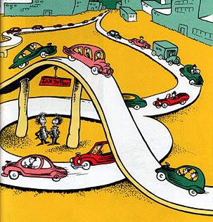
1. Write about a time you have encountered people who acted similar to those in The Zax.

2. Was there ever a time where you acted in a similar way to those in The Zax? Discuss.

3. Discuss the advantages and disadvantages of stubbornness versus flexibility.

4. Discuss how does this story relate to business management?

