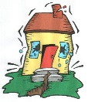
WU: What do you know about Earthquakes?

- What is an earthquake?

- What causes an earthquake?

- How is an earthquakes energy released? (draw a model)

- How can we prevent damage or prevent buildings from collapsing during an earthquake?

