Geofile - The Haiti Earthquake 2010 – A study of Vulnerability

Directions:
- Read the section of the article that you are assigned

  - Introduction
  - Haiti & Plate Margins (w/ fig. 1)
  - Why was Haiti so vulnerable? (w/ fig 2)
  - The immediate impacts of the earthquake (w/ fig 3)
  - Early Aid
  - The NGO problem
  - Later Actions
  - Problems in the camps
  - The cholera outbreak
  - Haiti a year on (w/ fig 4)
  - Conclusion (w/ fig 5)

- Be ready to share out to the class about your section
- Present your section to the class
- Answer the following questions as we share out as a class
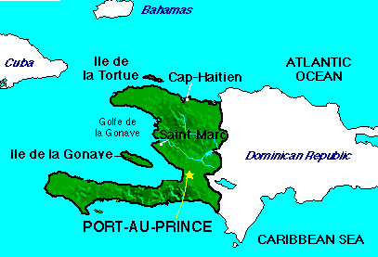
----------------------------------------------------------------------------------------------------------------------------------------------------------------Questions:
- What were the details of the 2010 earthquake?

- What plates does Haiti sit on?

- How far did the plates move?

- Why was Haiti so vulnerable – list the top 3 reasons…

- What were some of the immediate impacts of the earthquake?

- What type of aid was given right away?

- Who provided the aid?

- What was the NGO (non-governmental organization) problem?

- How did this affect Haiti?

- After the earthquake, what actions were taken to help Haiti?

- What were some of the main issues with the camps?

- Describe the cholera outbreak.

- A year after the earthquake, what has improved?

- Describe the overall conclusion of this study.

