Article Questions: The Engine that Drives the Earth
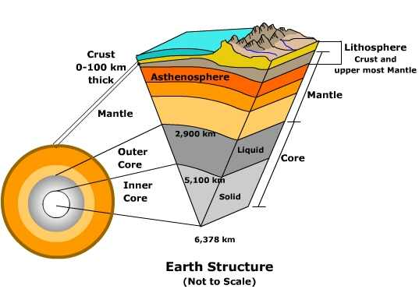
- What does it mean by “Earth is actually a very dynamic body”?

- Describe some of the pieces of evidence that show earth is a “dynamic body”.

- Explain why the rocks in Earth’s mantle able to deform and flow like a slowly moving fluid.

- a. Name the type of energy that drives the movement within the mantle.

b. List the two main sources of this energy within the Earth.

- Draw a side view of the earth and show with labels and arrows the movement within the mantle.

- Describe the Lithosphere.

- List the three places within the Oceans where we can see evidence of this “movement of plates” and draw what is happening at each place.

- What is a “Geophysical CAT Scan” and what can it tell scientists?

- Answering the question of how the mantle convection engine works will require the integration of data from

_____________________________, ____________________________, and mineral physics with

_____________ - ________________ modeling of mantle convection.

- List some of the new tools that will be used to “look under the hood” at earth’s engine and the forces that drive the changes on the face of the Earth.

