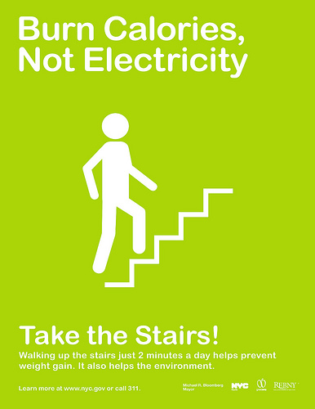
Work it! Show your Power Lab.
Background Information:
Force and Work.
We are constantly using forces to move ourselves, vehicles, and bodies of all kinds from one place to another. When a force moves a body on which it acts in the direction of the force, we say it has done work. A mover lifting a box from the floor to a table or pushing a piano a few meters across the floor is exerting a force that is doing work. In each case, a force is actually moving the body in the direction in which the force is acting. The work done by a force is found by multiplying the force by the distance it has pushed the body in the direction of the force. The unit of work is obtained by simply combining the unit of force and the unit of distance, this unit is also referred to as the joule (J). If the force responsible for the work is not parallel to the displacement, then the component of the force parallel to the displacement must be used, force times the cosine of the angle between the force and the displacement.

Power
We are often interested not only in how much work is done but also in how fast it is done. The rate at which work is done is called the average power of a machine or device. The SI unit in which power is measured is the watt (W). Since the watt is a relatively small unit of power, it is more often convenient to measure power in kilowatts (10³ watts). A kilowatt of power is equivalent to 1000 watts. James Watt was a British scientist who invented the steam engine. To find out how the power of his engine compared to that of a horse, Watt measured how fast an average horse could do work. He found the answer and expressed the amount of the work performed per second as a horsepower. A nonmetric unit of power commonly used in commerce and industry in the US is horsepower (hp). One horsepower is equivalent to 746 watts.

Pre-lab:
- The formula for work is W=

- The combined units: ___________________ (or joule) is the work done by a force in moving an object a distance in the direction of the applied force.

- The formula for Power is P=

- The combined units: ___________________ (or watt) is the power supplied by an engine, motor, etc., that does work in the direction of the applied force at the rate of 1 _____________per ____________ is 1 watt.
- If the work on an object were to be done at an angle to the force, then the component force must be used. How would this affect the formula for work?

Objective:
1) To find out how much work is done and power you use when exercising.
2) To practice calculating work and power.

Materials:
scale metric ruler stairs stopwatch dumbbell

Part I Procedure:
1) Measure your weight using the scale. Weight should be expressed in newtons.
Convert pounds to newtons.4.45 lbs = 1 N
2) Measure the height of one stair (in meters).
3) Count the number of steps you will be climbing—and multiply this by the height of a step to find the total height, in meters.
4) Climb the stairs at a walking pace while your partner times you. Record the time as accurately as possible. CAUTION: Be very careful. Make sure you hold onto the hand rail.
CAUTION: Be careful, if you are feeling overly exerted, do not continue.
5) Climb the stairs as quickly and as safely as possible while your partner times you. Record the time as accurately as possible. CAUTION: Be very careful. Make sure you hold onto the hand rail.
6) Switch roles with your partner and repeat steps #4 & #5.

Observations:
1) Were the 2 climbing times for each person roughly the same?

2) Did you feel as if you exerted the same effort on each climb? Explain.

Name | Weight (lbs) | Weight (N) | Time walking (s) | Time fast pace (s) | Distance (m)
 |  |  | Trial 1 | Trial 2

Analysis: Show the work for the first set of calculations only.

Name |  | Work (____ or ___) |  |  | Power (W) |  |  | Power (hp)
 | Trial 1 |  | Trial 2 | Trial 1 |  | Trial 2 | Trial 1 |  | Trial 2
Conclusions: Answer in your lab book.
1) Was the amount of work you did for each trial the same? Why?
2) Was the amount of power you expended the same for each trial? Why or why not?
3) Compare your power output with the output of a horse by looking at your horsepower.
(Do you think you could keep up that power level for hours, like horses do?)

Part II Procedure: Quick Experimental Design:
Determine the work done and power used to do a bicep curl with a dumbbell.
Consider the forces at work on the dumbbell to help you design your experiment. Make sure your procedure minimizes error.

Write your procedure in your Lab book.
Present your procedure and data table setup to Mrs. Jestel

Present your data and data analysis to Mrs. Jestel

Extensions:
1) How does your power output in climbing the stairs compare to the power output of a 100-watt light bulb? If your power could have been harnessed and the energy converted to electricity, how many 100-watt bulbs could you have kept burning during your climb?

2) What is the difference between work and power?

3) Two people climbed to the roof of a building. The old person walked up a gentle ramp. The young person climbed up a steep spiral staircase. Which person did more work? Explain.

4) What should a graph of force versus displacement look like for walking up the stairs at an steady pace? Sketch the presumed relationship, assuming that we were running at constant speed and we never ran out of energy.
5) To what is the area beneath the plotted line equivalent? (Think!)

