AP Physics – Work and Energy

Now we turn, no, not turn, we, uh, fling ourselves upon! Yes, that’s the ticket. We fling ourselves upon the grand branch of physics that deals with the wondrous concept of energy! Oh, and also work. Work has a bad reputation with the teeming masses as it has a lot of associations with labor, sweat, toil, &tc. – things that actually have nothing to do with the grand science of physics (right? This is because there is no labor, sweat, toil, &tc, in physics! It is never toil to do something that you positively love doing.).

In physics work one of the grandest things there is! As you shall see.

Work in the real world is what you do to get a paycheck, &c. It is very likely that if you are employed you are probably not fond of your work. Most people aren’t. Of course there is the odd person, called a ‘workaholic’ who lives to do work much as you, the dedicated AP Physics student, live to do physics.

Weird Fact:

Each human being (this would include you, dear reader) has the same number of hair follicles as a chimpanzee. These means that you have the same number of hairs as one of the great apes - not that humanoids aren’t already the greatest of apes! So how come you aren’t hairy all over like Tarzan’s buddy Cheeta? Well, it’s because your hairs are utterly pathetic when compared with the attractive, fully developed hairs of your friendly next door orangutan. Homo sapiens hairs are very fine and short. We have a gene that prevents the production of normal hairs from the body follicles. In some people this gene is not switched off, and these folks are hairy enough to impress even King Kong. They often find work in the circus on the midway in tasteful enterprises called “freak shows”.

In physics, work has its own special meaning, specifically:

Work is done when a force causes an object to move.

To be specific, work is the product of the component of a force in the direction of the displacement it causes and the magnitude of the displacement. For work to be accomplished a force has to move an object and the force and displacement have to be in the same direction. If you lift a book a distance of one meter, you have done work on it. The book moved up and the force was directed up. If you hold a heavy book stationary at some height above the floor, you have done no work on it. The force was up, but there was no displacement, so there was no work.

A simple equation for work is:
W is work, F is the applied force, and Δr is the change in displacement.

This is a “special case” equation. The force and the displacement have to be in the same direction. If you took physics last year, this was the equation that you used.

- You lift a 1.2 kg book a distance of 1.0 m, how much work did you do on the book?

This is a simple problem. The force doing the work has the same magnitude as the weight of the book (that’s what it takes to lift it), mg.

The unit we ended up with is a newton meter. This is defined in physics as a joule. The symbol for the joule is J. (The joule is named after James Joule, a big name in the area of energy.)

In the United States the most common unit of work is the foot pound.

What happens when the force and the displacement aren’t in the same direction?
In mathematical terms, we get this general equation:

Here the ‘F’ and ‘cosθ ‘ part of the equation is the component of the applied force that is in the direction of the displacement.

The drawing above represents the motion of a crate being moved by an applied force. The crate is moved a distance . The work done is simply

We find this equation in its AP form as:

Here is work, is the net force, is the distance the object is moved, and is the angle the net force makes with the direction of motion.

It’s two equations in one. The first one is for when the angle is zero and the net force has the same direction as the motion. So we can say that

The second one is used when there is an angle between the net force and the motion direction.

- A force is applied to a crate at an angle of 25°. The crate is dragged across the deck a distance of 2.5 m. If the amount of work done after it has been moved is 1 210 J, what was the applied force?

This is a simple problem, all we have to do is solve it for F!

Work is a scalar quantity. This means you can add and subtract work without treating it as a vector. How convenient!

Joules are a small unit, so it is very common to deal with kJ and MJ. A joule is roughly the amount of work you do when you lift a Big Mac one meter. That’s not very much work, is it?

This brings us to the next exciting topic: energy!

Energy: Energy is another one of those common terms that you hear all the time. Interestingly enough, in everyday language, it is used pretty much correctly. Hmmph. Imagine that.

In physics we define energy as: Energy ≡ the ability to do work.

But what does that mean? Well work is done when something is displaced by a force. If work is done, it takes energy. If you lift a 1 N rock 1 m, you’ve done 1 J of work and expended 1 J of energy.

Energy and work, intimately related as they are, use the same unit.

Energy comes in a vast array of types and all sorts of ways have been devised to classify the different types of energy. No doubt you can think of lots of them. There’s electrical energy, solar energy, nuclear energy, thermal energy, chemical energy, &tc. Lots of energy types.

Initially we will be dealing with mechanical energy. This is the energy associated with motion and forces. There are two types of mechanical energy (these types can be applied - and often are – to all types of energy, keep in mind). The two types are kinetic energy and potential energy.

Kinetic Energy: This is the energy of motion. When a system is moving, it has kinetic energy. Thus the object’s motion can be transformed into work. All this means is that a moving object can hit something and make it move, thus accomplishing work. The unit for kinetic energy is the joule. The equation for kinetic energy is:

K stands for kinetic energy, m is the mass of the object, and v is its velocity.

- How much kinetic energy does a 2.5 kg ball possess if it is thrown with a velocity of 21 m/s?

Very simple problem, just use the equation.

Can you see how the unit ends up being a joule?

When an object is given kinetic energy (by applying a force to it, of course), the amount of work required to do this is, ignoring friction, equal to the kinetic energy the object gains.

We can say this in a more fancy way. We say that the net work done on an object by a net force is equal to the change in its kinetic energy.

If it starts at rest, then the K₀ term is zero and the net work is equal to the final kinetic energy.

- A net 6 500 N force is applied to a resting 1 500 kg car, moving it forward. What is its kinetic energy and speed after being displaced 150 m?

There are two equations we can use:

The car begins at rest and the force is in the direction of the car’s motion. And

First we calculate the amount of work the force does, this will give us the amount of kinetic energy the car ends up with. (Oh my, is that a dangling participle? The Physics Kahuna is not sure about that sort of thing. Just what the heck is a participle?)

This is equal to the kinetic energy of the car at the end of the event. So

Now to find the velocity. We can use the equation for kinetic energy, since we’ve calculated its value:

Anything in motion has kinetic energy – falling water, the wind, moving electrons, &tc. We will find that analyzing an object’s kinetic energy is a very powerful weapon in the old physics problem-solving arsenal.

Potential Energy: Potential energy is stored energy. There are many ways that energy can be stored. An electric battery represents stored energy, water piled up behind a dam, and chemical bonds in molecules to name just a few are also common ways to store energy. The type of potential energy that we will initially be interested in has to do with the energy of position brought about by gravity and by a spring being compressed or elongated.

First let’s look at gravitational potential energy. When an object is lifted to a height above a reference frame, work is done and object gains potential energy. The energy it gains is equal (ignoring friction) to the work done on it. The standard form that the equation for potential energy of position takes is:

although it’s usually written as simply:

U is potential energy, m is the mass, g is the acceleration of gravity, and y is the vertical displacement.

It is also very common to write it in a slightly different form as:

Where (standing for height) simply means the vertical displacement.

An object which is lifted to some new position can, if released from that position, do work as it falls back down. Old-fashioned clocks use weights in this way to power the clockwork mechanism.

The net work done by falling object is simply the change in potential energy.

When solving potential energy problems, the reference frame should be chosen to simplify the solution.

One sets the bottom position as zero and then all other displacements are measured in reference to the zero position.

- A 12 500 kg boulder is 157 m above a cabin. What is its PE with respect to the cabin?

Conservation of Energy: One of the most important laws in all of science is the law of conservation of energy. In chemistry you probably looked at it in this form: energy can not be created or destroyed. In physics, we say:

Energy is neither gained nor lost in any process.

Energy can be transformed from one type to another, but, in any closed system the amount of energy cannot change.

We can examine conservation of energy by dropping a rubber ball. The ball begins at some initial height – it therefore has a certain amount of potential energy. As it is not moving, it has no kinetic energy whatsoever. The ball is released and starts falling downward. As it falls it accelerates and falls faster and faster. This means that its kinetic energy is increasing as it falls. Its potential energy is decreasing because its height is becoming smaller. What is happening is that its potential energy is being converted into kinetic energy. Just before it hits, all of its potential energy will have been transformed into kinetic energy.

But what happens when it hits?

The ball deforms on contact; it gets squished. Its kinetic energy is being transformed into potential energy – the same kind of potential energy as you would find in a compressed spring or stretched rubber band. The ball then “unsquishes” itself (wow, the Physics Kahuna has invented a word!) and rebounds. The potential energy stored in the ball is transformed back into kinetic energy and the ball goes back up. On the bounce, this kinetic energy is converted back into potential energy as the ball moves upward. When the ball stops, all of its kinetic energy has been transformed into potential energy, and so on.

The interesting thing, and a point that makes one doubt the law of conservation of energy, is that the ball doesn’t bounce back to its original height. So the uninformed observer thinks, “Hey, energy got lost here! It didn’t go to the same height so some of its energy was destroyed! Hah! So much for the stupid law of conservation of energy!”

Well, the law of conservation of energy always works – it is the law, after all. What happens is that the energy of the ball is transformed into energy forms that do not contribute to the bounce height. We call these transformations energy losses. They are not really energy losses, however, in the sense that energy has been destroyed.

When the ball falls it encounters friction with the air. It must push aside air molecules, giving them some of its energy. The air molecules gain energy during the collisions with the ball as it falls and some of the molecules making up the ball also gain energy. The effect of this is to heat the air and the ball to slightly higher temperatures. This means that its kinetic energy is less than what is expected (but not by much, the decrease in energy for a ball falling a few meters on the surface of the earth is almost insignificant). The ball finally hits the deck. Most of its kinetic energy goes into making the ball deform. When the ball “undeforms itself” this energy is converted back into kinetic energy since the ball will be going up. The deformation, however, causes the individual molecules that make up the ball to gain energy - they vibrate more; the effect of this is to heat the ball. The energy that makes the ball’s particles vibrate more vigorously is no longer available as potential energy in the squished ball. The ball’s temperature increases. This means that the potential energy stored in the ball is less than the kinetic energy it began with before the squish. The deck under the ball is also distorted and heated slightly.

The ball also produces a noise when it hits, this is another energy loss. Energy is also lost to friction with the air as it rises after the bounce. The effect of these energy losses is that the ball doesn’t bounce as high as the place from whence it came.

If we total up the sum of all the energies and energy transformations that occurred during the ball drop event (the frictional heating, the deformational heating, the sound produced, &tc.), however, we would find that the final sum of energy is equal to the initial amount of energy.

One of the demonstrations we did was one with a bowling ball, the one where it swung back and forth. Remember? A bowling ball was hung from a line that was secured to a hook in the ceiling. The ball was swung like a big pendulum.

Looking at the drawing of the ball’s path to the right, where does the ball have maximum/minimum kinetic energy and where does it have maximum/minimum potential energy?

Point A represents the maximum deflection to the left, point B represents the lowest point in the path, and point C represents the maximum deflection to the right.

At point A the ball is held at rest. All of its energy is potential energy because of its height y above the lowest point of travel.

The ball is released and its potential energy is converted into kinetic energy. At point B, the lowest point in its path, all of the energy will be kinetic energy. With respect to point B, chosen as our zero point, it has no potential energy (although it does have potential energy with respect to the deck below, but the rope won’t let it fall). As it rises to reach point C the kinetic energy is converted into potential energy. At point C all of its energy is potential. As the ball swings back and forth, the energy is transformed continually from potential energy to kinetic energy and so on.

Of course energy is converted into other forms besides potential and kinetic energy, so the ball will eventually come to rest. Each swing of the ball will end up at a slightly lower position until the ball stops moving. This is why the brave student could release the ball from a position where it was touching her nose and be absolutely confident that it would not come back and smash in her teeth.
The ball had to obey that laws of physics, didn’t it.

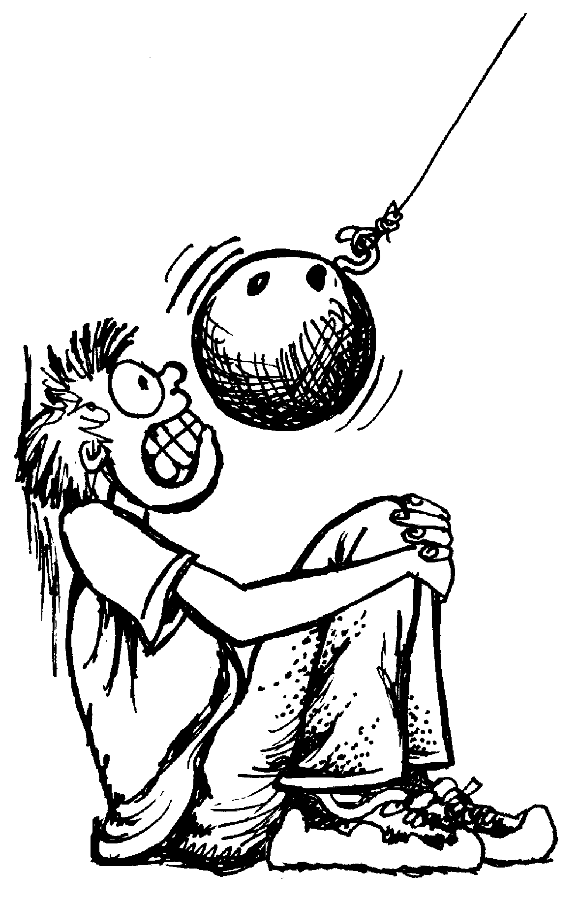The law of conservation of energy was developed during the 1800’s. It is credited to Hermann von Helmholtz, although most of the work was done by James Joule. Turned out that nobody believed Joule (he was of the lower class and did not have a great deal of prestige at the time) but von Helmholtz had a grand reputation – he had the “von” thing going with his name, see, and so physicists believed him and gave him the credit. Joule got the final victory, however, there is no unit named the”von Helmholtz”.

Anyway, the implication of the law is really profound. It’s easy to accept that the energy of a small isolated system is constant, but what about the universe? The universe is an isolated system, ain’t it? You bet it is. This means that the total energy within the universe is unchanging. The universe began with “x” amount of energy around 15 billion years ago and today, it still has that same amount of energy.

This is, if you think about it, mind-boggling.

This means that for 15 billion years the universe’s energy has been busy plugging away changing from one form to another. Will it ever get tired of doing this?

Using the Law of Conservation of Energy:

The energy in an isolated system can’t change. This is powerful stuff.

Energy Before = Energy After or E = E'

(The little apostrophe mark added to the E making it E' means the quantity after some event. We pronounce E’ as “E prime”.)

Let us look at a simple example. A rock is held at some height y above the deck. The rock is dropped and falls. We examine the energy before and the energy after and, thanks to the law, determine that the two quantities must equal each other. Let us note that we are ignoring all other energy losses, which is reasonable for this sort of event. Very little energy is lost by the rock as it falls a few meters.

The energy before (prior to being dropped) is:

The energy after (just before the rock hits) is:

Using these two relationships, we can write a general equation for the example.

In general, without knowing the specifics, we can write the following equation:

This simply means that the energy before is the sum of its initial kinetic energy and potential energy. The energy after the event is the sum of its final kinetic and potential energy.

- A 1.5 kg ball is dropped from a height of 2.3 m. What is its speed the instant before it strikes the deck?

This problem could be solved using the acceleration equations that we’ve already learned about, but it can also be solved quite easily using the law of conservation of energy.

We can assume that the ball’s potential energy at the top will equal its kinetic energy just before it hits.

Thus,

The ball has no initial kinetic energy and no final potential energy, so the equation can be simplified by dropping out their terms. We can also eliminate the little subscript thingees.

Solve for the speed. Also note that the masses cancel out on each side.

- A 500.0 g ball is thrown straight upward with a velocity of 35.4 m/s. How high does it go?

Use the law of conservation of energy. Rather than write out all the terms of the energy equation, we’ll just use the parts that apply.

solve for y.

These problems are quite simple. The conservation of energy can also be used to solve some really complicated problems.

A roller coaster train is at rest at the top of a hill, the brakes are released and it rolls down some sort of a curved slope. What will be its speed at the bottom of the hill?

This seems to be a very complicated problem. The train will not be accelerating at because it’s going down a ramp. It isn’t even a straight ramp, they usually curve, so how can you find its speed?

Conservation of energy! The energy at the top equals the energy at the bottom! (Ignoring friction of course.)

- A roller coaster pauses at the top of a 75 m hill. What will be its speed at the bottom of the hill?

- The first hill on a roller coaster is 94 m tall, the second hill is 68 m tall. If it starts from rest on the first hill, what theoretical speed will the roller coaster have on the second hill?

The train has only potential energy at the top of the first hill, but it has both potential and kinetic energy at the top of the second hill. This is because it is moving and is not at the bottom of the system at zero vertical displacement.

Let’s complicate things a bit more.
- A 655 N diver leaps into the water from a height of 10.0 m. What is his speed 2.00 m above the water?

An even simpler method was to have your zero displacement position be 2.00 meters above the surface of the water, then the energy equation would be:

- A sled and rider together have a mass of 87 kg. They are atop a hill elevated at 42.5°. They slide down the slope a distance of 35 m and reach the bottom. Find the speed at the bottom of hill. Assume no friction.

The simplest way to solve the problem is to use conservation of energy.

We need to calculate the height.

Dear Doctor Science,
The Flintstones cars ran on foot power. Why didn't they just walk instead of pulling the heavy car everywhere?
-- Justin Wallin from Hacienda Heights, CA

Dr. Science responds:
Cavemen were gluttons for punishment, frequently confusing pain with pleasure and chronic frustration for life itself. In this way, they resembled modern day graduate students, who often labor long hours for little financial and no discernable long-term gain. Especially those foolish enough to confuse achieving a graduate degree in the arts or humanities with artistic or human achievement itself, all the while ignoring the reality of a job market already glutted with increasingly
disillusioned bearers of such worthless diplomas. So, in that way cavemen were really quite sophisticated, if being sophisticated can be defined as a form of masochism.

