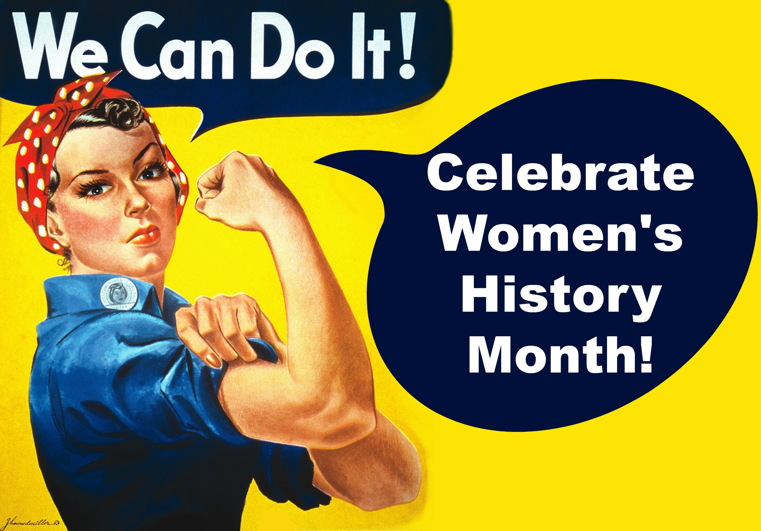
Women in Science
Online Poster Project
You will choose a female scientist from the list below to research and create an online poster about her. You may have never heard of these scientists before because some of these women never got credit for their work.

Marie Curie | Rosalind Franklin | Lisa Meitner | Ada Lovelace
Gertrude B Elion | Chien-Shiung Wu | Barbara McClintock | Irene Joliot-Curie
Rachel Carson | Dorothy Hodgkin | Rita Levi-Montalcini | Grace Hopper
Jocelyn Bell Burnell | Dian Fossey | Reatha Clark King | Emilie du Chatelet
Sally Ride | Elizabeth Blackburn | Mae C Jemison | Gerty Cori
Shirley Ann Jackson | Virginia Apgar | Lynn Margulis | Inge Lehmann
Sophie Germaine | Vera Rubin | Melissa Franklin | Florence Bascom
Katherine Johnson | Mary Jackson | Dorothy Vaughn | Kalpana Chawla

You will create this poster in Google Docs or Google Slides and submit it in Google Classroom. You must use at least three reliable sources and cite them at the end of your online poster.

How to Submit (2 options):
- Attach a copy (word, powerpoint) of your online poster to the submission
- Share the link (use the share button in the right hand corner) to attach to your submission. Click on “Share” then “Get Shareable Link”. DO NOT copy the URL from your browser and DO NOT email your teacher a copy of it.

Online Poster Requirements:
- Full Name of Scientist
- Picture of the Scientist
- Birth and Death Date
- Country born/died in and countries worked in
- What type(s) of science did she study
- What was she famous for? This should be bullet points or sentences of at least 3 different discoveries, accomplishments, etc.
- SOURCES- You must have at least 3

Choose 5 out the following to add to your poster
- A quote by your scientist or a quote about your scientist
- A picture of what they worked on or invented
- Where they went to school/college
- If they had any other professions (teacher, lawyer, doctor, etc)
- Family information (spouse, children, parents, siblings, etc)
- What else was happening when they were famous (WWII, Great Depression, etc)
- Did they work with another scientist? If so, who and what did they do?
- Are there any museums, colleges, schools, etc named after your scientist? If so where?
- Did your scientist win any awards? If so, what awards or honors?

Schedule:
Day 1 & 2: Choose Scientist, Conduct Initial Research, Choose Slides or Doc, Begin Creating Poster

Day 3 & 4: Work on Poster and Citing Sources.

Day 5: Make sure you have all requirements and sources and turn it in on Google Classroom!

