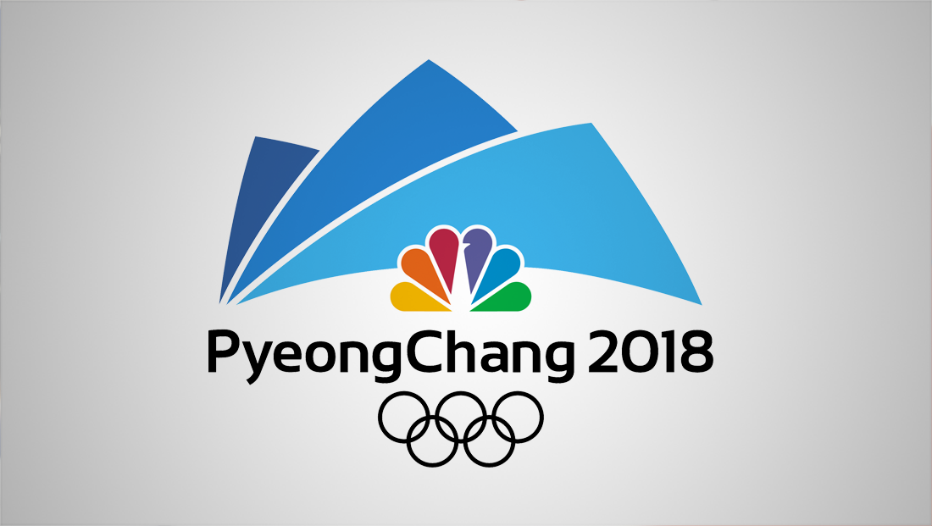
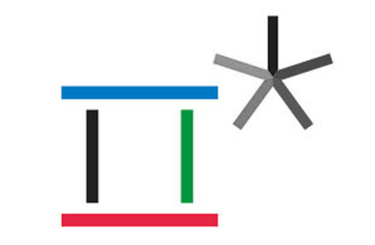
Marketing Products through Sports
Wheaties Box Project

It’s the breakfast of champions, or the champion of breakfast. Ever since we can remember, Wheaties, cereal boxes have been synonymous with celebrity athletes. The covers have been graded by the likes of Cal Ripken Jr., Mary Lou Retton, and Michael Jordan. Over the years many Olympic athletes have also appeared on the Wheaties boxes.

Scenario
You have been selected as the advertising team to design a new Wheaties box based on the 2018 Winter Olympics in PyeongChang, South Korea. You must follow the guidelines below to help you create a box. In order to create the best box design possible you should complete research on your athlete or team to learn their background and determine why the athlete or team would be a good to have as a spokesman to help market Wheaties products.

Objective
Students will be able to design a Wheaties advertisement to be placed on all sides of the Wheaties box using an athlete or team from the 2018 PyeongChang, South Korea Winter Olympics to help market the Wheaties product.

Tasks
- Chose a 2018 PyeongChang South Korea Winter Olympics athlete or team and create a Wheaties box cover – all sides.
- Research previous Wheaties box athletes and teams to help you create the best Wheaties box advertisement for the athlete/team and the Wheaties product.

Requirements for the FRONT of the box
- Wheaties name, slogan, and logo
- General Mills logo
- Product net weight
- Picture of the athlete/team from the 2018 PyeongChang South Korea Winter Olympics (should be relevant to the athlete/team role in the Olympics)
- Athlete name or team name
- Replica signature of the athlete (nothing needed if a team is being used)
- 2018 PyeongChang South Korea Winter Olympics logo, mascot, and network broadcast logo

Requirements for the BACK of the box
- Meet the athlete/team
- Facts about their successes at the 2018 PyeongChang South Korea Winter Olympics
- Placement in each event they competed
- Testimonial regarding how good nutrition has helped them be successful and a champion
- Two pictures of the athlete/team performing in their sport/event
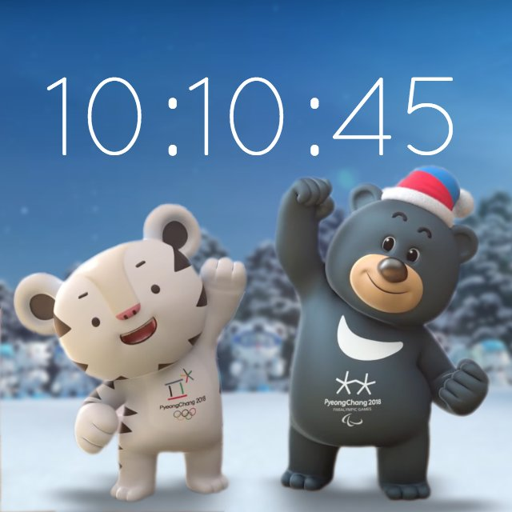
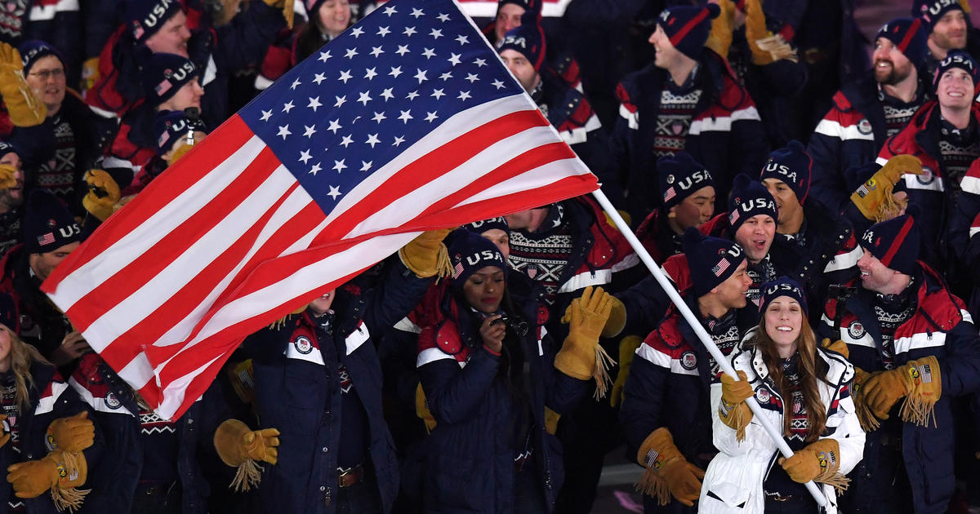
Requirements for the SIDES of the box
- Nutritional information
- Wheaties/General Mills customer contact information
- Information, logo, mascot, and broadcast network for the 2022 Beijing China Winter Olympics

 | Excellent (x20pts) | Good (x20pts) | Okay (x20pts) | Needs Work (x20pts)
Front of Box | - Student(s) had all or mostly all required items (7 items – had 7 +))  - Student(s) content was displayed in an attractive fashion on the box – pictures and text displayed in a well-organized clear fashion  - Student used correct colors & attractive fonts on the box | - Student(s) did not have all required items (7 items – had 6 or less)  - Student(s) content was satisfactorily displayed on box – pictures and text displayed in a fairly organized fashion  - Student displayed correct colors & text fonts on the box | - Student(s) did not have all required items (7 items – had 5 or less)  - Student(s) content was satisfactorily displayed on box – pictures and text displayed in a fairly organized fashion  - Student displayed correct colors & text fonts on the box | - Student(s) did not have all required items (7 items required – had less than 4)  - Student(s) did not organize content attractively on box.  - Student used incorrect colors and fonts were not clear on the box
Back of Box | - Student(s) had all or mostly all required items (5 items – had 5 +))  - Student(s) content was displayed in an attractive fashion on the box – pictures and text displayed in a well-organized clear fashion  - Student used correct colors & attractive fonts on the box | - Student(s) had all or mostly all required items (5 items – had 4)  - Student(s) content was displayed in an attractive fashion on the box – pictures and text displayed in a well-organized clear fashion  - Student used correct colors & attractive fonts on the box | - Student(s) did not have all required items (5 items – had 3 or 4)  - Student(s) content was satisfactorily displayed on box – pictures and text displayed in a fairly organized fashion  - Student displayed correct colors & text fonts on the box | - Student(s) did not have all required items (5 items required – had less than 2)  - Student(s) did not organize content attractively on box.  - Student used incorrect colors and fonts were not clear on the box
Side of Box | All nutrition and ingredient information is present | Some nutrition and ingredient information is present | Limited nutrition and ingredient information is present | No nutrition and ingredient information is present
Side of Box | All information is present for the 2022 Beijing China Winter Olympics | Some information is present for the 2022 Beijing China Winter Olympics | Limited information is present for the 2022 Beijing China Winter Olympics | No information is present for the 2022 Beijing China Winter Olympics
Creativity and Attractiveness | - Student(s) demonstrated a high level of creativity and provided new ideas for a box design  - Box was very eye appealing to a target audience | - Student(s) demonstrated some creativity and/ or provided some new ideas  - Box had eye appeal to a target audience | - Student(s) demonstrated limited creativity and/ or provided some new ideas  - Box had little eye appeal to a target audience | - Student(s) did not demonstrate creativity or provide any new ideas  - Box was not eye appealing to a target audience

