Working with Shape and Form-
Exploring the work of Edward Weston in Black and White
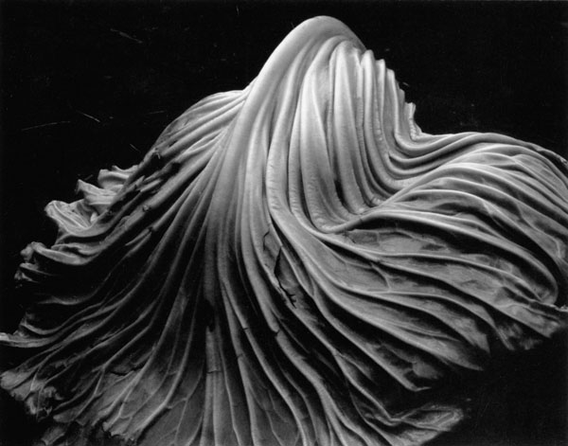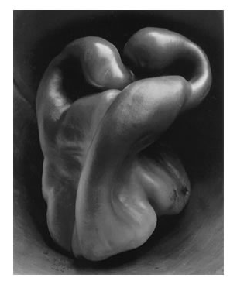
Digital Photo 1

Objective: Students will learn about the photographer Edward Weston while exploring the effects of light on shape and form in their photographs. Then they will apply their knowledge in a Weston like approach to shooting a single object.
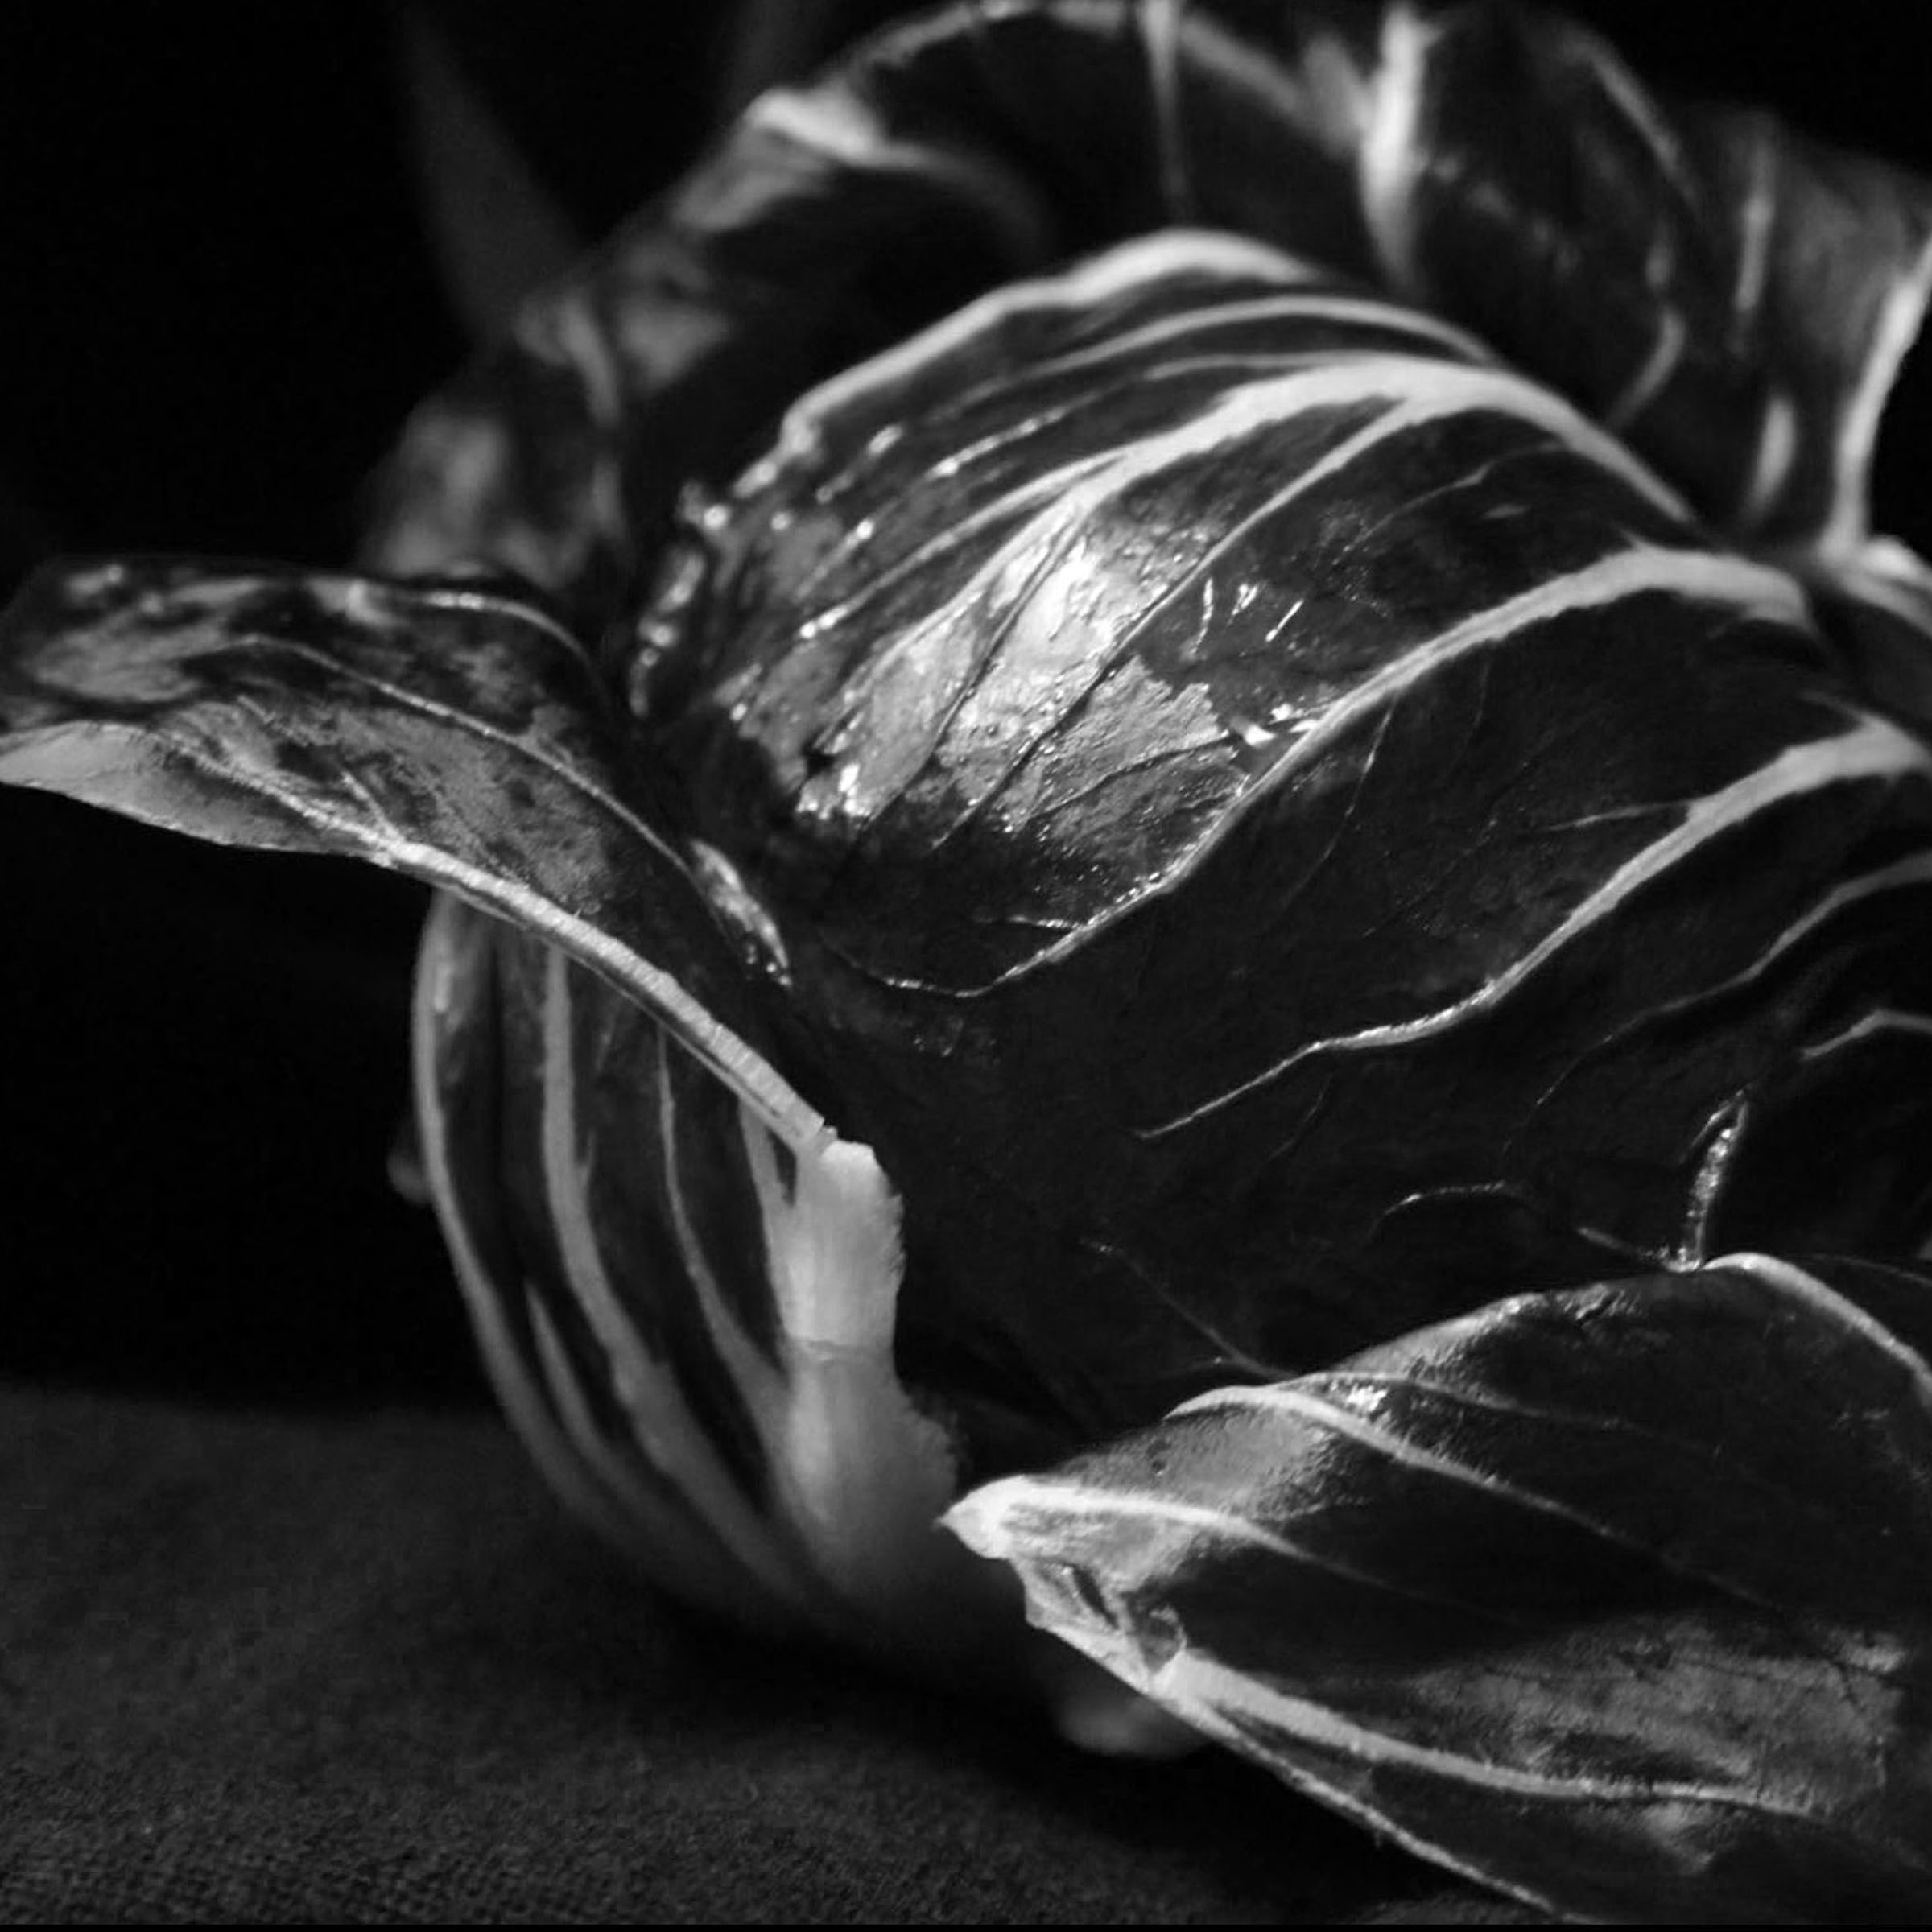
Vocabulary: Composition, Camera Angle, Simplicity, Still Life, High Contrast, Focus, shadow, shape, form, Abstraction, Light, Aperture, shutter speed.

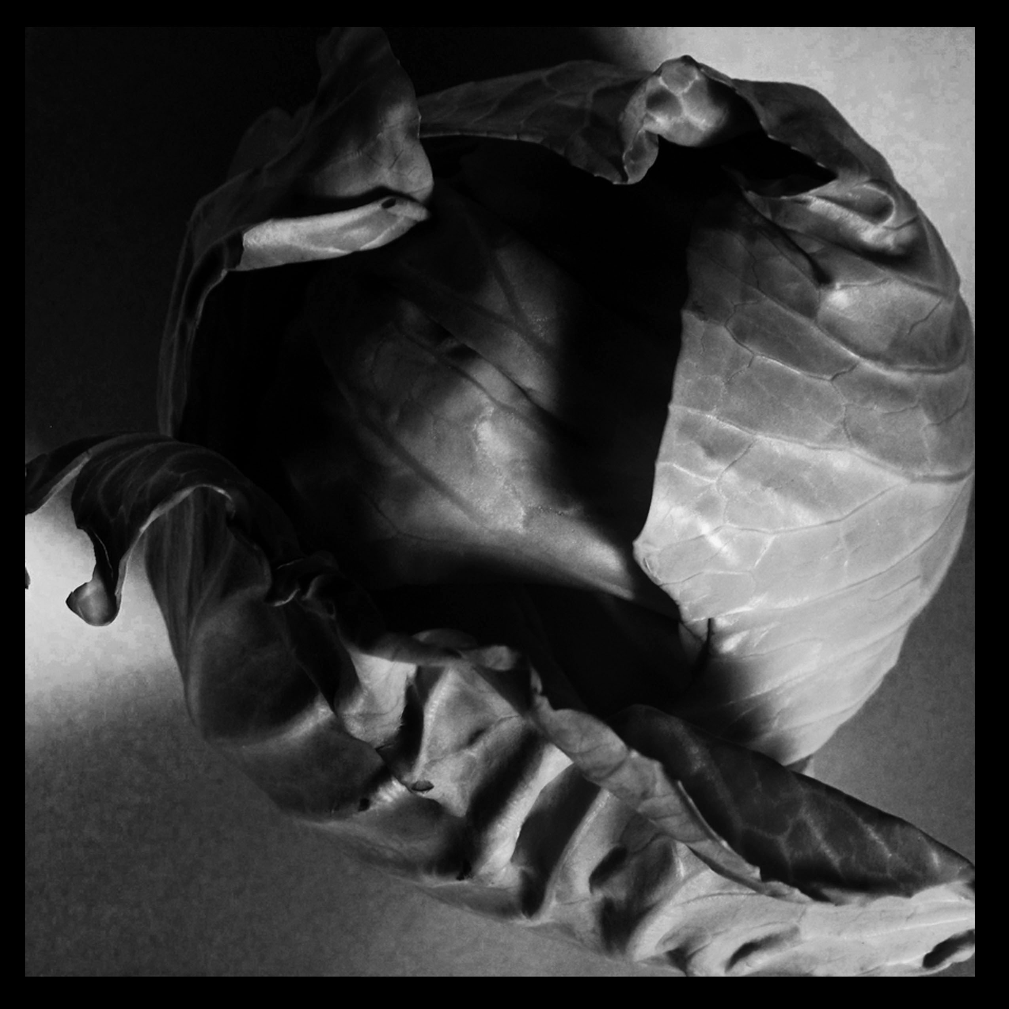
Description: We have looked at and discussed the still life work of Edward Weston and you have had the opportunity to view How through his handling of black and white imagery, Weston was able to elevate a single simple object.
You will work to do the same. You will be shooting a single object on a plain backdrop. a variety of Objects, Fruits and Vegetables will to shoot. You will also have lights to work with to bring out the form of what you are shooting. What effect does the lighting have? Should you defuse the light? Look for Hot spots and angles that you can shoot at, to create interest. All of these things you will discuss in your evaluation. You will be working on the aperture setting. This allows you to adjust your depth of field (area in focus) the shutter speed will adjust automatically.
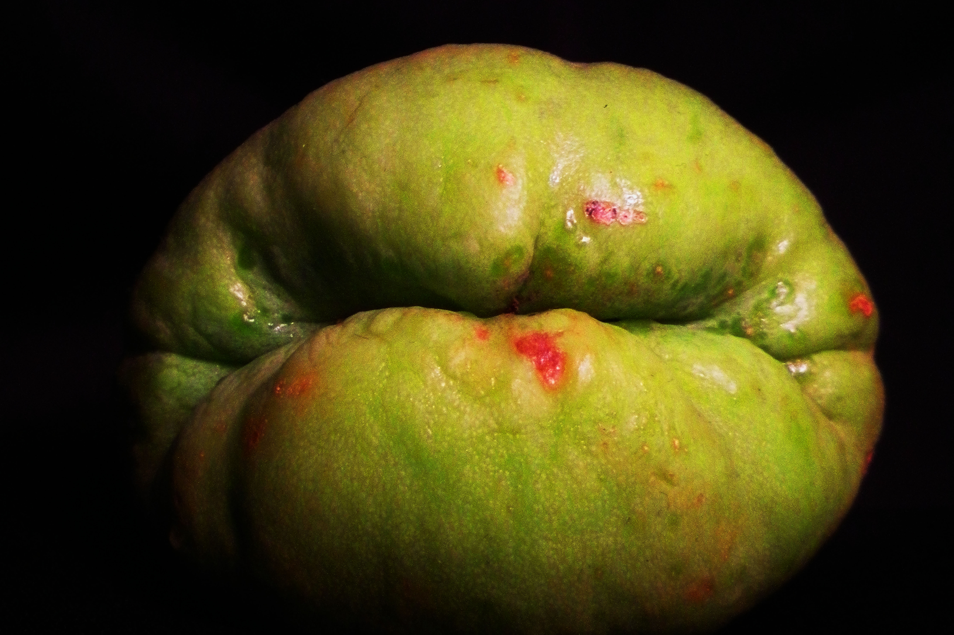
The Requirements: For this shoot you must use both a black and gray background. You must also shoot at least 5 different fruits, vegetables and objects (No Groups- only singles). You should have no less than 70 images on your contact sheet. You will turn in 4 images in black and white. Turn in contact sheet, evaluation sheet, a 4 best sheet and 1Final, these will be placed in the classroom.

Due By_______________

