
Chemistry Bingo
For each letter, find one person about whom the statement is true. Write each name in one of the boxes below.
A Knows the six most common elements in living things B. Has drank dihydrogen monoxide
C. Can name the 4 biological macromolecules D. Knows the pH of blood
E. Knows how much water you should drink everyday F. Knows what CER stands for
G. Knows how to find the atomic mass of an element H. Has used science this summer
I. Can draw an atom of hydrogen J. Knows the most abundant element
K. Has a food label with them right now L. Is wearing the element Ag (#47)
M. Knows how many naturally occurring elements exist N. Can name the 4 states of matter
O. Can list at least three different types of molecular bonds P. Can name at least 3 greenhouse gasses

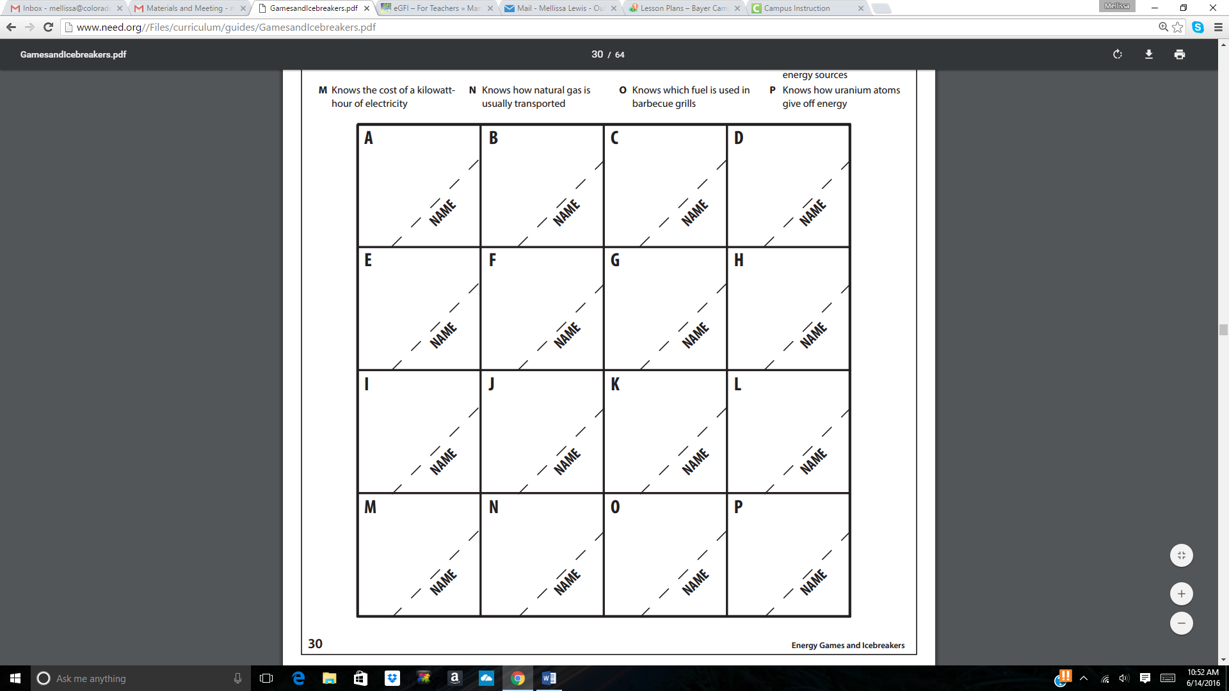

Welcome to Chemistry Bingo
Bingo makes an excellent icebreaker for classroom activities and workshops. This chemistry vocabulary and fact bingo also makes an excellent formative assessments. Bingos are quick to prepare, and take 20-45 minutes to play, depending on the students and set-up you choose.
Get Ready
Download the bingo.
Make a copy of the card for each person in your class or group.
In addition, decide now if you want to give the winner of your game a prize and what the prize will be.
Get Set
Pass out one bingo card to each player.
GO!

Part 1: Give the following instructions for filling in the bingo sheets.
- This bingo activity is very similar to regular bingo. However, there are a few things you’ll need to know to play this game. First, please take a minute to look at your bingo sheet and read the 16 statements at the top of the page. Shortly, you’ll be going around the room trying to find 16 people about whom the statements are true so you can write their names in one of the 16 boxes.
- When I give you the signal, you’ll get up and ask a person if a statement at the top of your bingo sheet is true for them. If the person gives what you believe is a correct response, write the person’s name in the corresponding box on the lower part of the page. For example, if you ask a person question “D” and he or she gives you what you think is a correct response, then go ahead and write the person’s name in box D. A correct response is important because later on, if you get bingo, that person will be asked to answer the question correctly in front of the group. If he or she can’t answer the question correctly, then you lose bingo. So, if someone gives you an incorrect answer, ask someone else! Don’t use your name for one of the boxes or use the same person’s name twice.
- Try to fill all 16 boxes in the next 20 minutes. This will increase your chances of winning. After the 20 minutes are up, please sit down and I will begin asking players to stand up and give their names. Are there any questions? You’ll now have 20 minutes. Go!
- During the next 20 minutes, move around the room to assist the players. Every five minutes or so tell the players how many minutes are remaining in the game. Give the players a warning when just a minute or two remains. When the 20 minutes are up, stop the players and ask them to be seated.

Part 2: Give the following instructions for playing the game.
- When I point to you, please stand up and in a LOUD and CLEAR voice give us your name. Now, if anyone has the name of the person I call on, put a big “X” in the box with that person’s name. When you get four names in a row—across, down, or diagonally—shout “Bingo!” Then I’ll ask you to come up front to verify your results.
- Let’s start off with you (point to a player in the group). Please stand and give us your name. (Player gives name. Let’s say the player’s name was “Joe.”) Okay, players, if any of you have Joe’s name in one of your boxes, go ahead and put an “X” through that box.
- When the first player shouts “Bingo,” ask him (or her) to come to the front of the room. Ask him to give his name. Then ask him to tell the group how his bingo run was made, e.g., down from A to M, across from E to H, and so on.
- Now you need to verify the bingo winner’s results. Ask the bingo winner to call out the first person’s name on his bingo run. That player then stands and the bingo winner asks him the question which he previously answered during the 20-minute session. For example, if the statement was “can name two renewable sources of energy,” the player must now name two sources. If he can answer the question correctly, the bingo winner calls out the next person’s name on his bingo run. However, if he does not answer the question correctly, the bingo winner does not have bingo after all and must sit down with the rest of the players. You should continue to point to players until another person yells “Bingo.

