Name: ___________________ Hr: _____ 2018 Cefalu Chemistry
An Internet WebQuest: THE CHEMISTRY OF FIREWORKS

Kaboom! Oooh! Aahh! The golden sparkles explode and float down the darkened sky, thrilling everyone watching below. Every Fourth of July, millions of Americans go to local parks to watch exciting fireworks presentations. Fireworks have been a familiar part of celebrations for centuries. For most of that time, the designing of fireworks was a craft. Only recently have people begun to try and understand the science involved in creating the spectacular fireworks displays we all enjoy. What are the component parts of fireworks? What chemical compounds cause fireworks to explode? What chemical compounds are responsible for the colors of fireworks? In this WebQuest you will explore the chemistry of fireworks and answer some of these questions.

Go to Mrs. Cefalu’s Faculty Website. Click on the Fireworks Webquest link. This webquest may be completed in class during our computer lab date or from any internet capable device. All students are required to complete this webquest. Schedule a time to stay after school and use Mrs. Cefalu’s computers if needed.
Directions: Click on the underlined headings to find the information that will enable you to answer the questions. Each person must answer the questions on their own paper and turn in.
A History of Fireworks. At this site, you can learn about the history of fireworks.
- When were the first fireworks invented? By whom? __________________________________________ ___________________________________________________________________________________
- What was the 1st “natural firework” that was roasted in a fire? _________________________________
- Between 600 and 900 AD Chinese alchemists stumbled upon an early form of gunpowder. What were the 3 main ingredients? _______________________________________________________________
- According to legend, Captain John Smith set off the first firework display shown in America in Jamestown in ______.
- Laws are in place to attempt to control the dangers associated with firework production and use. According to the Consumer Product Safety Commission, ______________ Americans were injured due to fireworks in 2009.
NOVA Online: Kaboom! Go to this site for a diagram of the parts of a modern firework. Each part of the diagram has an active label. Click on each label to learn more about that part of the firework. Write in the correct name of each part on the diagram below. You may use the space to the right of the graphic to write a brief description of each part.
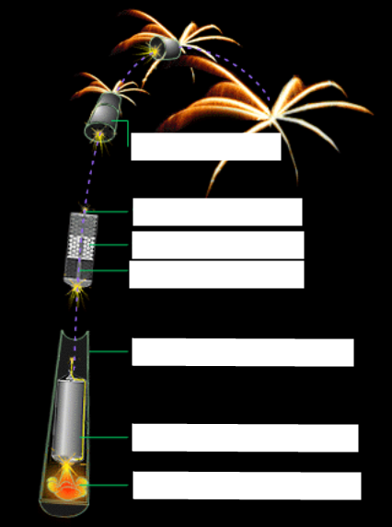

Sparkle, Fizz, Boom! Discussed are some of the reasons some fireworks are brighter than others. You will also find a chart of chemicals that will produce certain colors of fireworks. Click the page arrows to see each page of the article.
- Why is illegal to manufacture fireworks without a license? ____________________________________
___________________________________________________________________________________
- What are temples? ____________________________________________________________________
___________________________________________________________________________________
- What purpose do chlorates serve in fireworks? _____________________________________________
___________________________________________________________________________________
- Why aren't blue stars as bright as red, yellow, orange, and green stars? _________________________
___________________________________________________________________________________
- Explain the purpose of each of the following ingredients:
Water: _____________________________________________________________________________ dextrin: ____________________________________________________________________________
potassium perchlorate: _____________________________________________________________
sodium hydrogen carbonate: ____________________________________________________________

Professional Colors: Identify one compound that will produce the following colors .
Color Produced | 1 Compound that will produce this color
Gold
Purple
Silver
Pyrotechnics: It's ElementalGo to this site. Make sure that "Pyrotechnics" is selected from the drop down menu under "Most Abundant Elements In:" Visit each of the highlighted elements to learn their role in pyrotechnics. Complete the Element Columns in the following chart using the in.
Element | Color Produced within Fireworks |  | Element | Characteristics used in the ignition of Fireworks
 | Red |  |  | Part of Black Powder
 | Gold and Yellow |  |  | Combustible element that can ignite spontaneously
 | White |  |  | Fuels fireworks
 | Red |  |  | Combustible element that oxidizes fireworks
 | Green
 | Blue
 | Silver and White sparks |  |  | Deepens the colors produced by fireworks
 | Glitter
 | Sparks
 | Sparks
 | Smoke Clouds
Conclusion: In the process of completing this WebQuest, you’ve become informed about the chemistry behind fireworks, the chemical compounds that are responsible for the brilliant colors seen in fireworks, and about the component parts of modern fireworks. You have also learned a little about the history of fireworks. You have developed research skills as you explored the web sites given, and identified the relevant information to answer the set of questions above.

