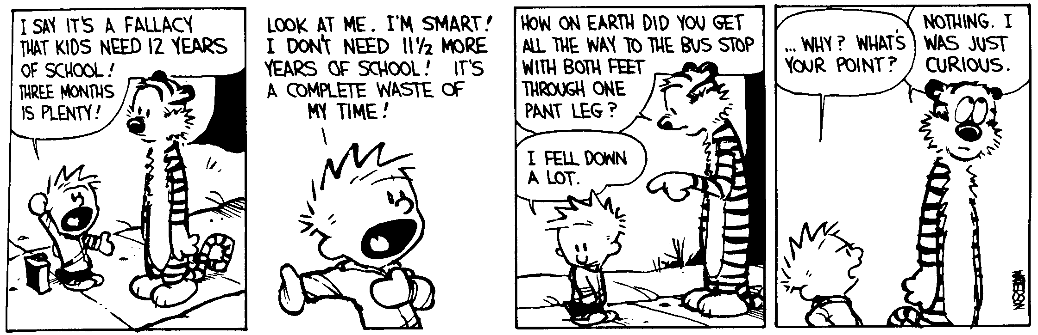
AP Physics – Waves Examination

Yes, place it here_____________________________________________________________Per___
A musician must make music, an artist must paint, a poet must write if he is to be ultimately at peace
with himself. What one can be, one must be. -- Abraham Moslow
- (20) A light wave with a wavelength of 635 nm in a vacuum travels through a bit of fused quartz which has an index of refraction of n =1.458. (a) Find the speed of light in the quartz. (b) What is the frequency of the light?

- (20) A beam of light, wavelength 525 nm in air, is incident on a block of glass (n = 1.51) at an angle of 30.5°. Find the angle of refraction.

- (20) Construct the image on the drawing below via ray tracing.

- (20) Construct the image for an object placed as shown below.
- (20) Find the minimum film thickness for constructive interference in reflected light for a thin film. The film’s index of refraction is 1.45. It is illuminated by light that has wavelength of 585 nm.

- (20) A double convex thin lens has a focal length of 25.0 cm. A 3.30 cm tall object is placed 38.0 cm from the lens, find (a) the image distance, (b) the magnification, (c) the image height.

- (20) The distance between two slits is 0.0500 mm and the distance to the screen is 2.50 m, find the spacing between the first-order and second-order bright fringes for yellow light with a wavelength of 580.0 nm

- (20) 585 nm light hits a slit (note, just the one slit) that is 0.300 mm in width. The observing screen is 2.50 m away. Find (a) the position of the first dark fringe and (b) the width of the central bright fringe.

