AP Physics – Waves Quiz

Howdy_________________________________________________________________Per___
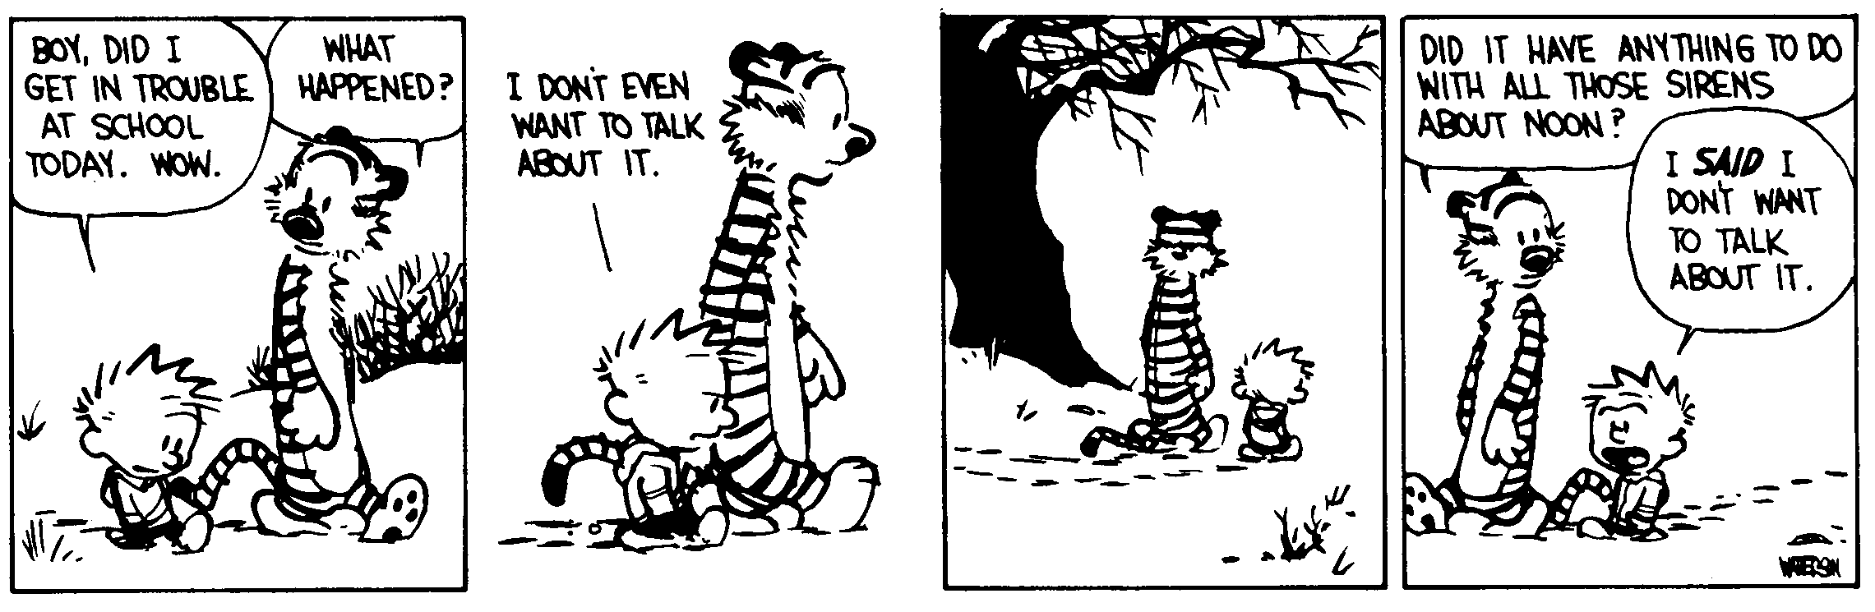
Whoever fights monsters should see to it that in the process he does not become a monster. And when
you look long into an abyss, the abyss also looks into you. -- Friedrich Nietzsche
- In a double slit experiment, the distance between the two slits is 0.0500 mm and the distance to the screen is 3.50 m, find the spacing between the first-order and second-order bright fringes for green light with a wavelength of 525.0 nm.

- Draw in the image formed by the lens (focal length is 22 cm) using the principle rays. If the 2.6 cm tall object is 9.0 cm from the lens, (a) what is the image distance? (b) What is the image height?

- A sheet of glass has an index of refraction n_{g} = 1.50. Monochromatic light is incident on the light at an angle of 60.0° as shown below. On the figure sketch the path the light takes the first time it strikes each of the two parallel surfaces;. Calculate and label the size of each angle on the figure, including angles of incidence, reflection, and refraction at each of the two parallel surfaces shown.

- A thin film is laid over a glass pane as shown. White light is incident on the film, coming straight in. At a point where the light is incident on the film, it appears green ( = 525 nm). Find (a) the frequency of the green light in air, (b) The frequency of the green light in the film (c) The wavelength of the green light in the film, and (d) the minimum thickness of film that would produce this green reflection.

