
United States Geological Survey
Earthquake Data Report

From: USGS National Earthquake Information Center
To: Sumatra Disaster Study Team
On May 22nd, 2013 at 1:53:00 am GMT, we received reports of a massive, Magnitude 9.1 earthquake near Banda Aceh, on the island of Sumatra, Indonesia. The earthquake appears to have been caused by the subduction of the Indian tectonic plate under the Burma tectonic plate. We estimate the depth of the earthquake epicenter to be roughly 30 km under the surface of the Earth.

A seismogram trace taken near the earthquake is shown below.

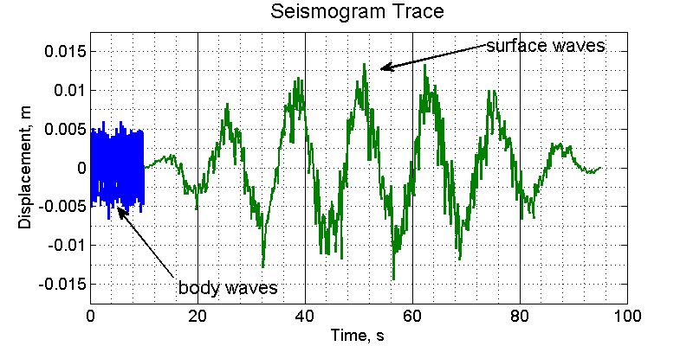
We know that several cities are of particular political interest to your team. Our analysts used measurements from several seismometers to make the data table below. [hours : minutes : seconds]

Location | Body-Wave  Arrival Time | Surface Wave  Arrival Time | Distance from Epicenter
Banda Aceh, Indonesia | 5/22/13 at 1:53:36.2 | 5/22/13 at 1:54:05.3 | 250 km
Chennai, India | 5/22/13 at 1:57:45.5 | 5/22/13 at 2:01:50.6 | 2027 km
Dar es Salaam, Tanzania | 5/22/13 at 2:07:56.1 | 5/22/13 at 2:21:02.1 | 6376 km
Mogadishu, Somalia | 5/22/13 at 2:06:25.9 | 5/22/13 at 2:18:27.2 | 5609 km
Padang, Indonesia | 5/22/13 at 1:54:24.8 | 5/22/13 at 1:55:58.0 | 687 km
Trincomalee, Sri Lanka | 5/22/13 at 1:57:08.4 | 5/22/13 at 2:00:35.1 | 1714 km


National Oceanic and Atmospheric Administration
Tsunami Data Report

From: NOAA Tsunami Program
To: Sumatra Disaster Study Team

On May 22nd, 2013 at 1:53:00 am GMT, a massive earthquake centered north of Sumatra, Indonesia initiated one of the largest tsunamis on record. The water was pushed violently upward and outward. Waves as high as 30 m were reported reaching the west coast of the island of Sumatra.

A sensor buoy on the open ocean, located far from shore, moved up and down a total of 0.6 m as the tsunami passed. Wave heights (crest to trough) reaching the shores of selected cities are shown below.

Location | Wave Height | Distance from Epicenter
Banda Aceh, Indonesia | 15 m | 250 km
Chennai, India | 4 m | 2027 km
Dar es Salaam, Tanzania | 1.5 m | 6376 km
Mogadishu, Somalia | 2 m | 5609 km
Padang, Indonesia | 25 m | 687 km
Trincomalee, Sri Lanka | 10.5 m | 1714 km

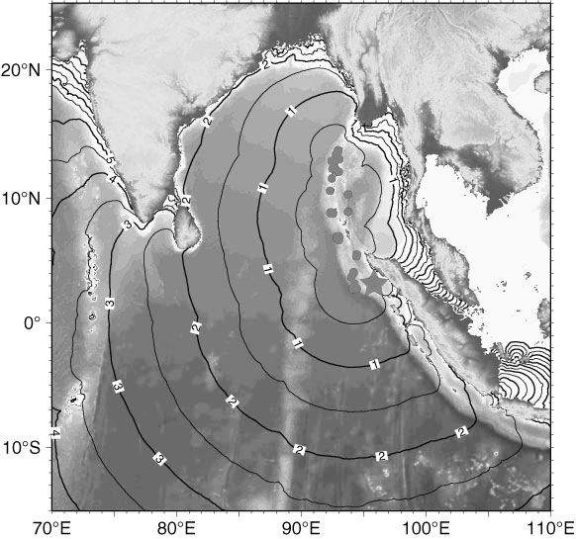
Using the data from sensor buoys, we assembled the following figures which show how the tsunami wave propagated across the ocean. The lines are half-hour intervals.
