Name: ___________________________ Date: __________________ Assigned City: _______________________________

Sumatra Disaster Project - Work Packet
A major earthquake and tsunami have been reported in Southeast Asia, near the island of Sumatra. You are part of the science team that has been tasked with investigating the physics of what happened.

Your grade on this packet will be based on easy-to-follow calculations, specific explanations, and clear reasoning.

Part A: Background Reading
The first thing we need to do is to get some background information about earthquakes and tsunamis. You should use suggested websites to find this information. Write this in your OWN WORDS.

1. Explain what causes an earthquake and how one happens.

2. What are p-waves and s-waves? Identify p-waves and s-waves as either transverse or longitudinal waves. Explain your reasoning.

3. Most of the damage from earthquakes is caused by surface waves. Why do you think this is?

4. Where does a tsunami get its energy from?

5. Is a tsunami a transverse or longitudinal wave? How do you know?

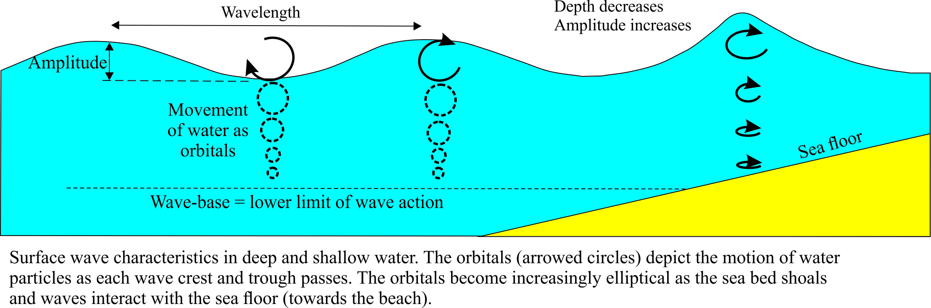

6. Look at the figure above. The figure shows the waves getting higher and slower as they approach the shore. Why do you think the waves get slower as their amplitude increases? (Hint: Think about what a wave does - transmit energy.)

Part B: Analyze the Data

Your disaster analysis team will receive two memos, one each from the USGS and NOAA, which are two of the government agencies that study the earth. Use these data to answer the following key questions about the wave physics involved in the disaster.

All team members should explain clearly what information they used, where they got the information, and show all calculations.

Helpful Tips:
- Try things out initially on a separate sheet of paper and use pencil.
- Splitting up the workload may speed up the process
- Two people working on the same problem can check each others work.
- Think about what the information means. Discuss and use drawings to clarify your thinking.
- Remember that not all information may be relevant!

The following questions refer to the EARTHQUAKE only. Refer to your data memo from the USGS.

7. Determine the amplitude, frequency, wave speed, and wavelength of the earthquake’s body waves. Assume a frequency of 4.5 Hz.

8. Determine the amplitude, frequency, period, velocity, and wavelength of the earthquake’s surface waves.

The following questions refer to the TSUNAMI only. Refer to your data memo from NOAA.
The open ocean refers to deep water, away from land.

9. Estimate at what time the tsunami wave arrived at your designated city and the average speed of the tsunami. Explain what data you used and how.

10. Find the amplitude of the tsunami on the open ocean and at the shore of your city. Why is there a difference in the two amplitudes, even though it is the same wave?

Part C: Interpret Your Findings

11. What evidence (from the data) is there that your answer to #5 is correct?

12. Order the four following waves from slowest to fastest: earthquake s-wave, earthquake p-wave, tsunami near the coast of your city, tsunami on the open ocean. How do you explain why these waves are in this order of speed? Be specific -- describe what is happening to the earth or water as the waves move.

13. Compare the wave height at your designated city to those at the other cities. Why do you think the wave heights are different from each other? How do you explain why the wave height reaching Padang was more than the wave height reaching Banda Aceh?

14. Which do you think caused the most damage to your city, the earthquake or the tsunami, and why?

Part D: Poster

Make a poster that summarizes your team’s investigative findings. Policymakers will want to see:
- Names of the team members.
- An explanation of the physics involved from the time of the earthquake until the tsunami hit your city. (Tip: Use your answers to Part A to help you frame this.)
- From Part B: Summary or diagram of final results.
- From Part C: Brief summaries of answers and reasoning.

