Sumatra Disaster Project - Overview

Waves are how the Universe transmits information and energy from one place to another. Sometimes this energy can be destructive to humans. In this project, you will take on the role of an investigative team that has been tasked with putting together an analysis about a major earthquake and tsunami.

This project is based on the 2004 Southeast Asia tsunami, caused by an earthquake just north of Sumatra. It was the third largest earthquake in the world since 1900. In total, 227,898 people were killed or were missing and presumed dead and about 1.7 million people were displaced by the earthquake and subsequent tsunami in 14 countries in South Asia and East Africa. The tsunami caused more casualties than any other in recorded history and was recorded nearly world-wide on tide gauges in the Indian, Pacific and Atlantic Oceans. (Source: USGS).

Your Task

A major earthquake and tsunami has just occurred in Southeast Asia. Governments, nonprofits, and private companies need scientifically accurate information fast, so that they know what happened and can decide how to move forward with responding to the disaster. One of the first things that needs to happen is to put together a team of scientists and engineers to analyze the situation.

You and your group are a science investigative team that has been assigned to analyze the wave physics of the earthquake and tsunami. You only have a few days, because resources need to be mobilized before its too late to help people. We also hope that by studying earthquakes and tsunamis, we can learn how to protect people.

In addition to the general investigation, each team will be responsible for one of the following cities of interest: Banda Aceh (Indonesia), Padang (Indonesia), Chennai (India), Trincomalee (Sri Lanka), Mogadishu (Somalia), and Dar es Salaam, (Tanzania). Certain questions will ask you for information specific to your group’s city. The star in the map below represents the earthquake’s epicenter.

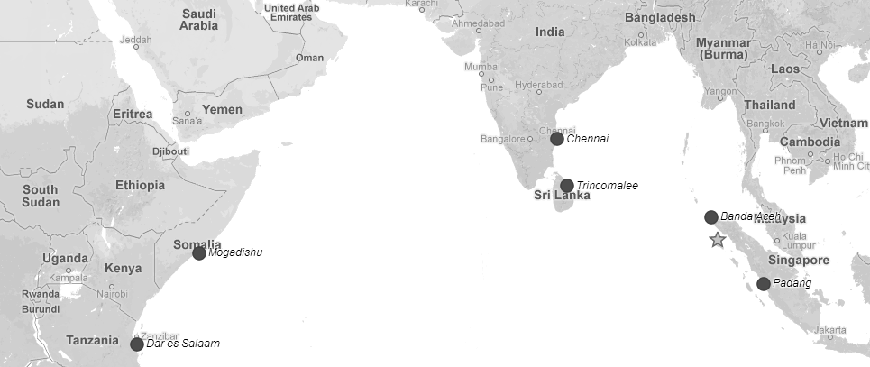

Resources
You will have access to several resources throughout the duration of this investigation.

Sources of Information
- The internet and suggested websites
- An earthquake data set from the United States Geological Survey
- A tsunami data set from the National Oceanic and Atmospheric Administration
- Most important: your own notes, research, and reasoning!

Grading
At the end of the project, each member of the team will rate his or her teammates contributions to the final result. Your peer evaluation will be a portion of your individual grade on the project. A rubric will factor in the individual work in the handout, observed teamwork, team final poster, and the peer evaluation.

Teamwork counts! Excluding group members will count against you just as much as not contributing.

For this project you can work by yourself OR with a partner.

Schedule:

Wednesday 9/26- Introduction to Project, Choose Groups, Get Assigned Area, Part A

Thursday- Part B and Part C

Friday- Finish Parts B and C, Start Part D (Poster)

Monday- Part D- Poster

Tuesday- Poster due at the end of class

