Lab Station 1
Chicken in a Cup! Vibrations and Sound
Materials:
2 Styrofoam or plastic cups
String
2 paper clips
Ruler
Cup of water

Procedure:
- Cut the string into 2 pieces with 2 different lengths. One should be a length of about 30 cm and the other should be a length of about 15 cm.
- Tie one paper clip to the end of each piece of string.
- Put the other end of the string through the hole in the bottom of the cup.
- Repeat with the other cup and string.
- Wet the string slightly and pull on the string. Gently allow your fingers to pull the entire length of the string.
- Repeat with the other cup and string.
- Have you and your partner pull on one cup’s string at the same time so that the sounds are amplified.
- Cut the Styrofoam cup in half and repeat the experiment.
- Remove the paperclip and replace it with a different size paperclip. Repeat the experiment.

Lab Station 2
Record Player
Materials:
Record Player
Paperclip
Piece of Paper
Record
Procedure:
- Unfold the paperclip until it is 1 long piece.
- Tape the paperclip to the paper as show below:
- Fold the paper until it resembles a cone.
- Tape the paper so that it stays in the shape of a cone.
- Turn on the record player with record in place.
- Use the paperclip as the needle by gently placing it on the record as it turns.
- Answer your questions.
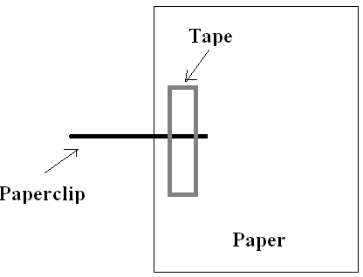

Lab Station 3
Tooth Tunes
Background Information:
A miniature electric motor and a speaker have the same basic components: a coil and a permanent magnet. When electrical impulses pas through the voice coil of a speaker, it interacts with the magnet and moves back and forth. When a current passes through the coil of a motor, it interacts with the magnet and spins. When sound is passed to a motor, it causes a slight vibration of the arm of the motor. These vibrations produce sounds.

Materials:
- 1.5 Volt motor. (I found the cheapest to be at the dollar store in the toy section. The remote control cars run off a tiny motor).
- Earphones
- Wooden Dowel (.5 cm diameter and about 10 cm long)
- Radio
- Thumbtack

Procedure:
  - Place a straw over the tip of the wooden dowel (for sanitary purposes)
  - Tune the radio to a clear station.
  - Plug the cord into a small radio and turn the radio’s volume on high.
  - You should feel the motor vibrating. If not, check your connections.
  - Clamp your teeth loosely over the wooden dowel (on the straw).
  - Use your fingers to close your ears.
  - You should hear the music clearly. The dowel is conducting the sound to your teeth, thru the bones of your skull, and to your inner ear.

Lab Station 4

Laser Oscilloscope
Introduction: Using the principles of optical amplification, sound patterns can be projected on a distant wall and the principles of an oscilloscope can be demonstrated.

Materials:
Empty soup or nut can
Playdoh
Super Glue
Balloon
Tape
12 in piece of molding
Rubber bands
Small Mirror
Laser
Procedure:

- Turn off the lights. Turn on the laser and observe the reflection off the mirror and onto a wall.
- Speak into the other end of the can and observe the pattern produced by the laser. This works even better if you add a lid to the open end and cut a small hole in the middle of the lid.
- Speak into the can very softly and observe the pattern created. Then speak loudly. Sketch the 2 patterns on your lab sheet.
- Try singing into the can and observe the patterns created. Now try clearing your throat in the can and notice the pattern. Record the difference in patterns on your lab sheet.
- Finally, say the alphabet into the can and notice the different pattern produced by each letter.

Lab Station 5
The Singing Rod
Materials:
Crushed Rosin
Singing Rods (3 sizes)
Procedure A:
1. Firmly hold the center of an aluminum rod horizontally using the thumb and forefinger of one hand.
2. Pinch and release a small amount of crushed rosin with the thumb and forefinger of the other hand.
3. Gently stroke the aluminum rod from the center to the end of the rod using your rosin coated thumb and forefinger. Repeat and slightly increase the pressure of your stroking hand until you hear a high-pitched tone. Too little pressure will not start the vibrations while too much will just freakin’ hurt!
Procedure B:
1. Firmly hold the rod vertically at a point ¼ the distance from the upper end.
2. Repeat and listen to the different pitched tone.

