Making your own vernier callipers

AIM
The aim of the experiment is to make your own vernier scale and then to use it to measure some small distances.

YOU WILL NEED
The paper version of the vernier and main scale drawn full size at the bottom of this sheet.
Scissors Card Glue

WHAT TO DO
Cut out the vernier and the main scale – at this stage you can leave some space round the edges.

Stick the paper versions on pieces of card and then very carefully cut round the edges so that the shapes are as shown in Figure 1. (Your teacher may do this for you with a sharp knife)
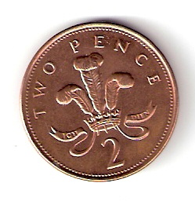
MAIN SCALE (CM)
1
3
2
4
0
5
VERNIER
5
Put the shapes side by side (Figure 1) and use it to measure the diameter of a coin (say a 2p piece).

Now try it with a series of other small objects – sizes less than 5 cm but more than 1 cm.

You will find all the explanation of how the vernier works by reading the file on the vernier:

See: 11-14/Text/General/Vernier callipers
MAIN SCALE (CM)
1
3
2
4
0
5
VERNIER
5
Figure 1

