AP Physics – Quizo O’Whizzo

Claim ___________________________________________________________________ Per___
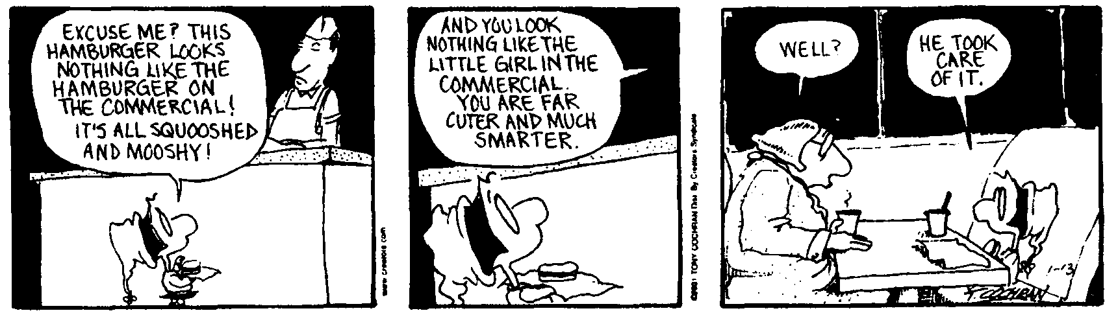
To believe all men honest would be folly. To believe none so is something worse. -- John Quincy Adams
- A car is initially at rest. It accelerates over a distance of 1250 m and reaches a speed of 112 km/h. Find: (a) the average acceleration for the car, (b) the average speed of the car, and (c) the time it took for it to reach this final speed.

- A cart moves horizontally along a straight track. The graph to the right describes it’s motion. What is:
- the acceleration from a – c?
- The acceleration from c – d?
- Identify areas where the speed of the cart is decreasing.
- Find the horizontal displacement at time = 12 seconds.

- A ship is steaming on a heading of due north at a speed of 12.0 kts (nautical miles per hour). The current is swirling at 4.25 kts going from east to west (so headed due west). (a)What course must the ship steer in order to make good a heading that is due north (000°)? (b) What is the ship’s speed over ground (the course it actually makes good to you lubbers)?

- You walk north a distance of 12.0 km. Then you travel east a distance of 5.0 km. (a) How far are you from the place you started from? (b) what is the direction from you to the starting point?

