Van De Graff Labs
1. Crack the top half of the globe of the generator off. Turn the generator on and observe the inner workings of the Van De Graff. Notice the how similar it is to a person rubbing his or her feet against a carpet.

2. Place an aluminum foil pie pan upside down on the dome of the Van De Graff. When you turn on the power, it will levitate and fly off the side since like charged objects repel each other. Now place two pie pans on the Van De Graff. Turn on the power and the top one holds the bottom one down, until the top one flies off, allowing the bottom one to fly off. Finally, try an entire stack of pie pans.
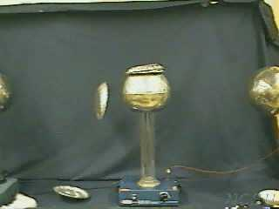

3. Place a balloon near the Van De Graff while it is powered up. It is repelled since like charges repel each other. Now rub the balloon on your hair and place it near the Van De Graff. It will be even more repelled since rubbing your hair created even more negative charges.
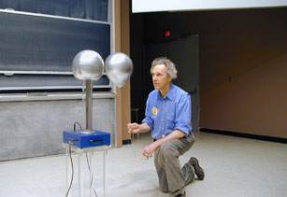

4. To charge the Leyden jar, the outer metal can needs to be connected to a ground. So attach the red wire to the hole in the Van De Graff and connect the alligator clip of the other end of the wire to the metal cup. Touch the attached ball to the Van De Graff while the Van De Graff is powered up. It should only take a few seconds for it to charge. If anyone touches just the ball or just the cup, no shock will be felt. You must have a complete circuit to feel a shock. Therefore, have someone touch both the ball and the side of the can at the same time.

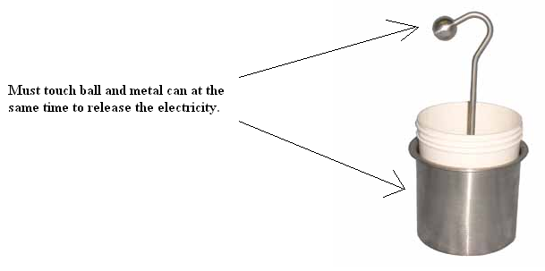
5. Electric Wind: This activity demonstrates how the air molecules around the generator are charged with static electricity. Bring a metal object near the Van De Graff dome and place a lit candle between the object and the dome. The flame is bent sideways. This happens because the charged particles flowing through the air.
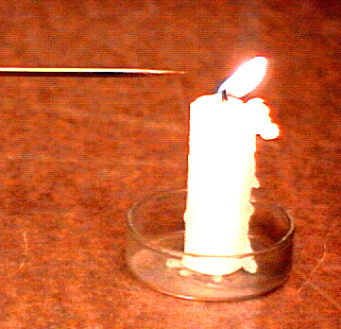
6. Gas Tube: Hold a tube filled with neon gas or other gases near the generator, and it will glow. The basic explanation for this is that the electricity created by the generator is flowing through the tube and exciting the gas particles. This gas particles then give off light once excited.

7. Place a foil covered piece of cardboard on the table. Place several crumpled up pieces of aluminum foil on the cardboard. Pick up the entire Van De Graff and move the sphere towards the crumpled foil pieces. The Van De Graff originally attracts the pieces but than transfers its negative charge to them which them makes them repelled. At a particular distance, you can get a piece of foil to hang unmoving in space.

8. Pour a small pile of Rice Crispies or Styrofoam peanuts in a Styrofoam bowl and place it on top of your Van De Graff and turn on the power. Now try standing on the stool, touch the Van De Graff with one hand and place several Rice Crispies in your other hand. Have someone turn on the Van De Graff and observe.
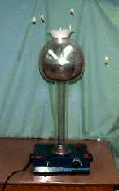
9. Blow soap bubbles at the Van De Graff. They will be initially attracted but than they will become negatively charged and will become repelled. Hold your hand above a charged bubble and keep it floating by attraction.

10. Tape a bent paper clip to the side of the sphere. Bend the wire so that it points outward. When the Van De Graff is running, a stream of charged wind spews out. This stream is called the ion beam. It will electrify distant surfaces, charge whole people if they are standing on the stool and will light a fluorescent tube at a distant. When this air gets on your clothes it makes them cling to you.

11. Tape strips of tissue all over the sphere. Turn it on so that the strips stand out; turn it off. Will the strips remain standing or fall?
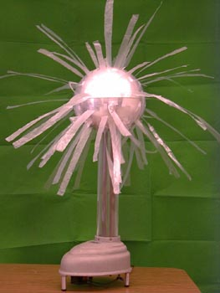

12. Hold the discharge electrode 4 inches from the dome of the generator. Plug in the ground cord. Once the generator is turned on, a bright bluish-white arc will jump from the dome to the electrode. You should also hear a sharp crack. This is the electricity moving to another object in search of a way to ground itself.
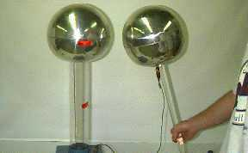

13. Charging Person's Hair: In this demo, the body is used as a conductor for the static electricity created from the generator. A volunteer is first insulated from the ground (so electricity will have no way of grounding itself) by having them stand on a plastic stool or crate. He/she then places both his/her hands on the generator before the generator is turned on. Once it is turned on, the volunteer must NOT remove his/her hand from the generator until it is turned off to avoid receiving a shock. If the demonstration is a success, the subject's hair should stand up (best results come from clean, straight, dry hair that is 3 to 4 inches long). From this demonstration, we can see how important it is to keep the subject insulated from the ground, so as to limit the number of ways he/she can "lose" charge. If too much is lost to the ground, not enough electricity will go through the hair.

14. Hold the discharge probe by the plastic rod and lower it between the 2 Van De Graff spheres, which should be placed about 15 centimeters a part. Adjust the distance of both Van De Graffs so that they both continually send a spark to the discharge electrode on both sides.

15. Make sure the Electroscope has 2 pieces of aluminum foil freely hanging inside. Place the electroscope on the table near the Van De Graff. Have a student stand on the stool and put one hand on the Van De Graff Ball. Turn on the Van De Graff. Have the student take his or her other hand and place it near the metal rod coming out of the electroscope. Do not touch the metal rod or you will get shocked! The electrical charge will transmit to the electroscope foil pieces. Notice what happens. The foil pieces should be repelled because the whole radiometer is filled with the same charge. Remove the electroscope and have another student touch the electroscope metal rod. Observe what happens to the aluminum foil pieces.

16. Have one student stand on the stool and hold hands with another student. Have the 2nd student hold hands with a 3rd student. This will create a human chain. Finally, have the 3rd person touch a 4th person after allowing the charge to build up.

17. Tie a cotton ball on a string and allow it to hang freely near the Van De Graff dome.
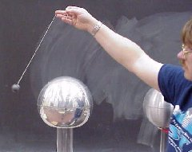

18. Tie an Aluminum can on a string and allow it to hang freely near the Van De Graff dome.
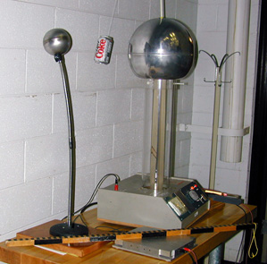

19. Place the aluminum can on a string between two generators. Turn them both on and observe the can.

20. Have a student stand on the stool and put one hand on the generator. Turn on the Van De Graff. Have a 2nd student pour water from one beaker to the other beaker. While the water is being poured, have the student with the hand on the generator, take her free hand and point a finger very close to the stream of pouring water. The water stream will be bent away from his or her finger. Sometimes the water is pulled farther to the side than you expect, and small droplets get pulled onto the globe of the generator, so have some paper towels ready.

