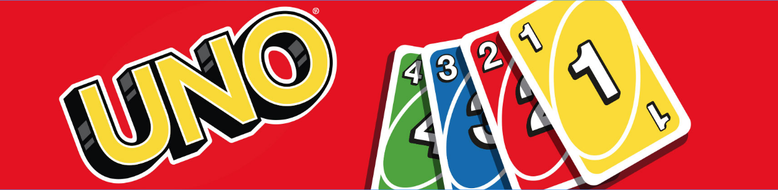

Fitness

Grab a deck of UNO cards and have fun getting fit at home!
Draw a Card. If your card is a:

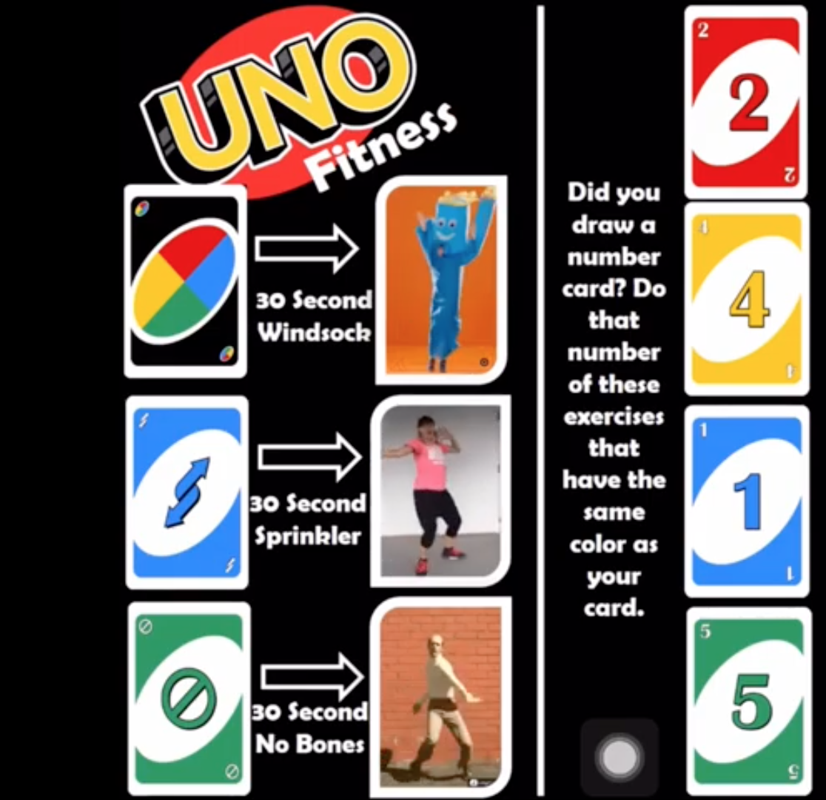

Red = Push Ups

Yellow = Reverse Curls

Blue = Dead Bug

Green = Cross Knees

Play music for a determined time. OR use the YouTube video.
https://www.youtube.com/watch?v=Hzy9lOrlnpQ / Phys.Ed.Review
(You can vary or change the exercises each time you play!)

