Unit I Test – Scientific Thinking

DO NOT WRITE ON THE TEST!! ANSWER ON THE SCANTRON FORM.
Select the single best response to each of the following questions.

1. In the pendulum lab, the variable(s) that affected the period of the pendulum was (were):
a. length
b. mass
c. drop height
d. all of the above

2. In the pendulum lab, the period was
a. the independent variable
b. graphed on the vertical-axis
c. graphed on the horizontal-axis
d. the variable you controlled

For the following questions consider the pendulum apparatus shown below. Bobs a and b have masses of 20. g; bob c has a mass of 10. g.
3. Suppose you pulled bobs a and b back through an angle of 5°, how would their periods compare?
a. the period of a is greater
b. the period of b is greater
c. the periods are equal
d. you can't tell because the lengths are different

4. Suppose that you pulled bobs b and c back through an angle of 5°, how would their periods compare?
a. the period of b is greater
b. the period of c is greater
c. the periods are equal
d. you can't tell because the lengths are different

A science class puts wide wheels onto a small cart and lets it roll down an inclined ramp and then across the floor. They measure the distance the cart travels. The investigation is repeated using the same cart but this time fitted with narrow wheels. The angle of the incline of the ramp remains constant. The mass of the cart is kept constant.

5. What is the relationship being studied?
a. The effect of the cart mass on the distance the cart travels.
b. The effect of the incline of the ramp on the speed the cart travels.
c. The effect of wheel width on the distance the cart travels.
d. The effect of wheel width on the speed the cart travels.

6. What is the dependent variable?
a. mass of cart
b. width of wheels
c. angle of incline
d. distance cart travels

7. What is the independent variable?
a. mass of cart
b. width of wheels
c. angle of incline
d. distance cart travels

8. If our class were to run this experiment, what variable would make the most sense to keep constant during the study?
a. temperature of room
b. width of wheels
c. angle of incline
d. distance cart travels

In questions 9-13, match a letter from each of the following graphs with its corresponding graphical analysis statement.

9. y vs. 10. y = kx

11. y is independent of x 12. yvs. x

13. y vs. x

14. In an effort to create a straight line graph from the data graphed at right, you should
a. square the volume values
b. invert the volume values
c. square the pressure values
d. square root the volume values
e. do nothing; you can't get a straight line out of this

15. The relationship for the graph above is best represented by
a. Pressure is directly proportional to the volume.
b. Pressure is proportional to the square root of the volume.
c. Pressure is inversely proportional to the volume.
d. Pressure is proportional to the square of the volume.
e. There is no relationship between pressure and volume.

16. The mathematical model for the graph at right is best represented by
a. d = t.
b. d = kt.
c. d = kt.
d. d = k.
e. d2 = kt.

17. The graphical representation between distance and time (shown above) could best be stated as
a. Distance is directly proportional to time.
b. Distance is proportional to the square of time.
c. Distance is inversely proportional to time.
d. Distance is proportional to the square root of time.
e. There is no relationship between distance and time.

- The following times were obtained by different observers when determining the period of a pendulum. Express the average period to the correct number of significant figures.
Time (s)
0.2502
0.2417
0.2487
0.2538

- 0.3 s
- 0.25 s
- 0.249 s
- 0.2486 s
- 0.24860 s

- Select the best measurement of the width of the piece of paper, to the correct number of significant figures, measured with the meter stick below:
  - 30 cm
  - 30. cm
  - 32 cm
  - 32.5 cm
  - 32.48 cm

The following graph corresponds to the next set of questions. The graph shows a relationship between the weight of a baby and its age.
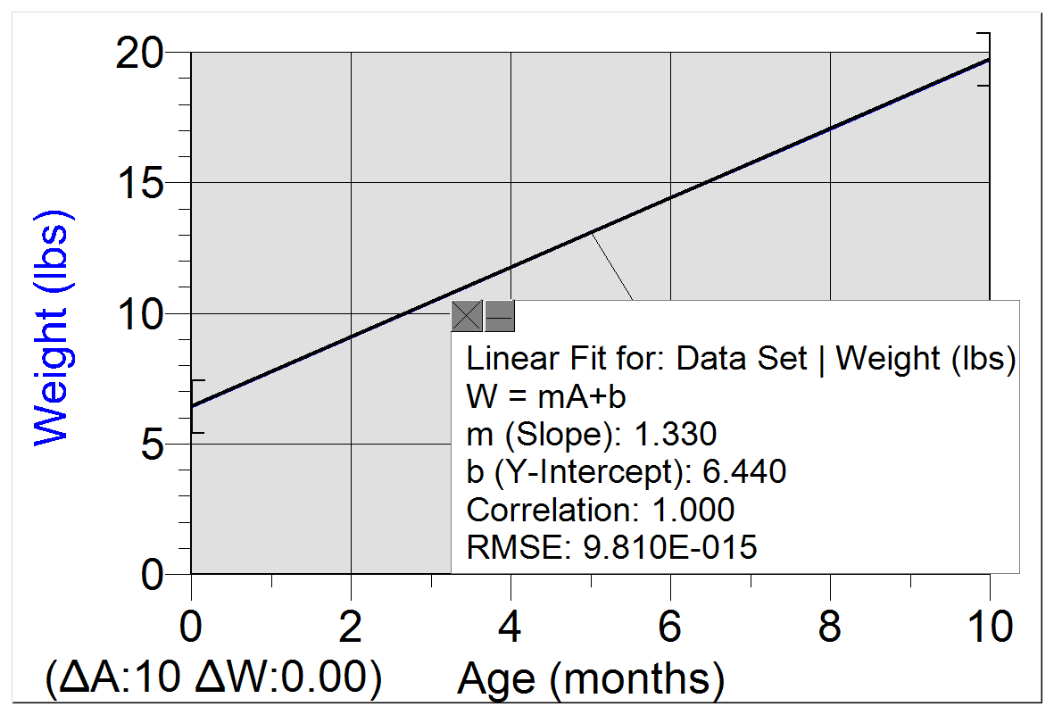
- The independent variable is
  - Weight
  - Lbs
  - Age
  - Months
  - C.O.R

- The dependent variable is
  - Weight
  - Lbs
  - Age
  - Months
  - C.O.R.

- The value of the slope is
(copy of graph from previous page)
  - 1.33
  - 0.0130
  - 6.440
  - 9.810 x 10⁻¹⁵
  - 1.00

- The units of the slope are
  - Lbs
  - Months
  - Lbs/months
  - Months/lbs
  - Lbs ∙ months

- The value of the y-intercept is
  - 1.33
  - 0.0130
  - 6.440
  - 9.810 x 10⁻¹⁵
  - 1.00

- The units of the y-intercept are
  - Lbs
  - Months
  - Lbs/months
  - Months/lbs
  - Lbs ∙ months

- The best meaning of the y-intercept is
  - A newborn baby’s age
  - A newborn baby’s weight
  - A newborn baby’s growth rate
  - A newborn baby’s height
  - The time it takes a pendulum to swing.

- The best model for the relationship between weight and age is

- Assuming that the relationship between weight and age remains constant, what weight does this model predict for a baby that is 15 months old?
  - 19.95 lbs
  - 26.39 lbs
  - 96.6 lbs
  - 97.93 lbs
  - 128.5 lbs

Use the following information to answer the next set of questions:
A pendulum that has a length of 0.75 m is measured to have a period of 1.74 s. The mass of the bob at the end of the string is measured to be 0.065 g.

- If only the original bob were replaced with a mass of 0.085 g while keeping all other variables the same, the new period would be
  - Greater than 1.74 s
  - Still equal to 1.74 s
  - Less than 1.74 s
  - It is impossible to say.

- If only the original length of the pendulum were increased to 1.00 m while keeping all other variables the same, the new period would be
  - Greater than 1.74 s
  - Still equal to 1.74 s
  - Less than 1.74 s
  - It is impossible to say.
Unit 1 Test – Scientific Thinking Name:_________________________________
Period:_________

Free Response Questions
Answer each of the following neatly and completely. If a measurement is supposed to have units attached to it, then attach units. If you can show work leading to your solution, then show work.

- Below is a sample set of pendulum data that has been graphed on the left in its raw form. Clearly label the axes on the linearized version of the graph with the appropriate variables and units.
RAW DATA LINEARIZED DATA
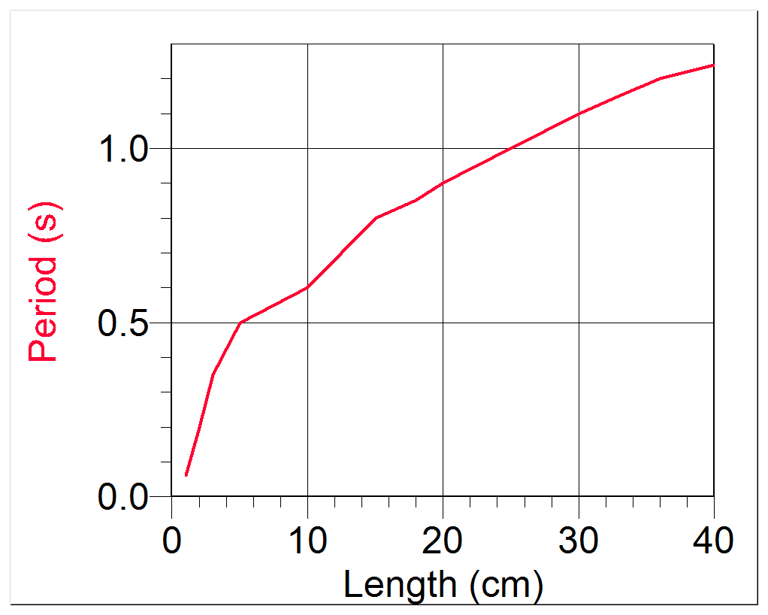
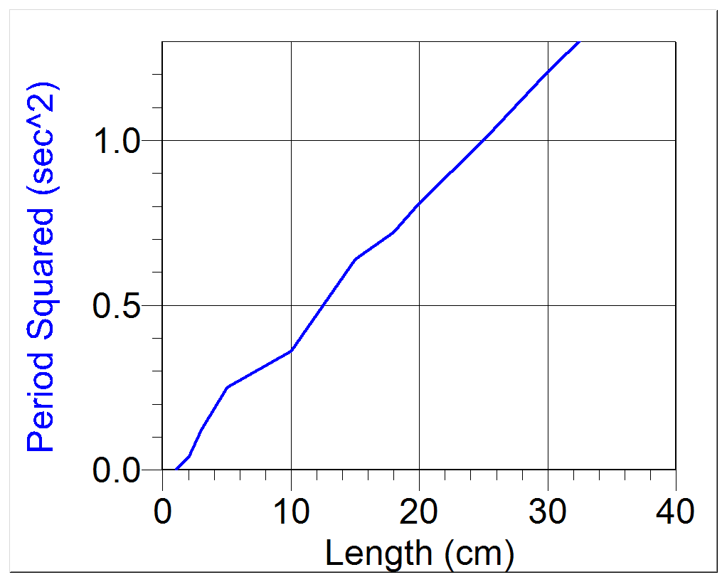

- Write the complete mathematical model that corresponds to the following graph.
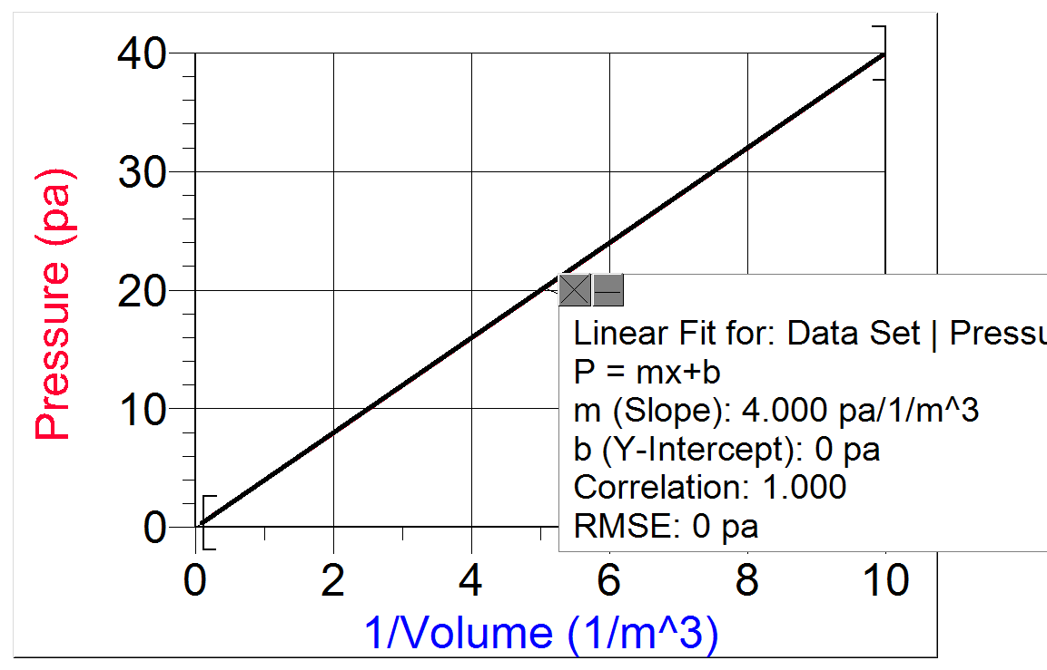

- Use the data in the previous problem to make an accurate prediction of the volume when the pressure is found to be 150 pa.

