
Unit 7 - Cellular Respiration Notes

FALL SEMESTER 2023
INSTRUCTOR:
instructor@email.com

Vocabulary / Key Terms/ Concepts | Unit 7: Cellular Respiration
photosynthesis  autotroph  heterotroph  cellular respiration  electron transport chain  aerobic  anaerobic  glycolysis  fermentation  Kreb’s Cycle | Student Expectations:  Cellular Respiration  - Know that all organisms undergo cellular respiration as long as oxygen is available.  - Explain the process of harvesting energy in aerobic cellular respiration  - Two units of ATP are used to break down glucose to pyruvate during the process of glycolysis. The result is a net gain of 2 ATP.  - The stored energy in pyruvate is broken down into 2 molecules of ATP and CO2 in the Krebs cycle.  - A final group of chemical reactions is the process called the electron transport chain. During this process, 32 ATP molecules are produced and water exits the cell.  - Explain the process of anaerobic respiration.  - When oxygen is NOT present, fermentation follows glycolysis, regenerating NAD+ needed for glycolysis to continue.  - Understand that compared to the chemical reactions that take place during cellular respiration, reactions during fermentation result in less ATP being produced; therefore less energy is made available during fermentation than cellular respiration for the chemical reactions that maintain an organism’s body functions  - Compare the reactants and products of photosynthesis:  - 6CO₂ + 6H₂O + energy → C₆H₁₂O₆ + 6O₂  - And cellular respiration:  - C₆H₁₂O₆ + 6O₂ → 6CO₂ + 6H₂O + energy (38-ATP)  - Glucose and oxygen are formed as a result of photosynthesis using carbon dioxide, water and energy  - Respiration uses the glucose and oxygen and releases carbon dioxide, water and energy  - Energy is required for photosynthesis and released during respiration  - Respiration is the reverse process of photosynthesis  Cellular ________________  - Oxygen requires a process that uses energy extracted from macromolecules (glucose) to produce energy (ATP), water and carbon dioxide.  C₆H₁₂O₆ + 6O₂ → 6CO₂ + 6H₂O + energy  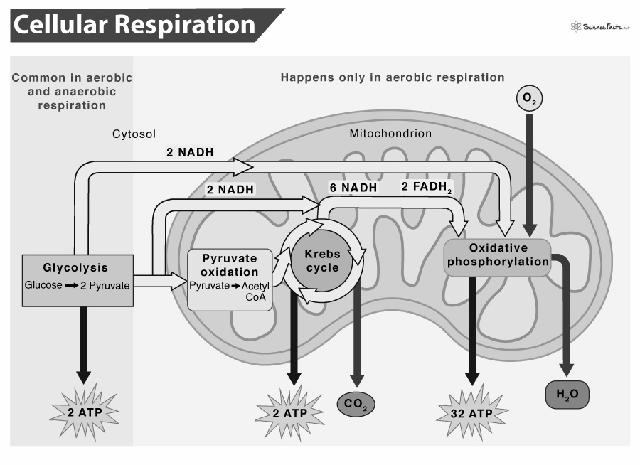  - Metabolic Pathway that breaks down ________________.  - Process is exergonic as high-energy glucose is broken down into CO2 and H2O.  - Process is also catabolic because the larger glucose molecule breaks into smaller molecules.  Steps of Cellular Respiration  - ________________  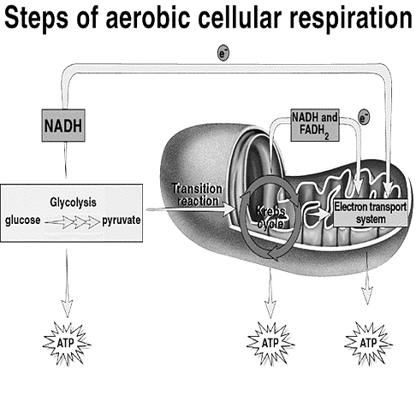  - ________________  - ________________  - ________________  The Where of Cellular Respiration  - Cellular respiration actually takes place in two parts of the cell.  - ________________occurs in the ________________.  - ________________ & ________________take place in the ________________  Step 1: ________________  - Overview:  - Takes place in the ________________.  - ________________(doesn’t use ________________)  - ________________input of 2 ________________.  - ________________splits into two molecules of ________________or Pyruvic Acid.  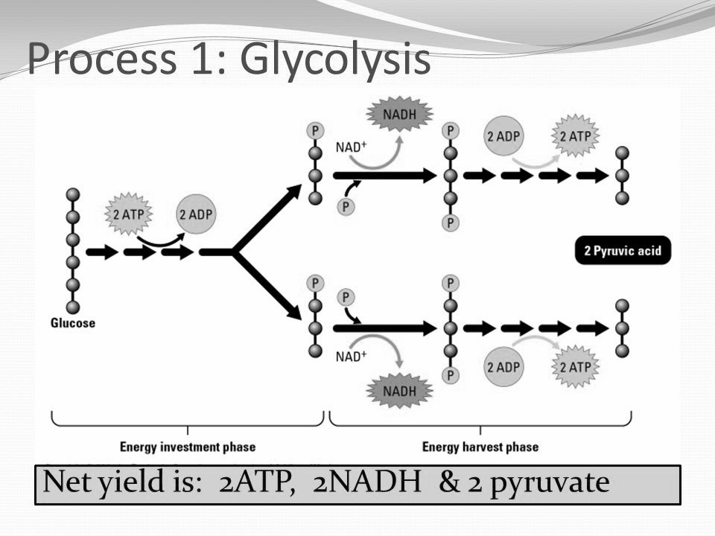  - Also produces 2 ________________ and 4 ________________.  - Two Phases:  - Energy ________________Phase (EIP) - Preparatory phase  - Summary: Even though glycolysis is an energy-releasing process, the cell needs to put in a little energy to get things going. At the pathway's beginning,  - 2 molecules of ATP are used up. In a way, those 2 ATP molecules are like an investment that pays back interest.  - Energy ________________Phase (EYP) - Energy payoff phase  - Summary: One of the reactions of glycolysis removes 4 high-energy electrons and passes them to an electron carrier called NAD+.  - Like NADP+ in photosynthesis, each NAD+ accepts a pair of high-energy electrons. This molecule, known as NADH, holds the electrons until they can be transferred to other molecules.  - By doing this, NAD+ helps to pass energy from glucose to other pathways in the cell. An advantage is that glycolysis itself does not require oxygen.  - This means that glycolysis can supply chemical energy to cells when oxygen is not available. However, when a cell generates large amounts of ATP from glycolysis, it runs into a problem.  - In just a few seconds, all of the cell's available NAD+ molecules are filled up with electrons.  - Without NAD+, the cell cannot keep glycolysis going, and ATP production stops.  - Total Net Yield in ________________:  - 2 - ________________ (PYR)  - 2 - ________________ (Substrate-level Phosphorylation: ATP is formed when an enzyme transfers a phosphate group from a substrate to ADP.)  - 2 - ________________(nicotinadenine dinucleotide)  ________________ Step - ________________  - Occurs when Oxygen is ________________(________________).  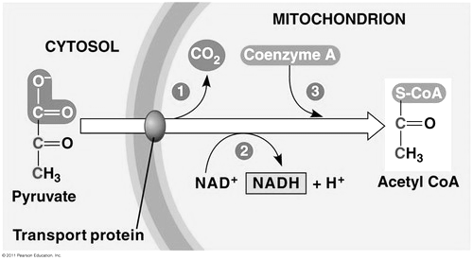  - 2 ________________ (3C) molecules are transported through the mitochondrial ________________to the matrix and are converted to 2 Acetyl CoA (2C) molecules.  - End products intermediate step:  - 2 - ________________  - 2 - ________________  - 2- ________________  Step 2: ________________ / ________________  - Location: mitochondrial ________________.  - Acetyl CoA (2C) bonds to Oxaloacetic acid (4C - OAA) to make Citrate (6C).  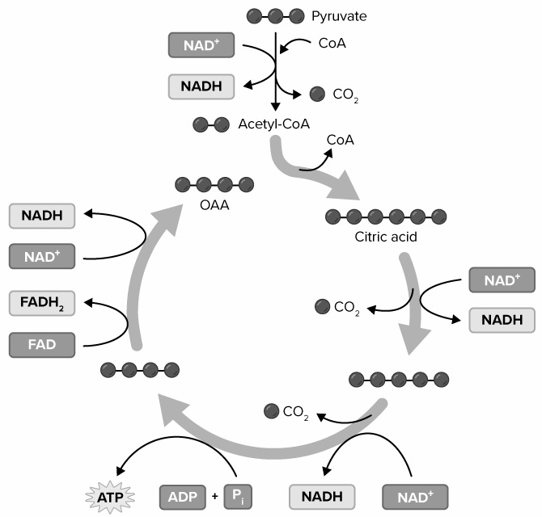  - It takes ________________ of the Krebs cycle to oxidize 1 ________________ molecule.  - Total Net Yield: (2 turns of Krebs Cycle)  - 2 - ________________ (substrate-level phosphorylation)  - 6 – ________________  - 2 - ________________ (Flavin-adenine dinucleotide)  - 4 - ________________  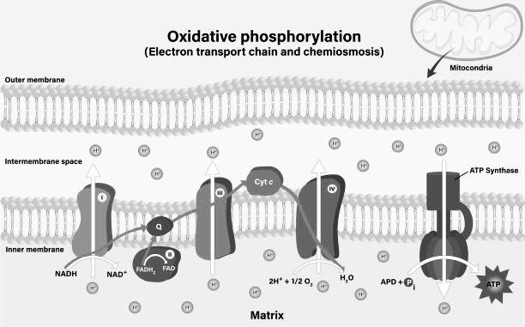  Step 3: Chemiosmosis – _______________________________  - Location: inner mitochondrial ________________.  - Uses ETC (proteins) and ________________ (enzyme) to make ________________.  - ETC pumps H+ (________________) across inner membrane  - The H+ then move via ________________through ________________ to make ATP.  - All NADH and FADH₂ converted to ATP during this stage of cellular respiration.  - Each NADH converts to _____ ATP.  - Each FADH₂ converts to _____ ATP (enters the ETC at a lower level than NADH).  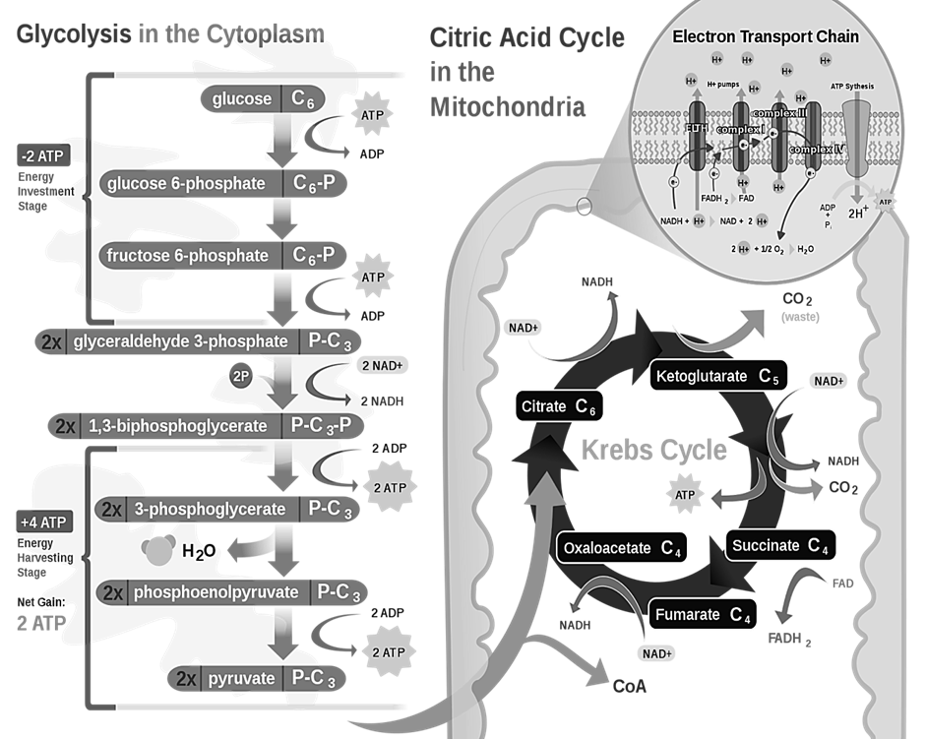  Total ATP Yield from Cellular Respiration  - _____ ATP - Glycolysis (substrate-level phosphorylation)  - _____ ATP - converted from 2 NADH - Glycolysis  - _____ ATP - converted from 2 NADH –intermediate step  - _____ ATP - Krebs cycle (substrate-level phosphorylation)  - _____ ATP - converted from 6 NADH - Krebs/ETC  - _____ ATP - converted from 2 FADH₂ - Krebs/ETC  _____ ATP – TOTAL  ________________: ________________  - Occurs in cytosol when oxygen is not present (called ________________).  - Glycolysis is a part of fermentation.  - Two Types:  - ________________Fermentation  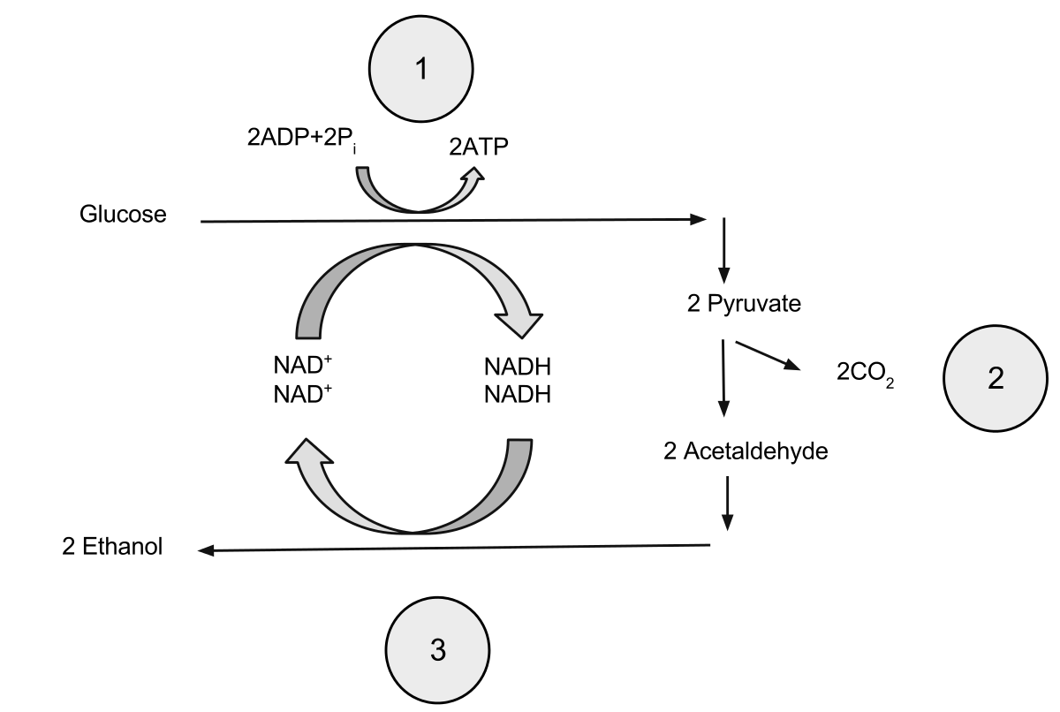  - Summary: Alcoholic Fermentation Yeasts and a few other microorganisms use alcoholic fermentation, forming ethyl alcohol and carbon dioxide as wastes.  - The equation for alcoholic fermentation after glycolysis is:  Pyruvic + NADH ➞ alcohol + CO2 + NAD⁺  - Alcoholic fermentation produces ________________ as well as ________________.  - Alcoholic fermentation causes bread dough to rise. When ________________in the dough runs out of oxygen, it begins to ferment, giving off bubbles of carbon dioxide that form the air spaces you see in a slice of bread. The small amount of alcohol produced in the dough evaporates when the bread is baked.  - Occurs in some ________________ (yeast) and is used to make beer, wine and bread.  - ________________ Fermentation  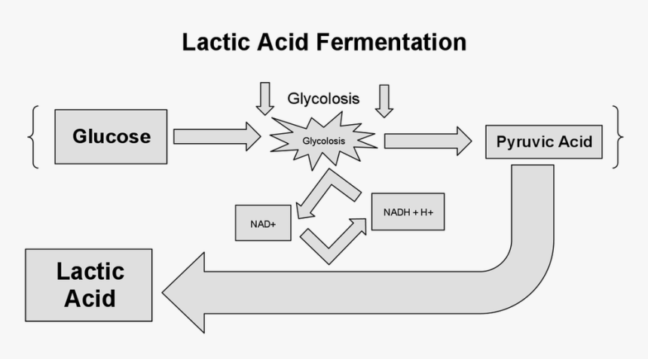  - Summary: Lactic Acid Fermentation In many cells, the ________________ that accumulates as a result of glycolysis can be ________________to ________________. Because this type of fermentation produces lactic acid, it is called lactic acid fermentation. This process regenerates NAD+ so that glycolysis can continue.  - The equation for lactic acid fermentation after glycolysis is:  Pyruvic acid + NADH ➞ lactic acid + NAD⁺  - Lactic acid is produced in your ________________during rapid exercise when the body cannot supply enough ________________to the tissues.  - Without enough oxygen, the body is not able to produce all of the ATP that is required. When you exercise vigorously by running, swimming, or riding a bicycle as fast as you can, the large muscles of your arms and legs quickly run out of oxygen. Your muscle cells rapidly begin to produce________________ by lactic acid fermentation.  - The buildup of lactic acid causes a painful, burning sensation. This is why muscles may feel sore after only a few seconds of intense activity. Unicellular organisms also produce lactic acid as a waste product during fermentation.  - For example, ________________are used in the production of a wide variety of foods and beverages, such as cheese, yogurt, buttermilk, and sour cream. Pickles, sauerkraut, and kimchee are also produced using lactic acid fermentation.  Aerobic Cellular Respiration Summary
   | Consumed | Produced
  Glycolysis | - 2 ATP’s | - 2 - 3C-Pyruvate (PYR)  - 2 - ATP  - 2 - NADH
  Intermediate Step | - 2 Pyruvate | - 2 - NADH  - 2 - CO2  - 2- Acetyl CoA (2C)
  Krebs Cycle | - 2- Acetyl CoA (2C) | - 2 - ATP (substrate-level phosphorylation)  - 6 – NADH  - 2 - FADH2 (Flavin-adenine dinucleotide)  - 4 - CO2
  Electron Transport Chain (ETC) | - 10 NADH  - 2 - FADH₂ | - 34 - ATP’s
Notes Summary

