Unit 3: The Cell - Article: History of the Cell: Discovering the cell Quickwrite

INSTRUCTOR:
no_reply@example.com

Article
- Newsela Article: History of the cell: Discovering the cell
By National Geographic Society, adapted by Newsela staff
Published:04/25/2019
Word Count:938
Recommended for:Middle School - High School

Although they are very different on the outside, on the inside, an elephant, a sunflower and an amoeba are all made of the same building blocks. From the single cells that make up the simplest organisms to the trillions of cells that make up the complex structure of the human body, each and every living being on Earth is made of cells. This idea is part of the cell theory and is one of the central concepts of biology. Cell theory also states that cells are the basic building blocks of living organisms and that all cells come from other cells. This knowledge is foundational today.

The Microscope Paved The Way
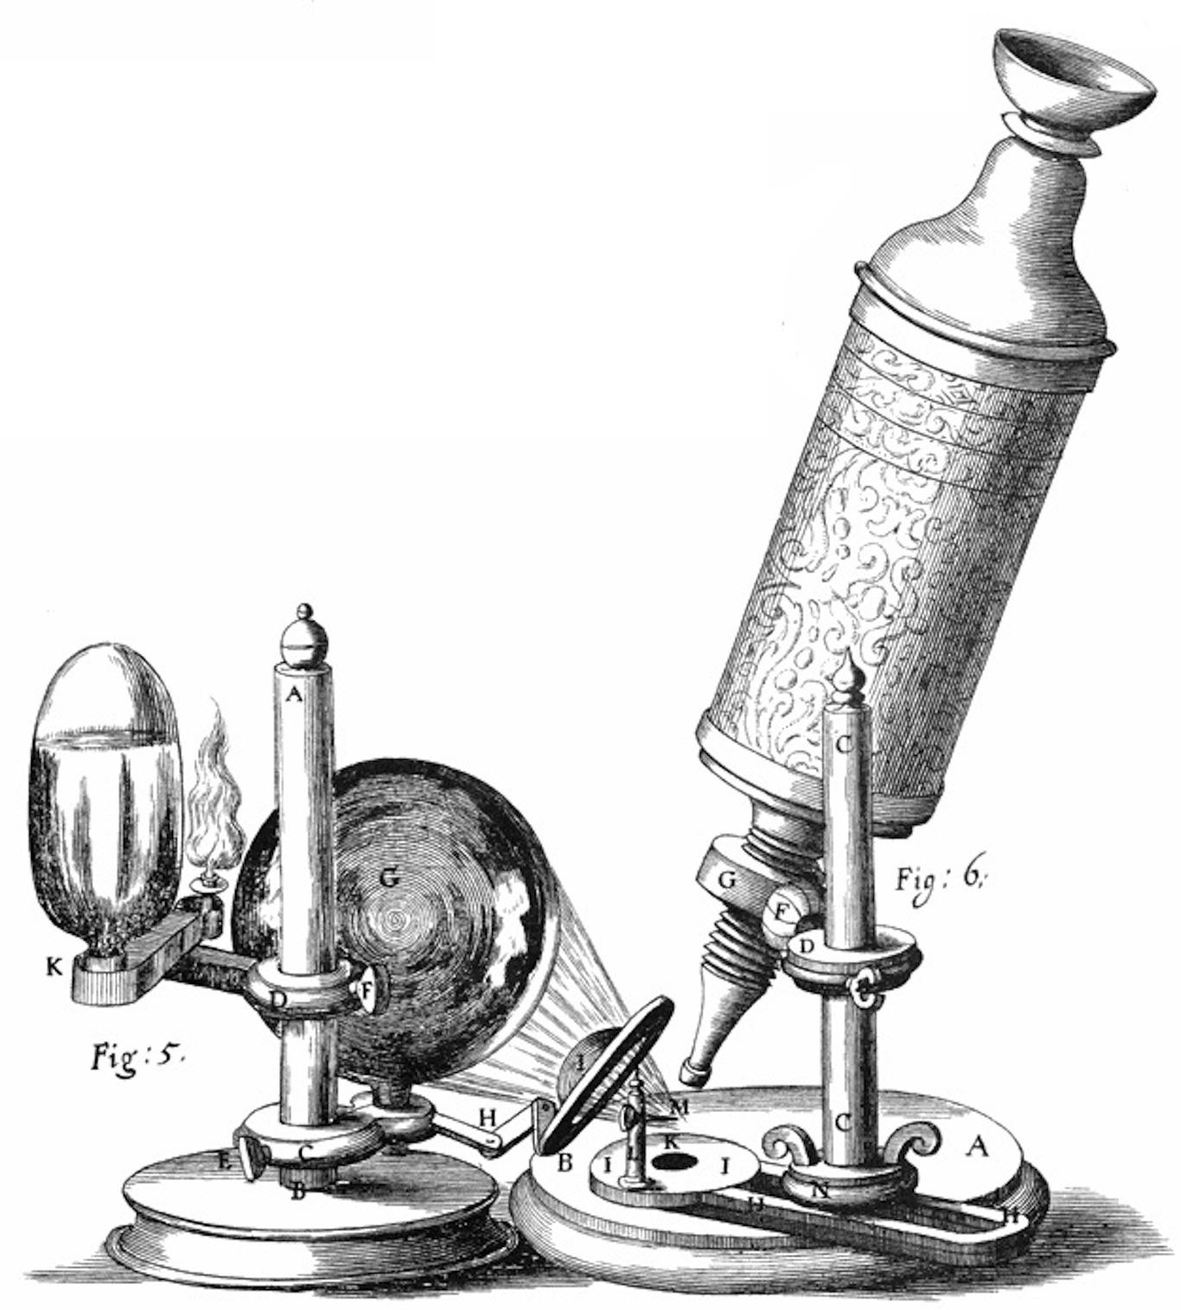
Scientists did not always know about cells, though. The discovery of the cell would not have been possible if not for advancements to the microscope. Interested in learning more about the microscopic world, scientist Robert Hooke improved the design of the existing compound microscope in 1665. His microscope used three lenses and a stage light, which lit up and enlarged the specimens. These advancements allowed Hooke to see something amazing when he placed a piece of cork under the microscope. To him, the cork looked as if it was made of tiny pores, which he came to call "cells" because they reminded him of the cells in a monastery.
Image 2. Robert Hooke's microscope.
Image from: Scheme I. of Hooke's
1665 Micrographia/Wikimedia
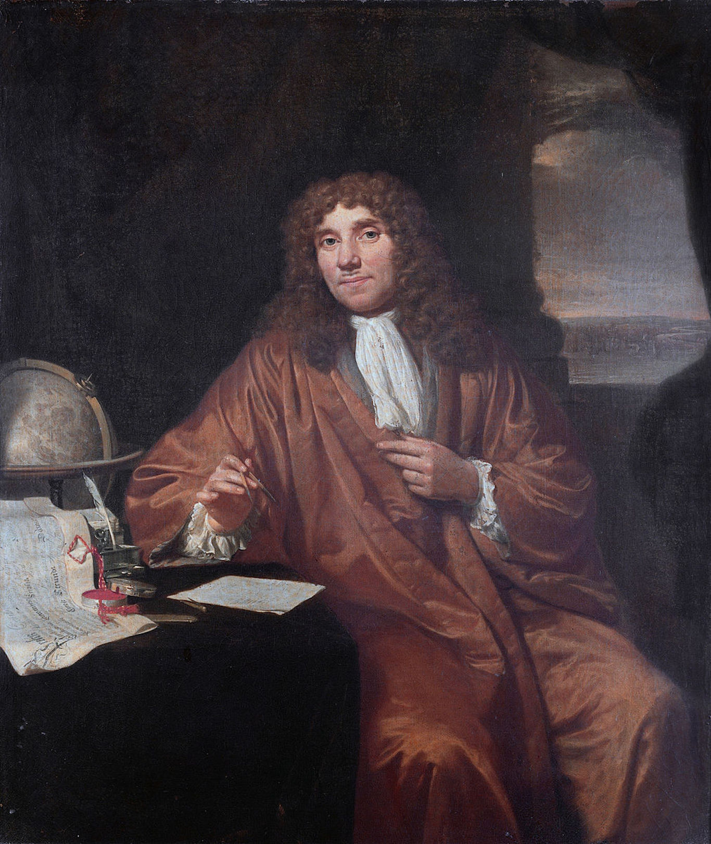
Not long after Hooke's discovery, Dutch scientist Antonie van Leeuwenhoek detected other hidden, tiny organisms called bacteria and protozoa. It was unsurprising that van Leeuwenhoek would make such a discovery. He was a master microscope maker and perfected the design of the simple microscope, which only had a single lens. The single lens enabled it to magnify an object by around 200 to 300 times its original size. What van Leeuwenhoek saw with these microscopes was bacteria and protozoa, but he called these tiny creatures "animalcules."
Van Leeuwenhoek became fascinated. He even took a look at the plaque between his teeth under the microscope. In a letter to the Royal Society, he wrote, "I then most always saw, with great wonder, that in the said matter there were many very little living animalcules, very prettily a-moving."

Both Plants And Animals Have Cells
In the 19th century, biologists began taking a closer look at both animal and plant tissues. Scientists could easily tell that plants were completely made up of cells. That's because plant cells have a layer on the outside called a cell wall. However, this was not so obvious for animal cells, which lack a cell wall. Many scientists believed that animals were made of "globules."
German scientists Theodore Schwann and Mattias Schleiden studied cells. Schwann studied animal cells, and Schleiden studied plant cells. These scientists identified key differences between the two cell types and put forth the idea that cells were the simplest units of both plants and animals.
However, Schwann and Schleiden misunderstood how cells grow. Schleiden believed that plant cells were "seeded" by the nucleus at the center and grew from there. Similarly, Schwann claimed that animal cells "crystalized" from the material between other cells. Eventually, other scientists began to uncover the truth. Another piece of the cell theory puzzle was identified by Rudolf Virchow in 1855. He stated that all cells are generated by existing cells.

Cells Carry Information To The Next Generation
At the turn of the century, attention began to shift toward cytogenetics. This field of science aimed to link the study of cells to the study of genetics, which focuses on genes. Genes tell the body how to grow and work. Chromosomes are like threads that carry genes and sit inside of cells. In the 1880s, Walter Sutton and Theodor Boveri identified the chromosome as being responsible for passing down genes from one generation to the next. The discovery forever linked genetics and cytology. Later discoveries further confirmed and solidified the role of the cell in passing characteristics down from one generation to another. One famous example is James Watson and Francis Crick's studies on the structure of DNA.

The Science Of Stem Cells
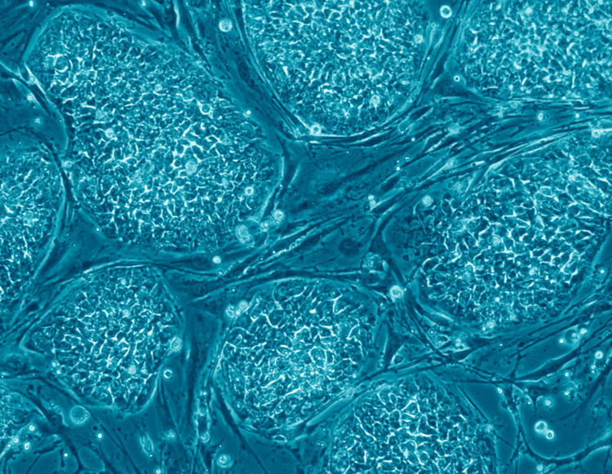
The discovery of the cell continued to be important for science 100 hundred years later, with the discovery of stem cells. Stem cells are simple cells that have yet to develop into more specialized cells. Scientists began to find and take out stem cells from unborn mice in the 1980s. In 1998, James Thomson isolated unborn human stem cells and developed cell lines. His work was then published in an article in the journal Science. It was later discovered that adult tissues, usually skin, could be reprogrammed into stem cells and then form other cell types. These cells are known as induced pluripotent stem cells. Stem cells are now used to treat many conditions, such as Alzheimer's and heart disease.

The Building Blocks Of All Living Things
The discovery of the cell has been far more important for science than Hooke could have ever dreamed in 1665. It gave us an understanding of the building blocks of all living organisms. It has also led to advances in medical technology and treatment. Today, scientists are working on personalized medicine, which would allow us to grow stem cells from our very own cells and then use them to understand disease processes. All of this and more grew from a single observation of the cell in a cork.
Image 4. Human embryonic stem cells. Image: Nissim Benvenisty/Wikimedia.

Prompt
- Write a short paragraph that explains the central idea of the article. Use at least two details from the article to support your response.

Stems
- All living organisms are made from…
- Modern Cell Theory is defined in three parts…
- The microscope, invented by…paved the way for…
- Plants and animal cells have a variety of similarities and differences…
- The information carried inside the cell's nucleus helps…
- Stem cells are…
- In summary, cells are the…

Quick Write

