
Unit 17: Plant Systems - Notes Key

SPRING SEMESTER 2023
INSTRUCTOR:
instructor@email.com

Vocabulary / Key Terms/ Concepts | Unit 17: Plant Systems

Student Expectations:
- Identify and Characterize types Non-Vascular plants
- Identify and Describe types of Vascular Plants – Seedless, cone-bearing, and Flowering plants
- Types of Describe the organs and tissues of vascular plants
- Identify the specialized cells of vascular tissues.
- Know that xylem transports water up from the roots (Remember: Xy = High, so water goes up)
- Explain capillary action.
- Know that phloem transports sugars down from the leaves (Remember: Phlo = low, so sugar down)
- Identify meristems as clusters of tissues as clusters of tissue that are responsible for continuing growth throughout a plant’s lifetime. It is the only plant tissue that produces new cells by mitosis
- Identify methods of reproduction in plants:
  - Understand that the flower is the reproductive structure of a plant.
- Describe the function of the parts of a flower.
  - Male reproductive parts are called stamen (has men in the word), includes the Anther and Filament
  - Female reproductive parts are Pistils; includes the Stigma, Style, and Ovary
  - Petals attract pollinators.
- Describe plants response to:
  - Light - Phototropism-stems and leaves of plant grow in the direction of a light source
  - Gravity - Geotropism- roots grow down into the soil so they are more apt to reach moisture and minerals in the soil
  - Touch- Thigmotropism- plant tendrils grasp onto objects so that a plant can grow and be supported by the object.
- Describe how Auxins, Cytokinins, Gibberellins, and Ethylene affect plant growth

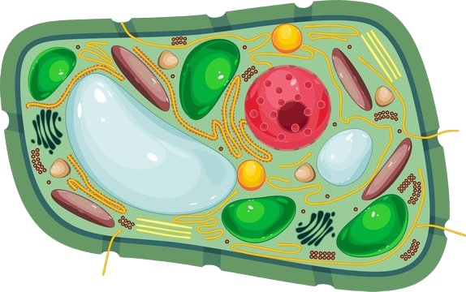
Overview
https://t3.ftcdn.net/jpg/01/83/20/48/360_F_183204883_OjcUprwbyaHGkOCEu8pulIR6iMIajEYy.jpg
- Characteristics
- Made of plant cells
- Cell wall
- Chloroplasts
- Central vacuole
- Organelles common to all eukaryotes (such as a nucleus, ribosomes, mitochondria, etc.)
- Multicellular organisms
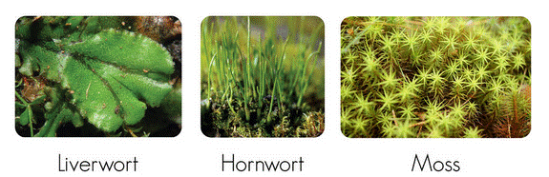
- Photosynthesis = the metabolic process for converting solar energy into chemical energy for plants to use
https://lh5.ggpht.com/-Qlrrbyp4SBQ/U06ydLPmZAI/AAAAAAAABGQ/EMKvnZDWy_Y/clip_image0028.gif?imgmax=800

Non-Vascular Plants - Bryophytes
- Types-
- Mosses
- liverworts, and
- hornworts
- Characteristics -
- Bryophytes do not have tubes to move water and nutrients through the plant.
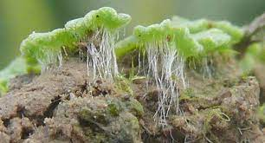
- Water simply moves from cell to cell. It moves from areas where there is plenty of water to areas where water is needed - Osmosis
https://www.google.com/url?sa=i&url=https%3A%2F%2Fdigitalcommons.mtu.edu%2Fcgi%2Fviewcontent.cgi%3Farticle%3D1037%26context%3Dbryo-ecol-subchapters&psig=AOvVaw3AUzvKrQVlYQBnQT_nPqVu&ust=1677538389776000&source=images&cd=vfe&ved=0CA8QjRxqFwoTCODeitGjtP0CFQAAAAAdAAAAABAD
- Bryophytes do not have true leaves, stems, and roots. Instead of roots, they have structures called rhizoids.
- Rhizoids anchor the plant to the ground.
- Bryophytes reproduce sexually and asexually. They have several structures that produce reproductive cells.
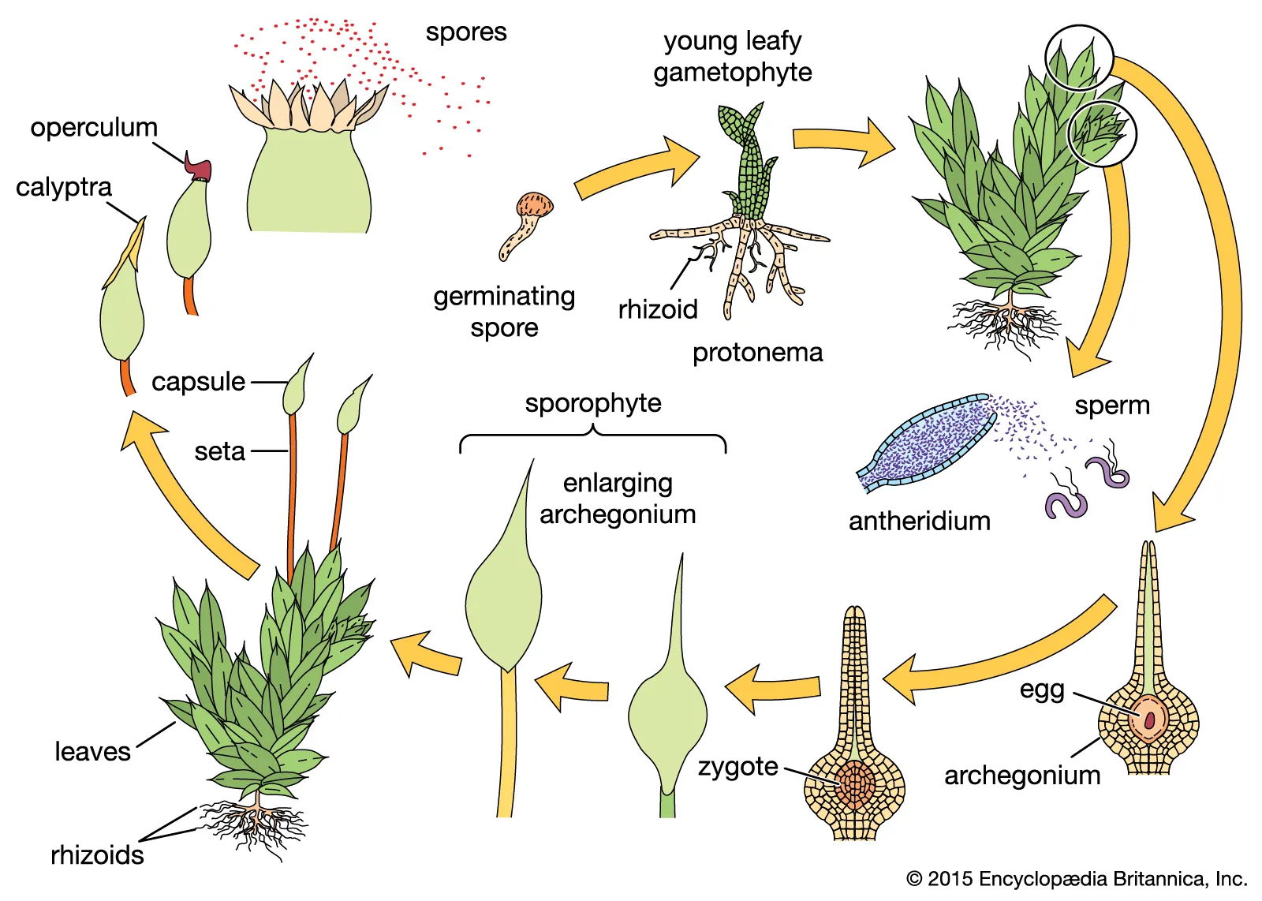
- Structures called antheridia make sperm.
https://www.google.com/url?sa=i&url=https%3A%2F%2Fwww.britannica.com%2Fplant%2Fbryophyte&psig=AOvVaw1CWBspRAYDrIPvyTsYhYC7&ust=1677538509585000&source=images&cd=vfe&ved=0CA8QjRxqFwoTCNCT24mktP0CFQAAAAAdAAAAABAD
- Structures called archegonia produce egg cells.
- Sperm cells must swim through water to fertilize eggs. This is why bryophytes must live in moist habitats.
- After fertilization, the diploid zygote grows to become a sporophyte.
- The sporophyte is made up of a capsule and a long stalk that remains attached to the haploid gametophyte.
- It relies on the gametophyte for food and water. Spores are made inside the capsule. When the capsule ripens, it opens and the spores are carried off by wind and water - dispersal
- When a spore lands in a moist place, it grows into the plant we think of as moss.
- This green plant is the haploid gametophyte.

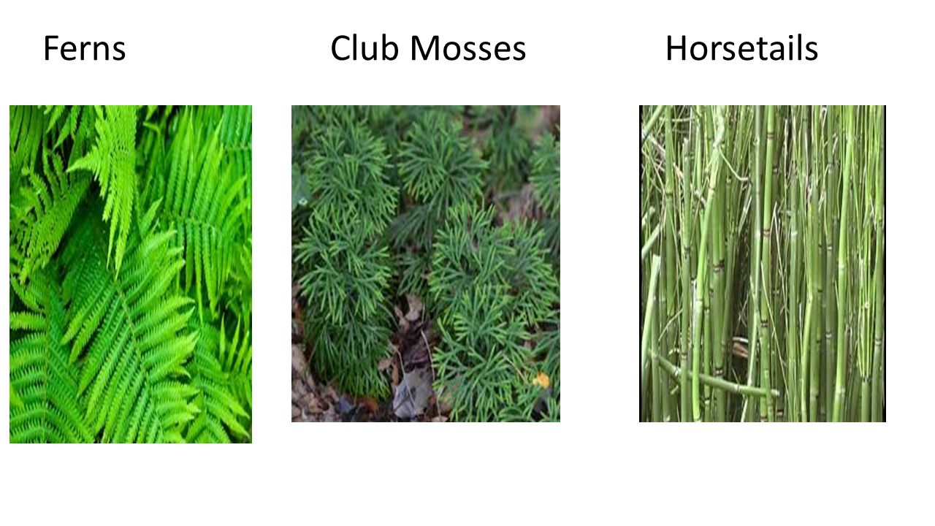
Seedless Vascular Plants
https://slideplayer.com/slide/10279093/35/images/11/Ferns+Club+Mosses+Horsetails.jpg
- Types -
- Ferns and their relatives were the first plants to have special tissues that carry water and food throughout a plant.
- club mosses
- horsetails
- ferns
- Tissue Types -
- There are 3 types of tissue.
- Dermal - used for protection and to prevent water loss
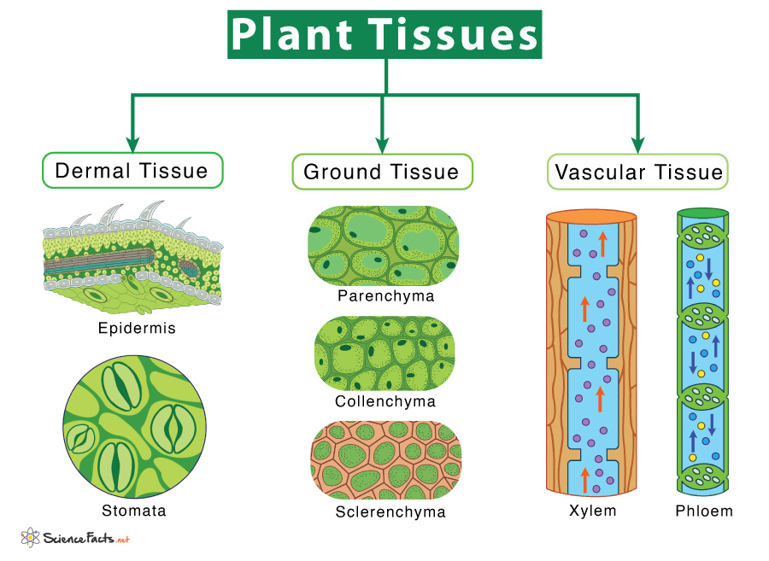
- Includes epidermis (mostly) and periderm (like bark)
https://www.sciencefacts.net/wp-content/uploads/2022/02/Types-of-Plant-Tissue.jpg
- Cuticle = a waxy layer.
- Ground - used for metabolism, storage and support (any tissue that isn’t dermal or vascular)
- Types:
- Parenchyma: traditional plant cells
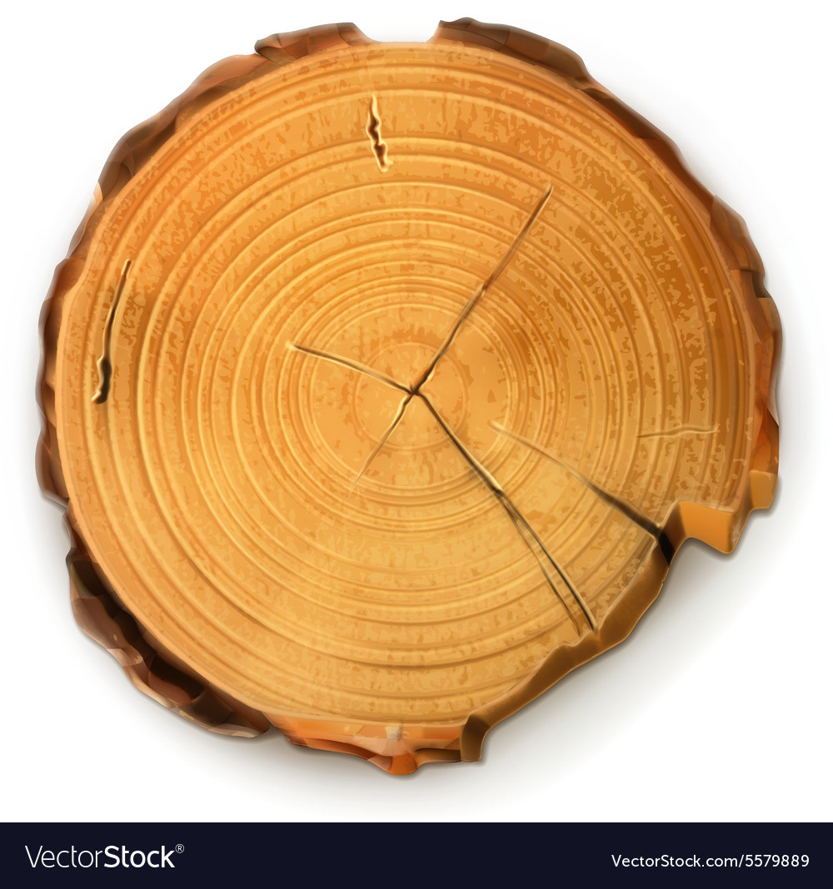
- Collenchyma: support, like cellulose
Dermal
Vascular
Ground
https://cdn5.vectorstock.com/i/1000x1000/98/89/tree-stump-round-cut-with-annual-rings-vector-5579889.jpg
- Sclerenchyma: wooded and durable (like what makes up an apple core)
- There are two types of vascular tissue.
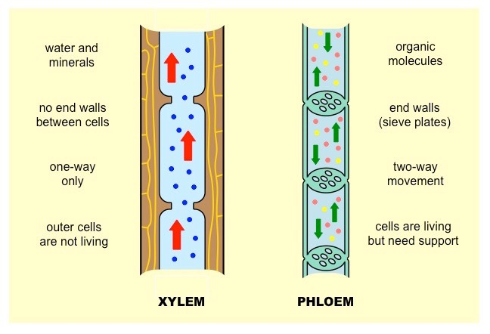
- Xylem (figure left) moves water from the roots to all parts of the plant.
https://www.google.com/url?sa=i&url=http%3A%2F%2Fib.bioninja.com.au%2Fhigher-level%2Ftopic-9-plant-biology%2Funtitled%2Fxylem-versus-phloem.html&psig=AOvVaw11qW9aK97jBHhQvcVXiOWL&ust=1677539528440000&source=images&cd=vfe&ved=0CA8QjRxqFwoTCLiAke-ntP0CFQAAAAAdAAAAABAY
- Special cells call tracheids make up xylem.
- They have thick, strong cell walls.
- The other type of vascular tissue is phloem.
- Phloem carries nutrients and food from place to place within the plant.

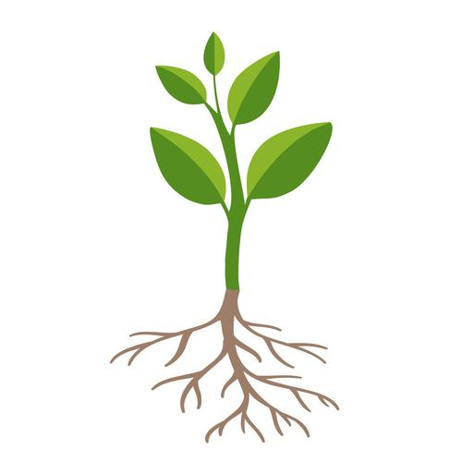
- Characteristics -
Leaves
Stem
Roots
https://content.anton.app/files/?fileId=image%2Fadobe_265405356_crop-705-660-1635-1635&etag=f8dc-13590
- These plants have true roots, leaves, and stems.
- Roots absorb water and minerals.
- Leaves make food by photosynthesis.
- Stems support the plant and connect leaves and roots.
- Life Cycle:
- In the life cycle of ferns, the diploid sporophyte is the dominant stage.
- Fern sporophytes produce spores (figure right) on the underside of the fronds.
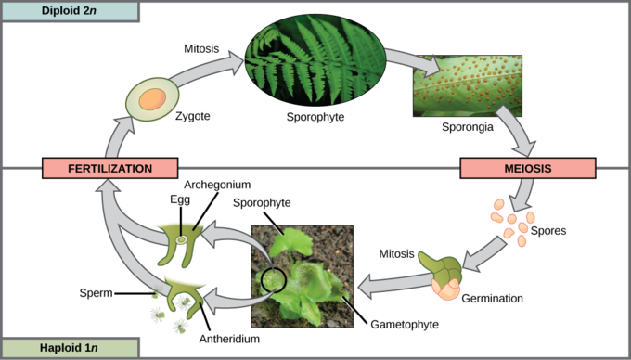
- These spores are haploid. When spores are ripe, they burst from sporangia and are carried by wind and water.
https://s3-us-west-2.amazonaws.com/courses-images/wp-content/uploads/sites/1842/2017/05/26231659/figure-25-04-07.png
- In the right conditions, they will grow to form haploid gametophytes. The haploid gametophyte is a thin, heart-shaped structure.
- The antheridia and archegonia are found on the underside of the gametophyte. When mature, sperm from the antheridia swim to the archegonia to fertilize the eggs.

Seed Plants
- Types -
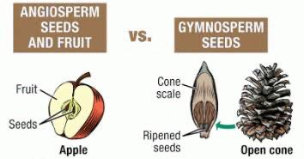
- Seed plants are divided into two groups: gymnosperms and angiosperms.
https://qph.cf2.quoracdn.net/main-qimg-22064f55001d4afe60e7ac1e5abe9d08-lq
- Gymnosperms, or cone-bearing plants, produce seeds directly on the surface of cones.
- Angiosperms, which are flowering plants, produce seeds inside a tissue that protects them.
- Like other plants, seed plants have alternation of generations.
- All the seed plants that we see are sporophytes.
- The gametophytes of seed plants are made up of only a few cells.
- They grow and mature within flowers and cones.
- The entire male gametophyte fits in a tiny structure called a pollen grain.
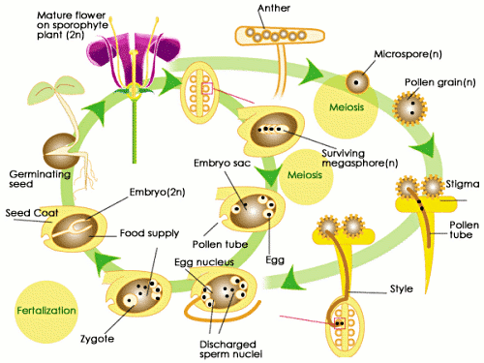
- Pollen is carried to the female gametophyte by wind, birds, mammals, or insects - seed dispersal
http://img.sparknotes.com/figures/9/9f79f1dbce762884bf644e4ac8450061/angiospermlifecycle.gif
- This process is called pollination. Seeds protect the zygote of seed plants.
- After fertilization, the zygote grows into a tiny plant.
- This plant is called an embryo.
- When conditions are right, the embryo grows.
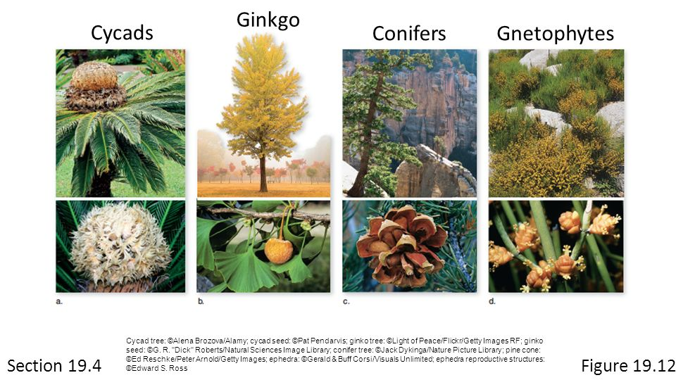
- It uses a supply of stored food inside the seed when it starts growing. A seed coat surrounds the embryo, protecting it from drying out.

- Gymnosperms are the oldest surviving seed plants.
- Gymnosperms include gnetophytes, cycads, ginkgoes, and conifers.
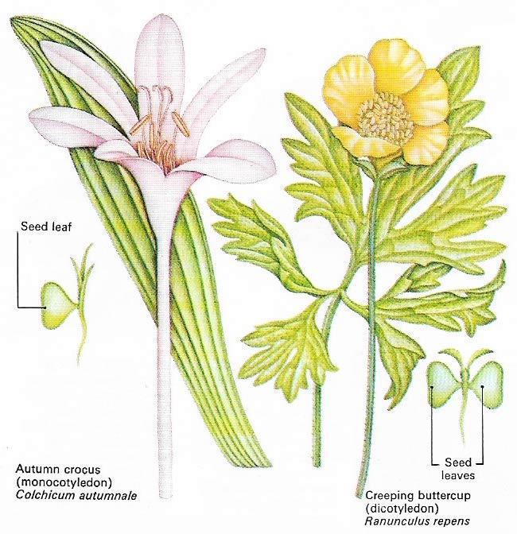
- These plants produce seeds that are protected by a seed coat.
http://www.daviddarling.info/images7/angiosperms.jpg
- However, the cone does not cover the seeds. This is why they are called naked seed plants.

- Angiosperms—Flowering Plants
- Angiosperms have reproductive organs called flowers. Flowers attract animals, which carry pollen from flower to flower.
- This is a more efficient way of pollination than the wind pollination of most gymnosperms.
- Unlike gymnosperms, the seeds of angiosperms are protected.
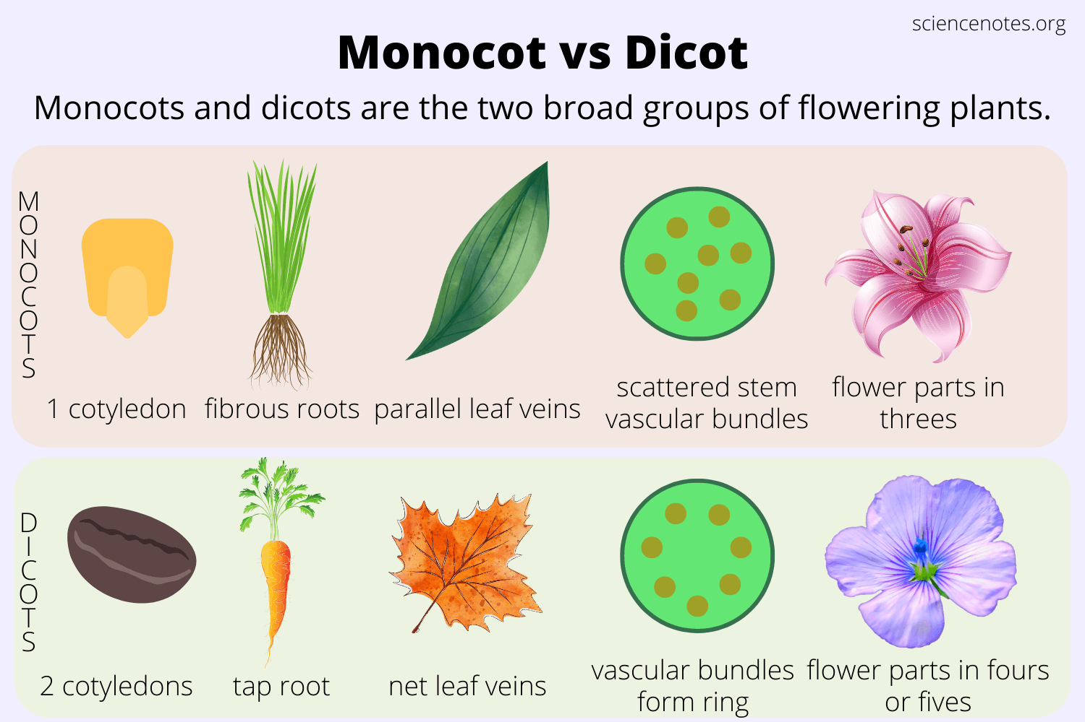
- The structure that protects the seeds develops into a fruit.
https://sciencenotes.org/wp-content/uploads/2022/07/Monocot-vs-Dicot.png
- There are two groups of angiosperms: monocots and dicots.
- Monocot embryos have one seed leaf, or cotyledon.
- Dicot embryos have two cotyledons.
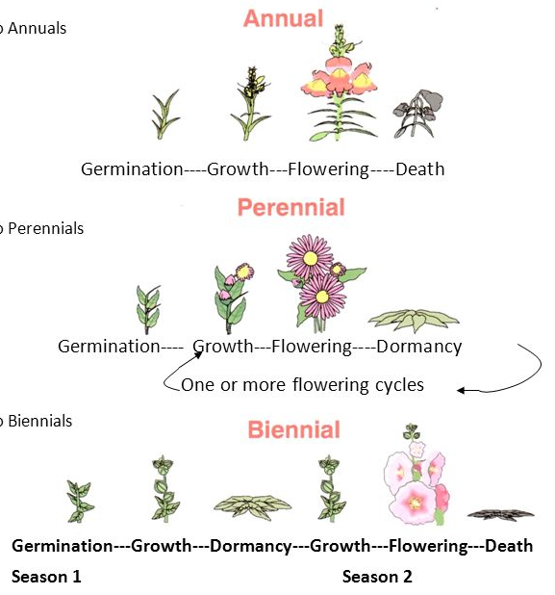
- Other differences include the arrangement of veins in leaves, the number of flower petals, the structure of roots, and the arrangement of vascular tissue in the stem.

https://slideplayer.com/slide/6528764/22/images/5/Courtesy+of+Interstate+Publishing.jpg
- Flowering plants have three different life spans.
- Annuals complete their life cycle within one growing season.
- Biennials complete their life cycle in two years. They produce seeds and die in the second growing season.
- Perennials live through many years. Some die each winter and regrow in spring. Others have woody stems.

Plant Reproduction
- Reproduction with Cones and Flowers
- Characteristics -
- Seed plants are completely adapted to life on land.
- They do not need water for reproduction.
- Cones, flowers, and seeds let seed plants reproduce without water.
- In the seed plant life cycle, the spore-producing generation (sporophyte) alternates with the gamete-producing generation (gametophyte).
- In seed plants, the familiar form of the plant is the sporophyte.
- The gametophyte of seed plants is hidden within the cones and flowers.
- Cones and flowers are two different methods of reproduction.
- Pine trees and other gymnosperms use cones for reproduction.
- Pollen cones produce the male gametophyte, which are called pollen grains.
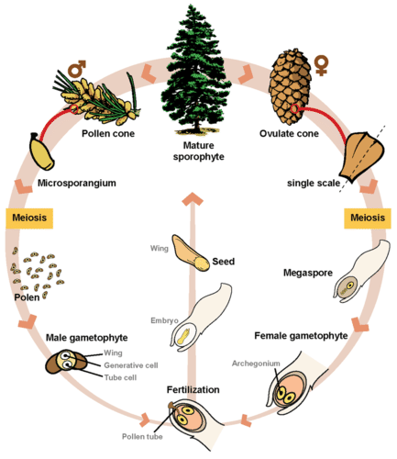
- Seed cones produce the female gametophyte in ovules.
https://dr282zn36sxxg.cloudfront.net/datastreams/f-d%3A72f8cd5229dc9d55c1b253e2f0ee1c57ee2880dd13867f2bbc6cb7f2%2BIMAGE_THUMB_POSTCARD_TINY%2BIMAGE_THUMB_POSTCARD_TINY.1
- A few large egg cells form within the ovules. When a pollen grain lands near an ovule, it grows a pollen tube into the ovule.
- A sperm from the pollen tube fertilizes the egg in the ovule. A zygote forms and grows into an embryo.
- The embryo becomes enclosed in a seed.
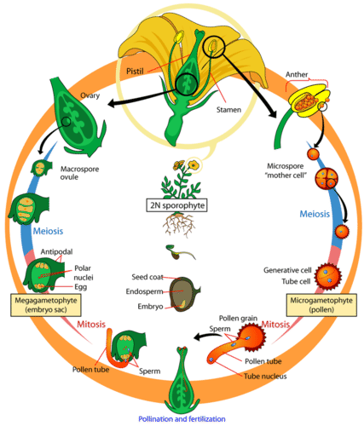
- Angiosperms, or flowering plants, reproduce with flowers.
https://dr282zn36sxxg.cloudfront.net/datastreams/f-d%3Aa7681511ae4db42a9449559aaa4d6b261e6dc89880e77423a2cd6007%2BIMAGE_THUMB_POSTCARD_TINY%2BIMAGE_THUMB_POSTCARD_TINY.1
- Flowers are organs that are made up of four kinds of leaves: sepals, petals, stamens, and carpels.
        - Sepals make up the outermost circle of floral parts and are often green. They protect the flower bud.
        - Colorful petals form the next circle. Petals attract insects and other pollinators to the flower.
        - Sepals and petals are sterile leaves. The inner circles of a flower are fertile leaves.
        - Stamens form the first inner circle. Each stamen has a long filament that supports an anther.
          - The anther produces male gametophytes.
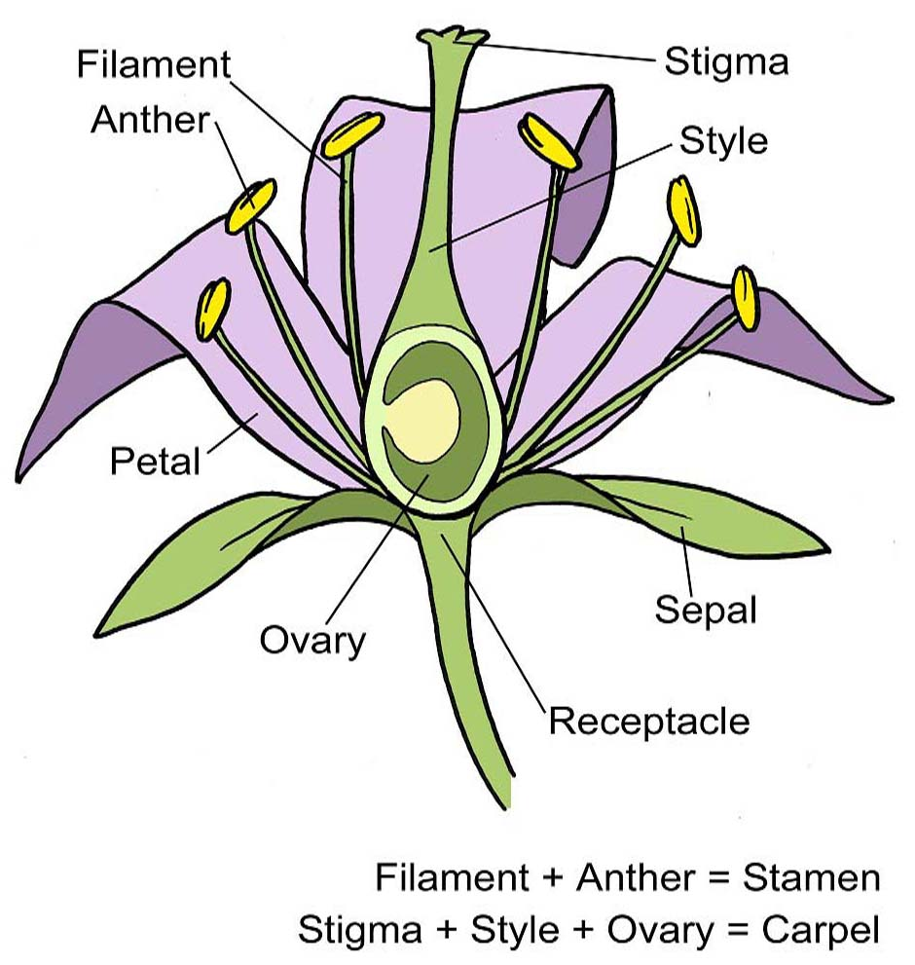
        - One or more carpels form the innermost circle. Carpels, also called pistils, produce female gametophytes.
https://schoolgardening.rhs.org.uk/getmedia/ddbc826a-1ab8-4597-aa72-b1c990a98f25/AS-flower-structure
          - Each carpel has a broad base called the ovary.
          - The carpel’s stalk is called the style.
          - At the top of the style is the stigma. The stigma has a sticky surface where pollen grains land.
        - Angiosperms may have stamens and carpels within the same flower or in separate flowers on the same plant.
- Reproduction in flowering plants takes place inside the flower.
        - Inside the anthers, each cell undergoes meiosis to produce four haploid spore cells.
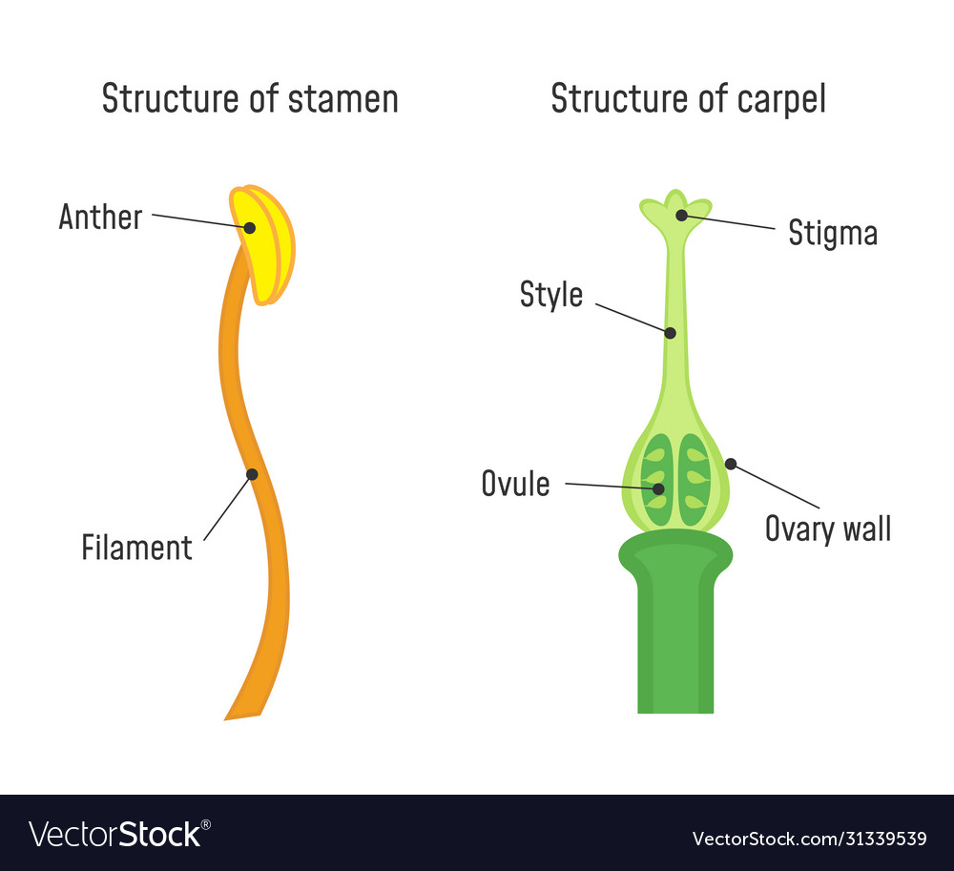
        - Each of these cells becomes a pollen grain.
https://previews.123rf.com/images/fancytapis/fancytapis1903/fancytapis190300004/124796333-structure-of-stamen-and-carpel-flower-part-diagram.jpg
        - Inside the ovaries are the ovules, where the female gametophyte develops.
        - A single cell goes through meiosis to produce four haploid cells.
          - One of these cells goes through mitosis, producing the embryo sac. This is the female gametophyte.
          - Within the embryo sac is the egg cell.
        - During pollination, pollen is transferred from the anther to the stigma. Most gymnosperms are wind pollinated. Animals pollinate most angiosperms.
        - Two distinct fertilizations take place in the embryo sac.
          - First, one sperm nucleus fuses with the egg to form a diploid zygote. The zygote will grow into the plant embryo.
          - Then, the other sperm nucleus fuses with two other nuclei in the embryo sac to form the endosperm. The endosperm provides food for the embryo. This is known as double fertilization.

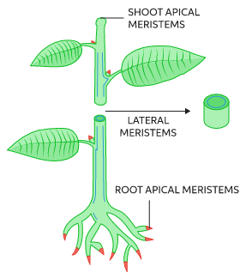
Plant Responses and Adaptations
https://images.ctfassets.net/vrrt8fsfwf0e/1695skmoADVtgWp93Ci5SG/cebd8c85e3205d83f53dbcc25e92266e/Meristem_art_1.svg
- Hormones and Plant Growth
- Background: Plant growth is not precisely determined. However, plant growth still follows general growth patterns that differ among species. Plant growth never stops. New cells are always being made in meristematic tissue.
- Growth -
- Apical Meristems are found at the tips of stems and roots and are involved in growth. New cells later develop into specialized tissues.
- Plants grow in response to environmental factors like light, moisture, gravity, and temperature.
- Control -
- Certain plant chemicals also control plant growth. These chemicals are called hormones.
- A hormone is a substance that is produced in one part of an organism and affects another part of the same organism.
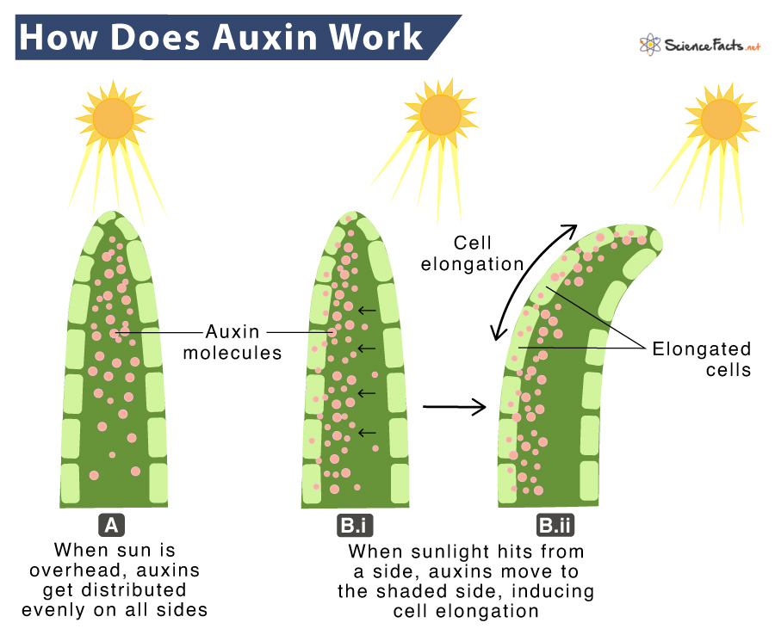
- The part of the organism affected by a hormone is the target cell or target tissue. Different kinds of target cells can respond to the same hormone. A single hormone may affect two different tissues in different ways.
https://www.sciencefacts.net/wp-content/uploads/2022/05/Auxin.jpg
- One important group of plant hormones is auxins.
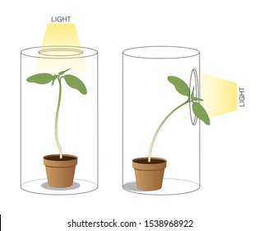
- Auxins have different effects on different tissues. Auxins make stems grow toward light and away from the pull of gravity.
https://www.shutterstock.com/image-illustration/phototropism-light-plant-moves-towards-260nw-1538968922.jpg
- Plant Responses - Tropisms -
- The tendency of a plant to grow toward light is called phototropism.
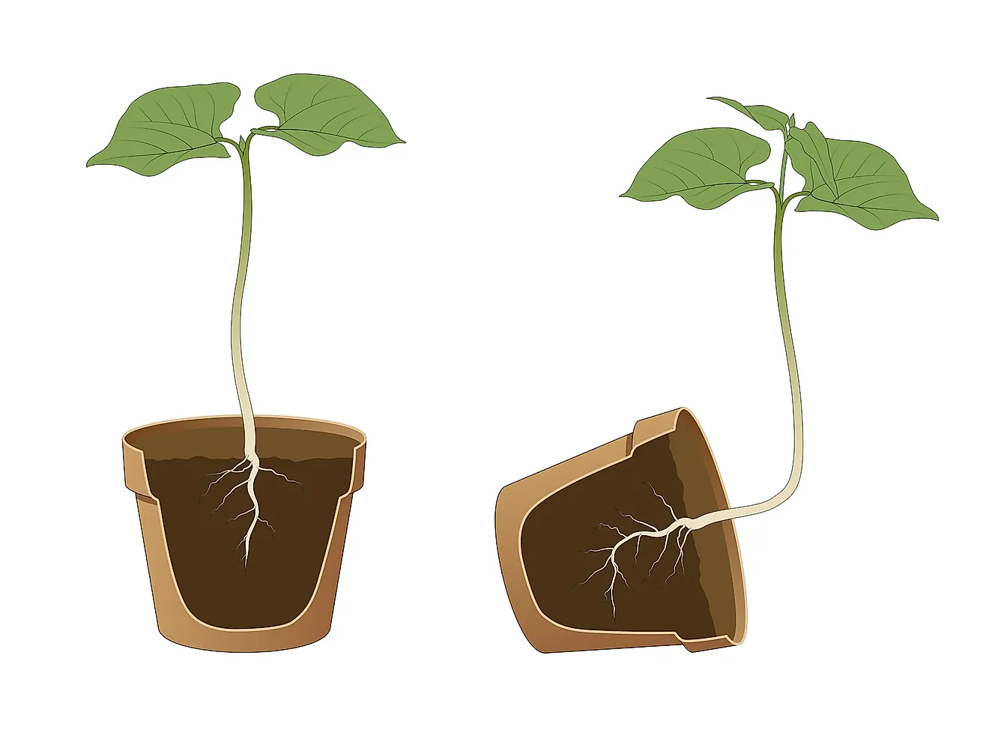
- Gravitropism is the response of a plant to the pull of gravity. Auxins make roots grow away from light and toward the pull of gravity. Auxins also control plant branching by keeping the buds on the sides of the stem from growing.
https://www.worldatlas.com/r/w1200/upload/31/8f/74/shutterstock-1540480469.jpg
- Thigmotropism - the tendency pf plants to grow around objects they are in contact with.
- Some plants have a rapid response to touch that does not involve growth.
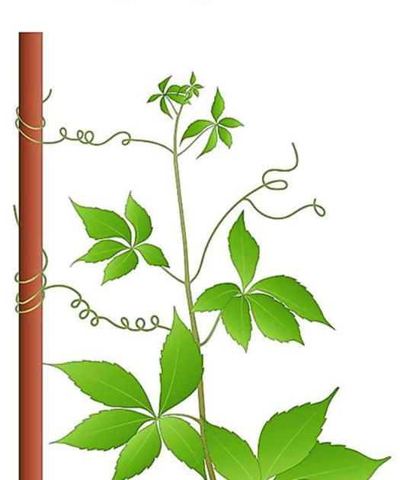
- This kind of response is caused by changes in the osmotic pressure of some cells. These pressure changes cause leaves to fold up or snap shut.
https://bloximages.chicago2.vip.townnews.com/agupdate.com/content/tncms/assets/v3/editorial/2/28/228e1a08-6322-55c3-b19e-c46257cd016e/601ef4906af51.image.jpg?crop=1440%2C756%2C0%2C342&resize=1200%2C630&order=crop%2Cresize
- This response enables a Venus’ flytrap to trap an insect. Many plants respond to periods of light and darkness. This is called photoperiodism.
- It is caused by changes in the length of periods of light and darkness. These changes affect plant pigments called phytochromes, causing plants to flower.

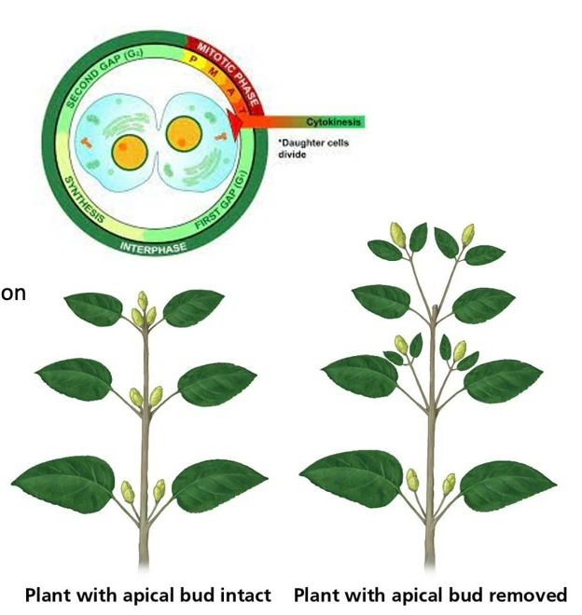
- Other Hormones -
https://i.ytimg.com/vi/SKRw5BIQNQs/maxresdefault.jpg

- Growing roots and developing fruits and seeds make hormones called cytokinins.
        - Cytokinins stimulate cell division and make dormant seeds sprout. Their effects are often opposite to the effects of auxins.
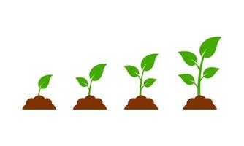
- In the 1920s, Japanese scientists identified a substance produced by a fungus that stimulated plant growth.
https://static.vecteezy.com/system/resources/thumbnails/006/220/906/small/plant-growth-sprout-from-the-ground-isolated-on-white-background-free-vector.jpg
        - They named this substance gibberellin. Later, scientists learned that plants also produce gibberellins.
        - Gibberellins cause dramatic increases in size and rapid growth.
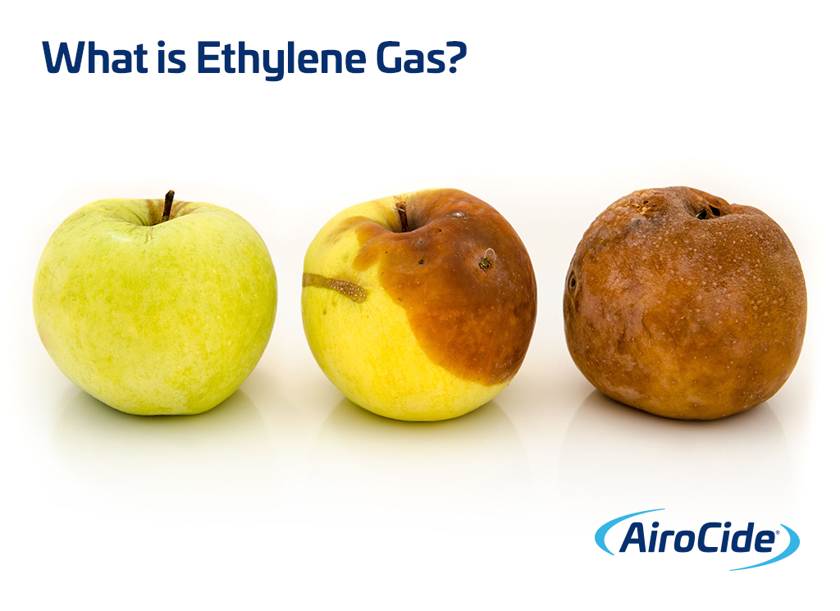
- Ethylene is another plant hormone. Plants release ethylene in response to auxins. Ethylene stimulates fruits to ripen.
https://kesair.com/wp-content/uploads/2019/07/What-is-Ethylene-Gas-Remove-with-AiroCide-Commercial-Air-Purification.jpg

Notes

