
Unit 17: Plant Systems - Notes

SPRING SEMESTER 2023
INSTRUCTOR:
instructor@email.com

Vocabulary / Key Terms/ Concepts | Unit 17: Plant Systems

Student Expectations:
- Identify and Characterize types Non-Vascular plants
- Identify and Describe types of Vascular Plants – Seedless, cone-bearing, and Flowering plants
- Types of Describe the organs and tissues of vascular plants
- Identify the specialized cells of vascular tissues.
- Know that xylem transports water up from the roots (Remember: Xy = High, so water goes up)
- Explain capillary action.
- Know that phloem transports sugars down from the leaves (Remember: Phlo = low, so sugar down)
- Identify meristems as clusters of tissues as clusters of tissue that are responsible for continuing growth throughout a plant’s lifetime. It is the only plant tissue that produces new cells by mitosis
- Identify methods of reproduction in plants:
  - Understand that the flower is the reproductive structure of a plant.
- Describe the function of the parts of a flower.
  - Male reproductive parts are called stamen (has men in the word), includes the Anther and Filament
  - Female reproductive parts are Pistils; includes the Stigma, Style, and Ovary
  - Petals attract pollinators.
- Describe plants response to:
  - Light - Phototropism-stems and leaves of plant grow in the direction of a light source
  - Gravity - Geotropism- roots grow down into the soil so they are more apt to reach moisture and minerals in the soil
  - Touch- Thigmotropism- plant tendrils grasp onto objects so that a plant can grow and be supported by the object.
- Describe how Auxins, Cytokinins, Gibberellins, and Ethylene affect plant growth

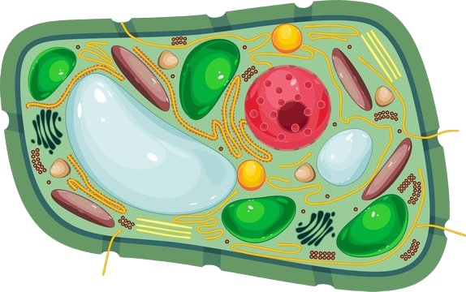
Overview
https://t3.ftcdn.net/jpg/01/83/20/48/360_F_183204883_OjcUprwbyaHGkOCEu8pulIR6iMIajEYy.jpg
- Characteristics
- Made of _____________________ cells
- _____________________
- _____________________
- Central _____________________
- Organelles common to all _____________________ (such as a nucleus, ribosomes, mitochondria, etc.)
- _____________________ organisms
- _____________________ = the metabolic process for converting solar energy into chemical energy for plants to use

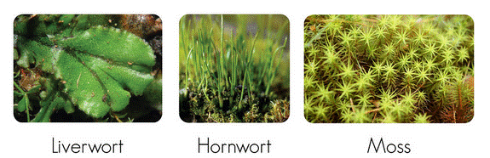
Non-Vascular Plants - _____________________
https://lh5.ggpht.com/-Qlrrbyp4SBQ/U06ydLPmZAI/AAAAAAAABGQ/EMKvnZDWy_Y/clip_image0028.gif?imgmax=800
- Types-
- _____________________
- _____________________ , and
- _____________________
- Characteristics -
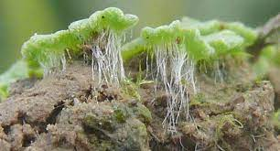
- Bryophytes do not have _____________________ to move _____________________ and _____________________ through the plant.
https://www.google.com/url?sa=i&url=https%3A%2F%2Fdigitalcommons.mtu.edu%2Fcgi%2Fviewcontent.cgi%3Farticle%3D1037%26context%3Dbryo-ecol-subchapters&psig=AOvVaw3AUzvKrQVlYQBnQT_nPqVu&ust=1677538389776000&source=images&cd=vfe&ved=0CA8QjRxqFwoTCODeitGjtP0CFQAAAAAdAAAAABAD
- Water simply moves from cell to cell. It moves from areas where there is plenty of water to areas where water is needed - _____________________
- Bryophytes do not have true _____________________ , _____________________ , and _____________________ . Instead of roots, they have structures called _____________________ .
- _____________________ anchor the plant to the ground.
- Bryophytes reproduce sexually and asexually. They have several structures that produce reproductive cells.
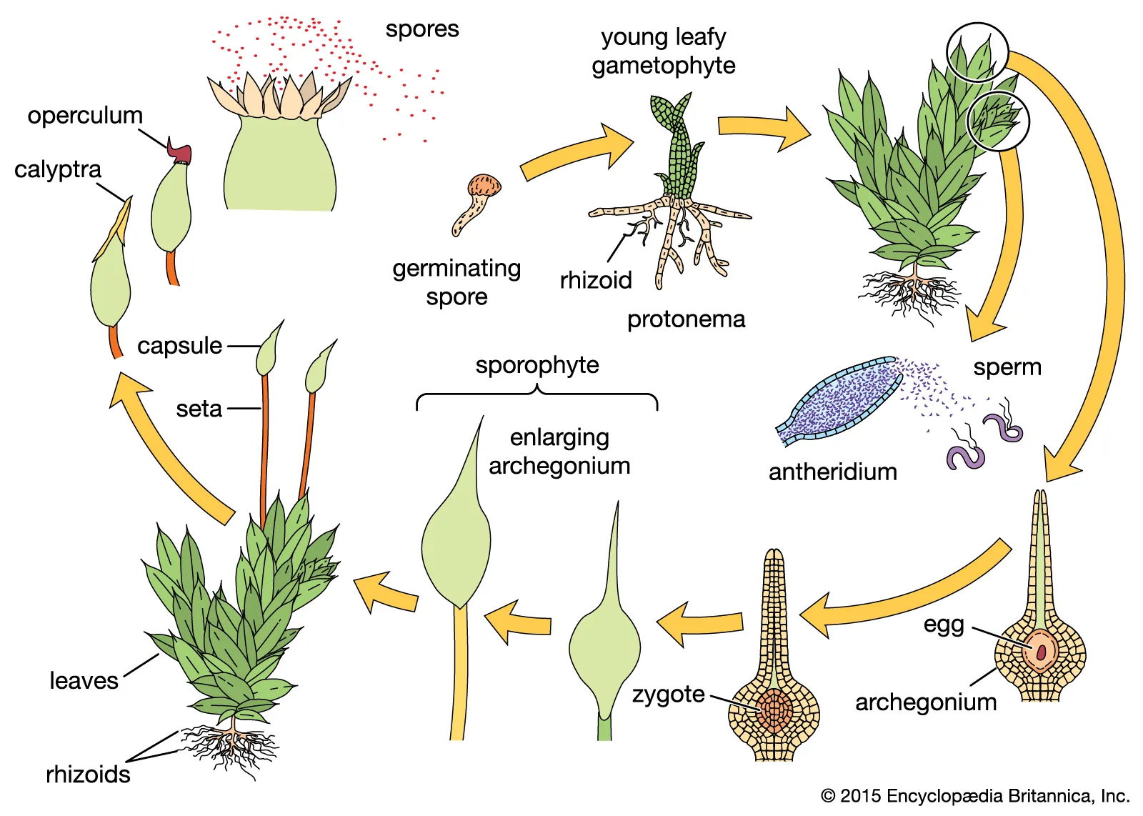
- Structures called _____________________ make _____________________ .
https://www.google.com/url?sa=i&url=https%3A%2F%2Fwww.britannica.com%2Fplant%2Fbryophyte&psig=AOvVaw1CWBspRAYDrIPvyTsYhYC7&ust=1677538509585000&source=images&cd=vfe&ved=0CA8QjRxqFwoTCNCT24mktP0CFQAAAAAdAAAAABAD
- Structures called _____________________ produce _____________________ cells.
- Sperm cells must swim through water to fertilize eggs. This is why bryophytes must live in moist habitats.
- After _____________________ , the diploid _____________________ grows to become a _____________________ .
- The _____________________ is made up of a capsule and a long stalk that remains attached to the haploid gametophyte.
- It relies on the _____________________ for food and water. Spores are made inside the capsule. When the capsule ripens, it opens and the spores are carried off by wind and water - _____________________
- When a spore lands in a moist place, it grows into the plant we think of as moss.
- This green plant is the _____________________ _____________________ .

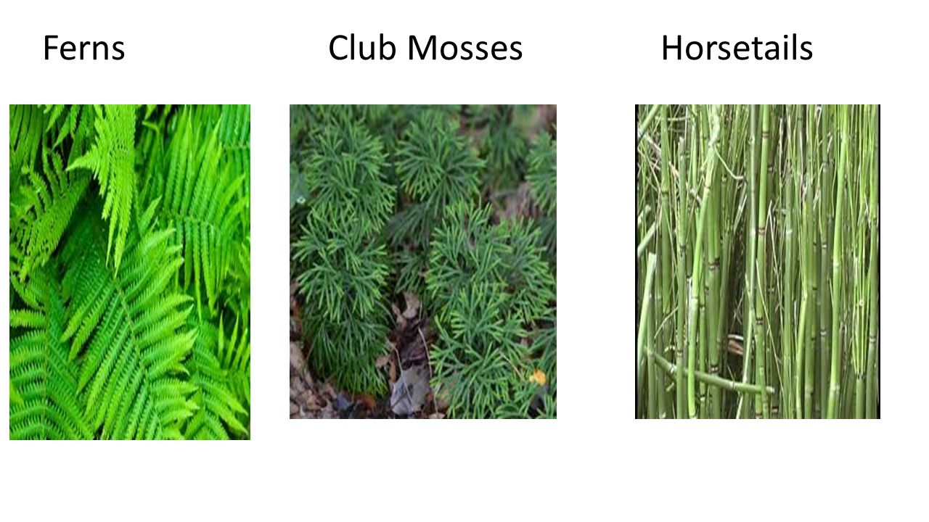
_____________________ Vascular Plants
https://slideplayer.com/slide/10279093/35/images/11/Ferns+Club+Mosses+Horsetails.jpg
- Types -
- _____________________ and their relatives were the first plants to have special tissues that carry water and food throughout a plant.
- _____________________
- _____________________
- _____________________
- Tissue Types -
- There are 3 types of tissue.
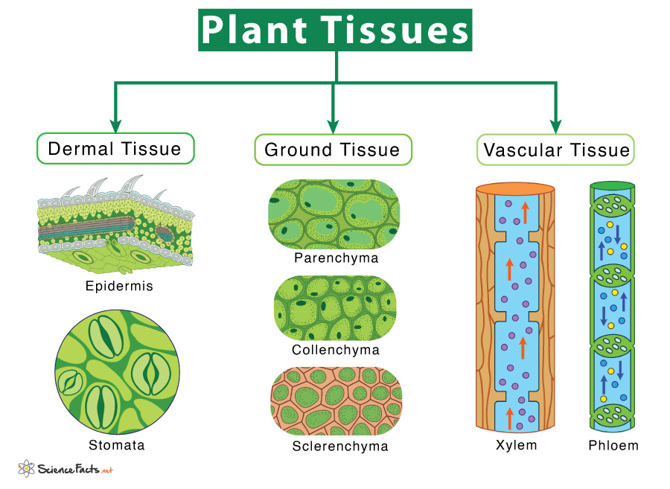
- _____________________ - used for protection and to prevent water loss
https://www.sciencefacts.net/wp-content/uploads/2022/02/Types-of-Plant-Tissue.jpg
- Includes epidermis (mostly) and periderm (like bark)
- Cuticle = a waxy layer.
- _____________________ - used for metabolism, storage and support (any tissue that isn’t dermal or vascular)
- Types:
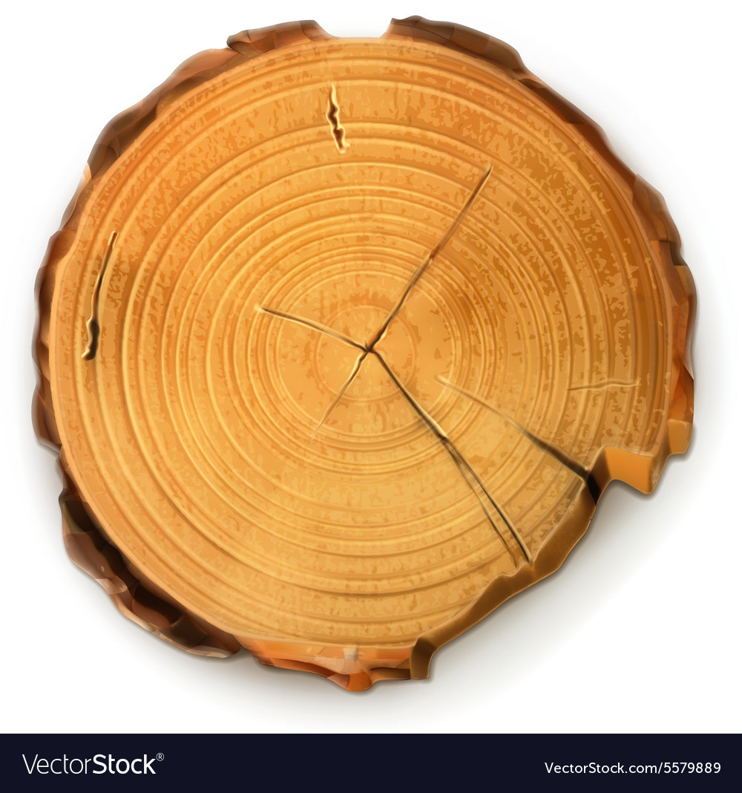
- _____________________ : traditional plant cells
Dermal
Vascular
Ground
https://cdn5.vectorstock.com/i/1000x1000/98/89/tree-stump-round-cut-with-annual-rings-vector-5579889.jpg
- _____________________ : support, like cellulose
- _____________________ : wooded and durable (like what makes up an apple core)
- There are two types of _____________________ tissue.
- _____________________ (figure left) moves water from the roots to all parts of the plant.
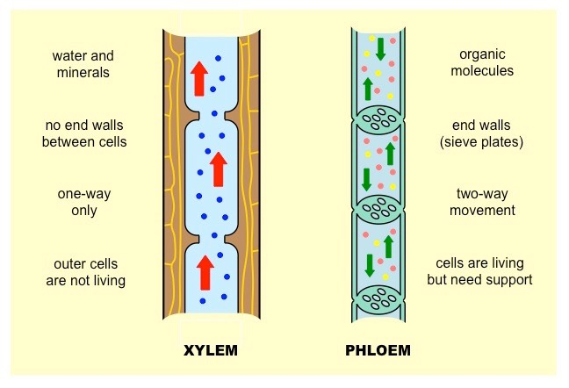
- Special cells call _____________________ make up xylem.
https://www.google.com/url?sa=i&url=http%3A%2F%2Fib.bioninja.com.au%2Fhigher-level%2Ftopic-9-plant-biology%2Funtitled%2Fxylem-versus-phloem.html&psig=AOvVaw11qW9aK97jBHhQvcVXiOWL&ust=1677539528440000&source=images&cd=vfe&ved=0CA8QjRxqFwoTCLiAke-ntP0CFQAAAAAdAAAAABAY
- They have thick, strong cell walls.
- The other type of vascular tissue is _____________________ .
- _____________________ carries nutrients and food from place to place within the plant.
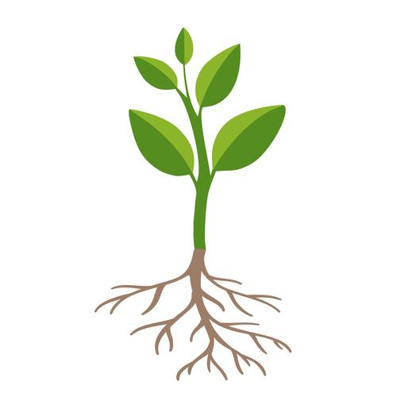
- Characteristics -
Leaves
Stem
Roots
https://content.anton.app/files/?fileId=image%2Fadobe_265405356_crop-705-660-1635-1635&etag=f8dc-13590
- These plants have true roots, leaves, and stems.
- _____________________ absorb water and minerals.
- _____________________ make food by photosynthesis.
- _____________________ support the plant and connect leaves and roots.
- Life Cycle:
- In the life cycle of ferns, the diploid _____________________ is the dominant stage.
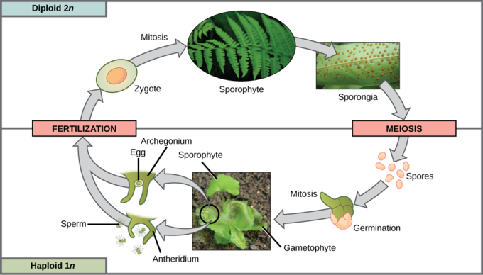
- Fern sporophytes produce _____________________ (figure right) on the underside of the fronds.
https://s3-us-west-2.amazonaws.com/courses-images/wp-content/uploads/sites/1842/2017/05/26231659/figure-25-04-07.png
- These spores are _____________________ . When spores are ripe, they burst from sporangia and are carried by wind and water.
- In the right conditions, they will grow to form haploid _____________________ . The haploid gametophyte is a thin, heart-shaped structure.
- The _____________________ and _____________________ are found on the underside of the _____________________ . When mature, sperm from the antheridia swim to the archegonia to fertilize the eggs.

_____________________ Plants
- Types -
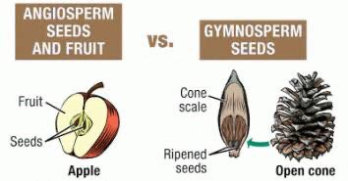
- Seed plants are divided into two groups: _____________________ and _____________________ .
https://qph.cf2.quoracdn.net/main-qimg-22064f55001d4afe60e7ac1e5abe9d08-lq
- Gymnosperms, or cone-bearing plants, produce seeds directly on the surface of _____________________ .
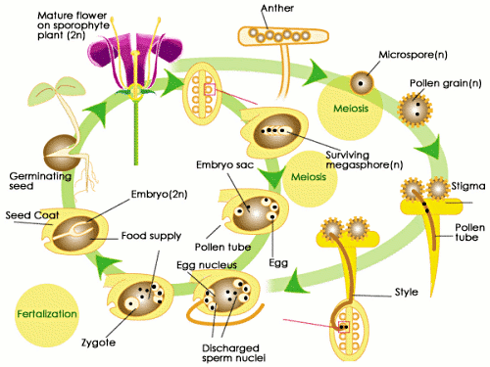
- _____________________ , which are _____________________ plants, produce seeds inside a tissue that protects them.
http://img.sparknotes.com/figures/9/9f79f1dbce762884bf644e4ac8450061/angiospermlifecycle.gif
- Like other plants, seed plants have _____________________ _____________________ .
- All the seed plants that we see are _____________________ .
- The _____________________ of seed plants are made up of only a few cells.
- They grow and mature within flowers and cones.
- The entire male gametophyte fits in a tiny structure called a _____________________ .
- Pollen is carried to the female gametophyte by wind, birds, mammals, or insects - _____________________
- This process is called pollination. Seeds protect the zygote of seed plants.
- After fertilization, the _____________________ grows into a tiny plant.
- This plant is called an _____________________ .
- When conditions are right, the embryo grows.
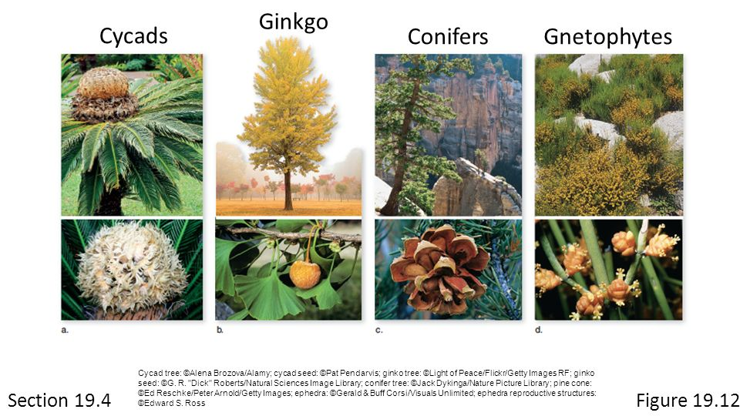
- It uses a supply of stored food inside the seed when it starts growing. A seed coat surrounds the embryo, protecting it from drying out.

- _____________________ are the oldest surviving seed plants.
- Gymnosperms include gnetophytes, cycads, ginkgoes, and conifers.
- These plants produce seeds that are protected by a seed coat.
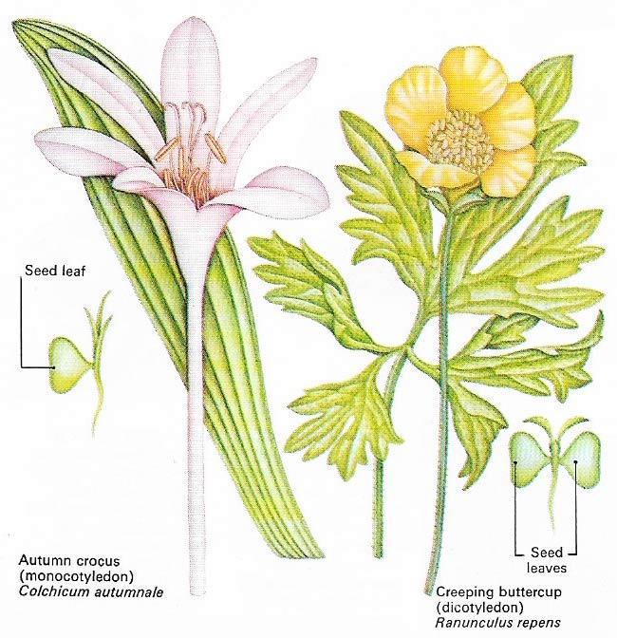
- However, the cone does not cover the seeds. This is why they are called naked seed plants.
http://www.daviddarling.info/images7/angiosperms.jpg
- _____________________ —Flowering Plants
- Angiosperms have reproductive organs called _____________________ . Flowers attract animals, which carry pollen from flower to flower.
- This is a more efficient way of pollination than the wind pollination of most gymnosperms.
- Unlike gymnosperms, the seeds of angiosperms are protected.
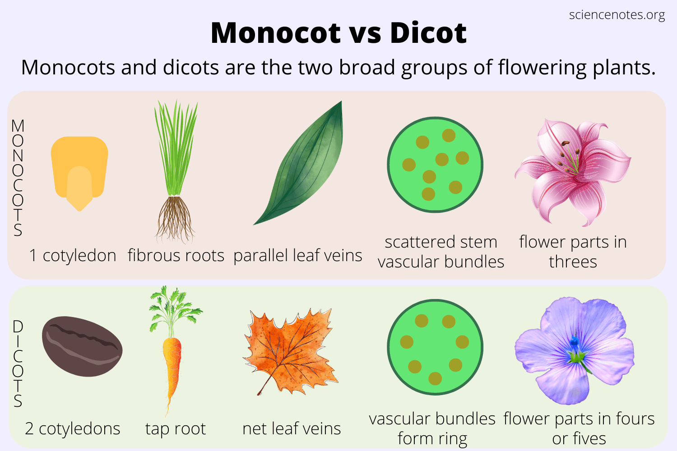
- The structure that protects the seeds develops into a _____________________ .
https://sciencenotes.org/wp-content/uploads/2022/07/Monocot-vs-Dicot.png
- There are two groups of angiosperms: _____________________ and _____________________ .
- _____________________ embryos have one seed leaf, or ____________________ .
- _____________________ embryos have two cotyledons.
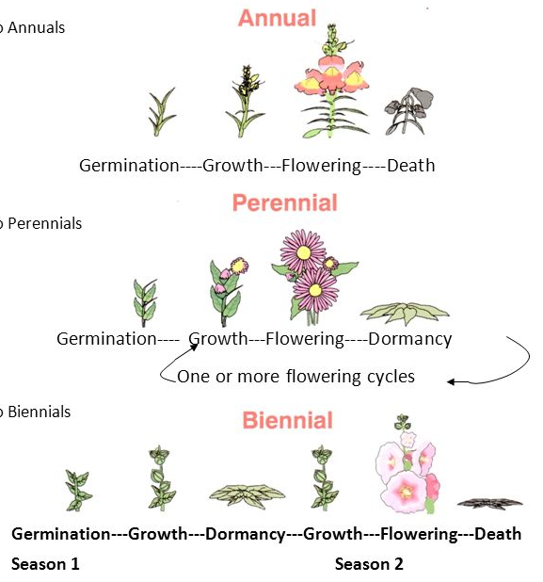
- Other differences include the arrangement of veins in leaves, the number of flower petals, the structure of roots, and the arrangement of vascular tissue in the stem.

https://slideplayer.com/slide/6528764/22/images/5/Courtesy+of+Interstate+Publishing.jpg
- Flowering plants have three different life spans.
- _____________________ complete their life cycle within one growing season.
- _____________________ complete their life cycle in two years. They produce seeds and die in the second growing season.
- _____________________ live through many years. Some die each winter and regrow in spring. Others have woody stems.

Plant _____________________
- Reproduction with Cones and Flowers
- Characteristics -
- Seed plants are completely adapted to life on land.
- They do not need water for reproduction.
- Cones, flowers, and seeds let seed plants reproduce without water.
- In the seed plant life cycle, the spore-producing generation (_____________________ ) alternates with the gamete-producing generation (_____________________ ).
- In seed plants, the familiar form of the plant is the _____________________ .
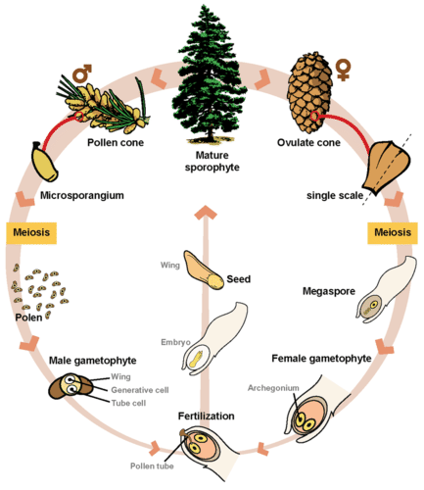
- The _____________________ of seed plants is hidden within the _____________________ and _____________________ .
https://dr282zn36sxxg.cloudfront.net/datastreams/f-d%3A72f8cd5229dc9d55c1b253e2f0ee1c57ee2880dd13867f2bbc6cb7f2%2BIMAGE_THUMB_POSTCARD_TINY%2BIMAGE_THUMB_POSTCARD_TINY.1
- Cones and flowers are two different methods of reproduction.
- Pine trees and other _____________________ use _____________________ for reproduction.
- _____________________ cones produce the male gametophyte, which are called pollen grains.
- Seed cones produce the female _____________________ in ovules.
- A few large _____________________ cells form within the ovules. When a pollen grain lands near an ovule, it grows a pollen tube into the ovule.
- A sperm from the pollen tube fertilizes the egg in the ovule. A zygote forms and grows into an embryo.
- The embryo becomes enclosed in a seed.
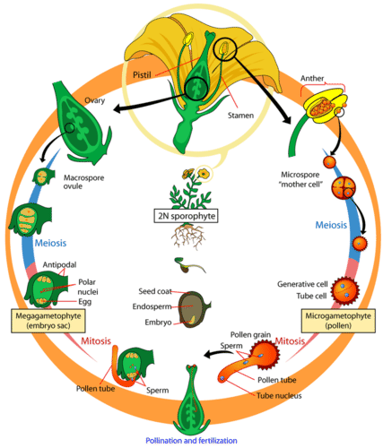
- _____________________ , or flowering plants, reproduce with flowers.
https://dr282zn36sxxg.cloudfront.net/datastreams/f-d%3Aa7681511ae4db42a9449559aaa4d6b261e6dc89880e77423a2cd6007%2BIMAGE_THUMB_POSTCARD_TINY%2BIMAGE_THUMB_POSTCARD_TINY.1
- Flowers are organs that are made up of four kinds of leaves: sepals, petals, stamens, and carpels.
        - _____________________ make up the outermost circle of floral parts and are often green. They protect the flower bud.
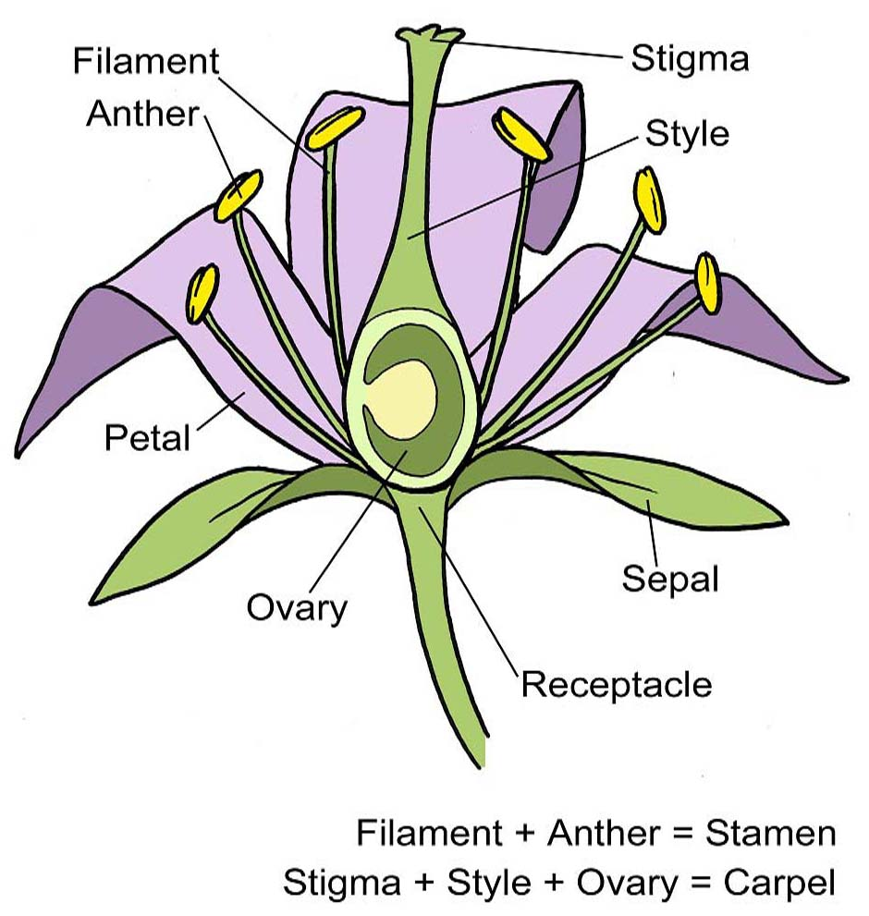
        - Colorful _____________________ form the next circle. Petals attract insects and other pollinators to the flower.
https://schoolgardening.rhs.org.uk/getmedia/ddbc826a-1ab8-4597-aa72-b1c990a98f25/AS-flower-structure
        - _____________________ and petals are sterile leaves. The inner circles of a flower are fertile leaves.
        - _____________________ form the first inner circle. Each stamen has a long _____________________ that supports an _____________________ .
          - The anther produces _____________________ gametophytes.
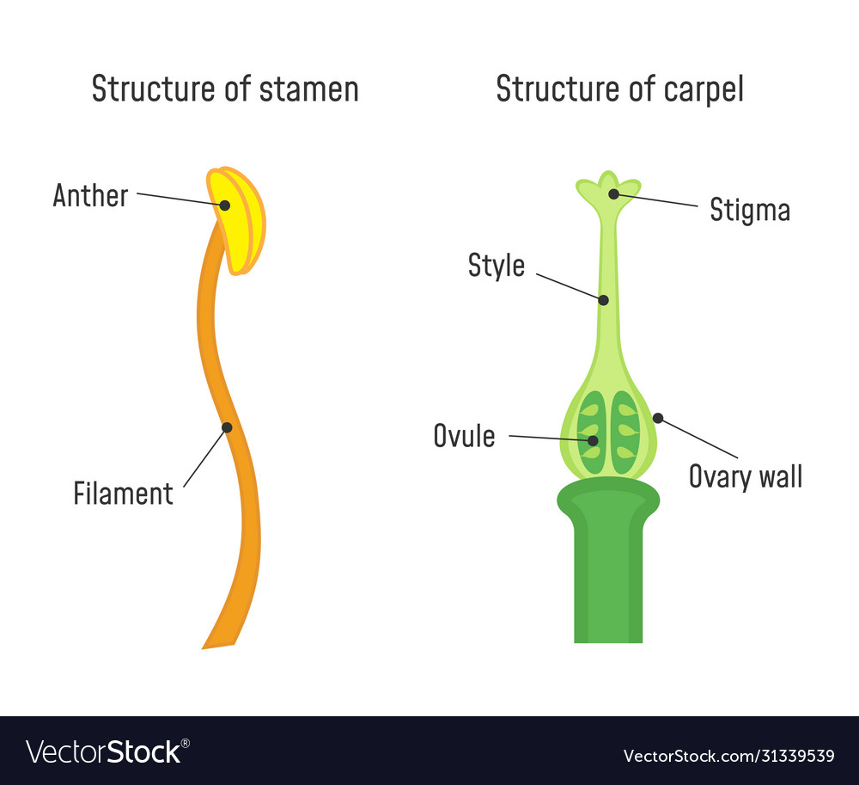
        - One or more carpels form the innermost circle. _____________________ , also called pistils, produce female gametophytes.
https://previews.123rf.com/images/fancytapis/fancytapis1903/fancytapis190300004/124796333-structure-of-stamen-and-carpel-flower-part-diagram.jpg
          - Each carpel has a broad base called the _____________________ .
          - The carpel’s stalk is called the _____________________ .
          - At the top of the style is the _____________________ . The stigma has a sticky surface where pollen grains land.
        - Angiosperms may have stamens and carpels within the same flower or in separate flowers on the same plant.
- Reproduction in flowering plants takes place inside the flower.
        - Inside the _____________________ , each cell undergoes meiosis to produce four haploid spore cells.
        - Each of these cells becomes a _____________________ grain.
        - Inside the ovaries are the _____________________ , where the female gametophyte develops.
        - A single cell goes through meiosis to produce four haploid cells.
          - One of these cells goes through _____________________ , producing the embryo sac. This is the female gametophyte.
          - Within the embryo sac is the _____________________ cell.
        - During pollination, pollen is transferred from the _____________________ to the _____________________ . Most gymnosperms are wind pollinated. Animals pollinate most angiosperms.
        - Two distinct fertilizations take place in the embryo sac.
          - First, one sperm nucleus fuses with the _____________________ to form a diploid zygote. The zygote will grow into the plant embryo.
          - Then, the other sperm nucleus fuses with two other _____________________ in the embryo sac to form the endosperm. The endosperm provides food for the embryo. This is known as double fertilization.

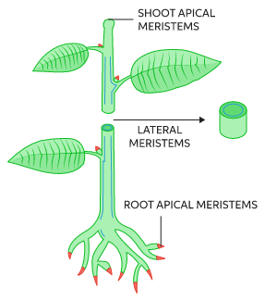
Plant _____________________ and _____________________
https://images.ctfassets.net/vrrt8fsfwf0e/1695skmoADVtgWp93Ci5SG/cebd8c85e3205d83f53dbcc25e92266e/Meristem_art_1.svg
- Hormones and Plant Growth
- Background: Plant growth is not precisely determined. However, plant growth still follows general growth patterns that differ among species. Plant growth never stops. New cells are always being made in meristematic tissue.
- Growth -
- _____________________ are found at the tips of _____________________ and _____________________ and are involved in growth. New cells later develop into specialized tissues.
- Plants grow in response to environmental factors like light, moisture, gravity, and temperature.
- Control -
- Certain plant chemicals also control plant growth. These chemicals are called _____________________ .
- A _____________________ is a substance that is produced in one part of an organism and affects another part of the same organism.
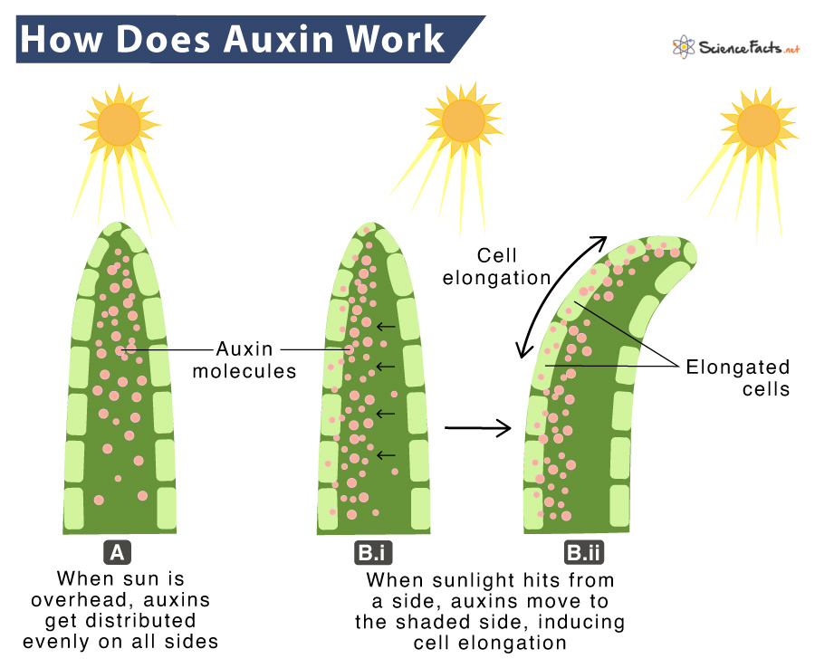
- The part of the organism affected by a hormone is the target cell or _____________________ tissue. Different kinds of target cells can respond to the same hormone. A single hormone may affect two different tissues in different ways.
https://www.sciencefacts.net/wp-content/uploads/2022/05/Auxin.jpg
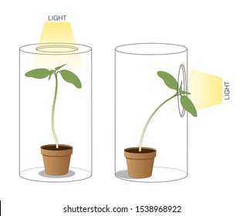
- One important group of plant hormones is _____________________ .
https://www.shutterstock.com/image-illustration/phototropism-light-plant-moves-towards-260nw-1538968922.jpg
- _____________________ have different effects on different tissues. Auxins make stems grow toward light and away from the pull of gravity.
- Plant Responses - _____________________ -
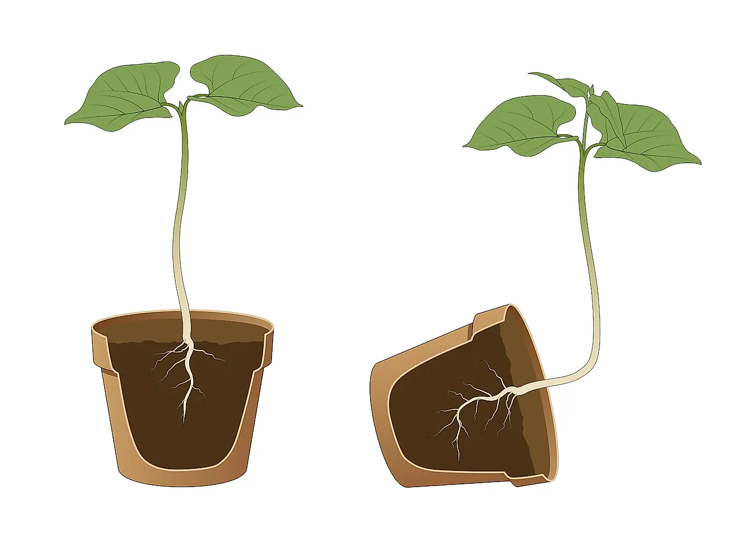
- The tendency of a plant to grow toward light is called _____________________ .
https://www.worldatlas.com/r/w1200/upload/31/8f/74/shutterstock-1540480469.jpg
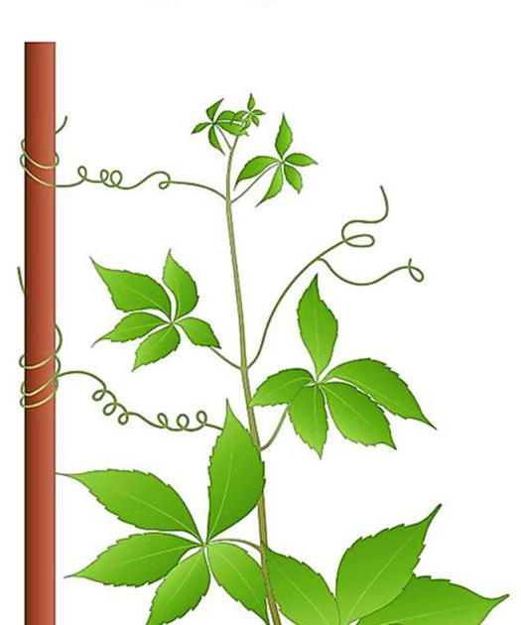
- _____________________ is the response of a plant to the pull of gravity. Auxins make roots grow away from light and toward the pull of gravity. Auxins also control plant branching by keeping the buds on the sides of the stem from growing.
https://bloximages.chicago2.vip.townnews.com/agupdate.com/content/tncms/assets/v3/editorial/2/28/228e1a08-6322-55c3-b19e-c46257cd016e/601ef4906af51.image.jpg?crop=1440%2C756%2C0%2C342&resize=1200%2C630&order=crop%2Cresize
- _____________________ - the tendency pf plants to grow around objects they are in contact with.
- Some plants have a rapid response to touch that does not involve growth.
- This kind of response is caused by changes in the osmotic pressure of some cells. These pressure changes cause leaves to fold up or snap shut.
- This response enables a Venus’ flytrap to trap an insect. Many plants respond to periods of light and darkness. This is called _____________________ .
- It is caused by changes in the length of periods of light and darkness. These changes affect plant pigments called _____________________ , causing plants to flower.
- Other Hormones -
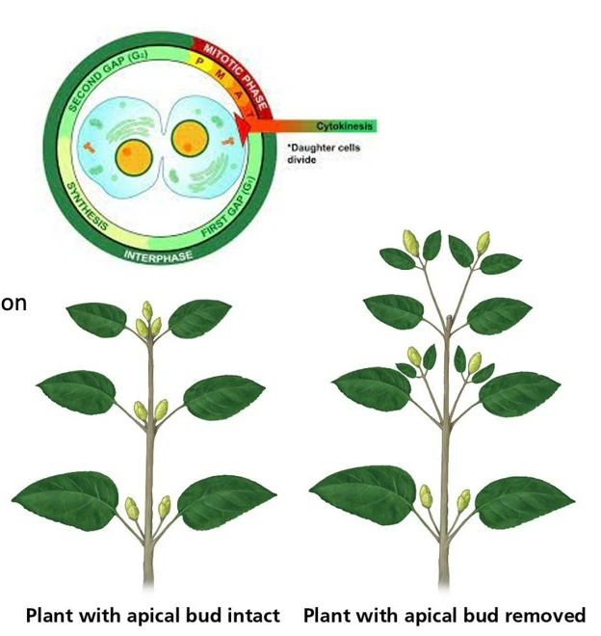
- Growing roots and developing fruits and seeds make hormones called _____________________ .
https://i.ytimg.com/vi/SKRw5BIQNQs/maxresdefault.jpg

        - Cytokinins stimulate cell division and make dormant seeds sprout. Their effects are often opposite to the effects of auxins.
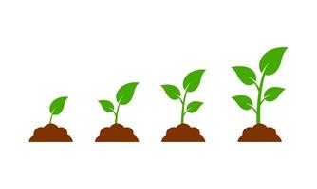
- In the 1920s, Japanese scientists identified a substance produced by a fungus that stimulated plant growth.
https://static.vecteezy.com/system/resources/thumbnails/006/220/906/small/plant-growth-sprout-from-the-ground-isolated-on-white-background-free-vector.jpg
        - They named this substance _____________________ . Later, scientists learned that plants also produce gibberellins.
        - Gibberellins cause dramatic increases in size and rapid growth.
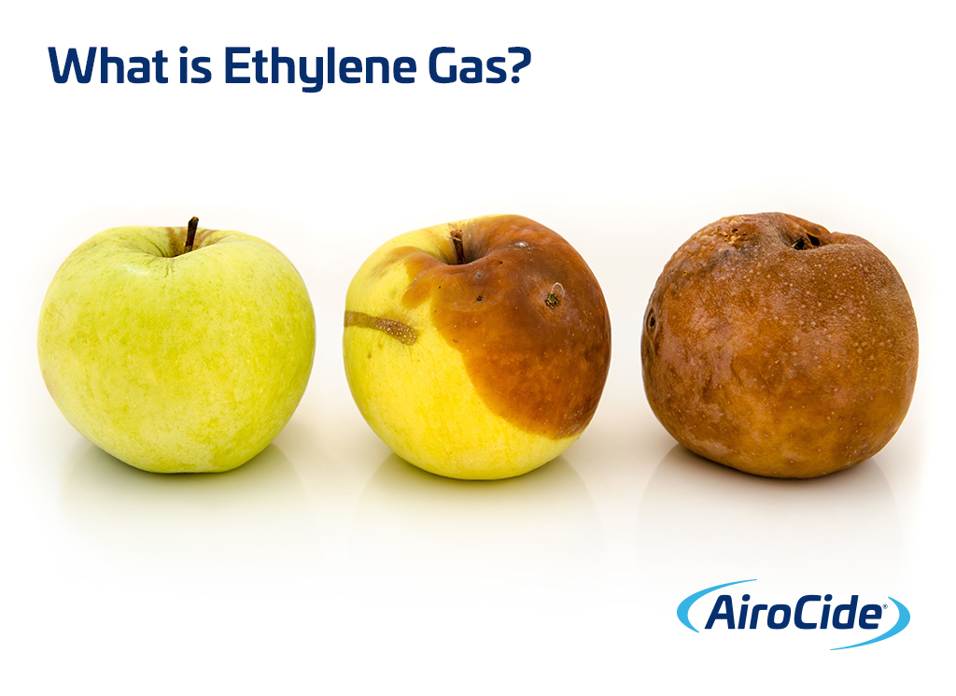
- _____________________ is another plant hormone. Plants release ethylene in response to auxins. Ethylene _____________________ fruits to _____________________ .
https://kesair.com/wp-content/uploads/2019/07/What-is-Ethylene-Gas-Remove-with-AiroCide-Commercial-Air-Purification.jpg

Notes

