

Use the following template to write your responses for the Macromolecules Stations:

Station 1 - Watch It: Answer the following based upon the content in the video

1.
2.
3.
4.
5.
6.
7.
8.
9.


Station 2 - Video It
Video Link: ___________________________________________________
In a quick 3 minute video - explain or answer the following using the sentence stems below.
- Dominant genes are genes that are.....while recessive genes are....
- A homozygous genotype is best described as....while a heterozygous one can be described as....
- A Punnett Square can be used to determine....
- I would calculate the phenotype probability of an individual with 2 traits by ...
- The probability of the phenotpye of the offspring of two parents that are heterozygous for both traits would be:



Station 3 - Write It
In a quickwrite (3-5 Sentences) - Using the image right…

In pea plants, round peas (R) are dominant to wrinkled peas (r). You do a test cross between a pea plant with wrinkled peas (genotype rr) and a plant of unknown genotype that has round peas. You end up with three plants, all which have round peas. From this data, can you tell if the round pea parent plant is homozygous dominant or heterozygous? If the round pea parent plant is heterozygous, what is the probability that a random sample of 3 progeny peas will all be round?


Station 4 - Examine It
Looking at the karyotype below, determine which one is abnormal and explain why
A

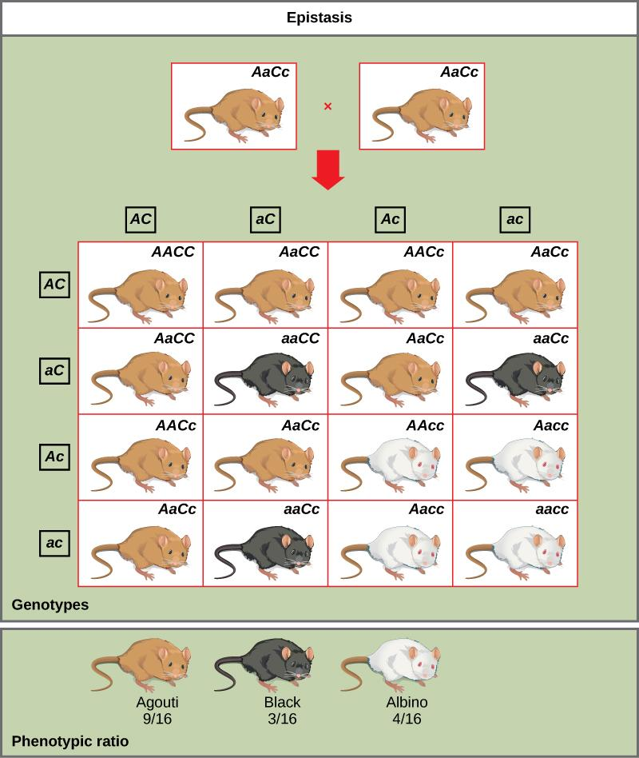
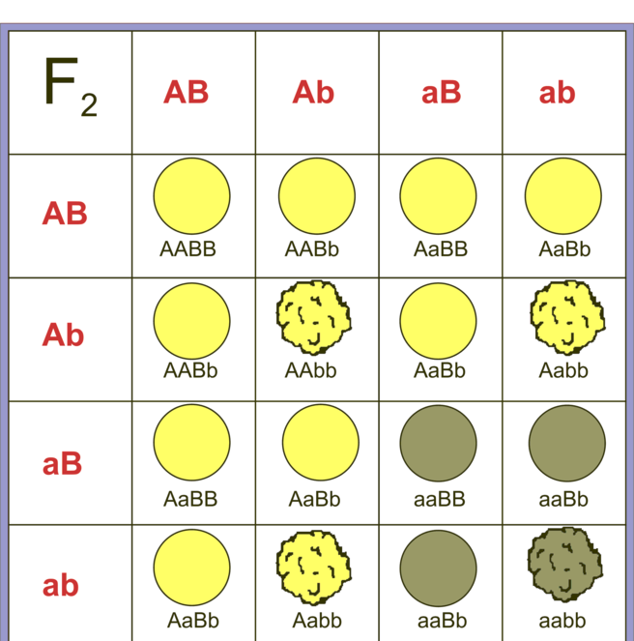
B



Station 5 - Answer It
1.
2.
3.
4.
5.
6.




Station 6 - Perform It
- Go the following website:
https://cgslab.com/genetics/index.html?22112512
- or use the QR code right -
- Answer the questions provided:


Station 7 - Read It
Read the following Article an fill out the chart below:

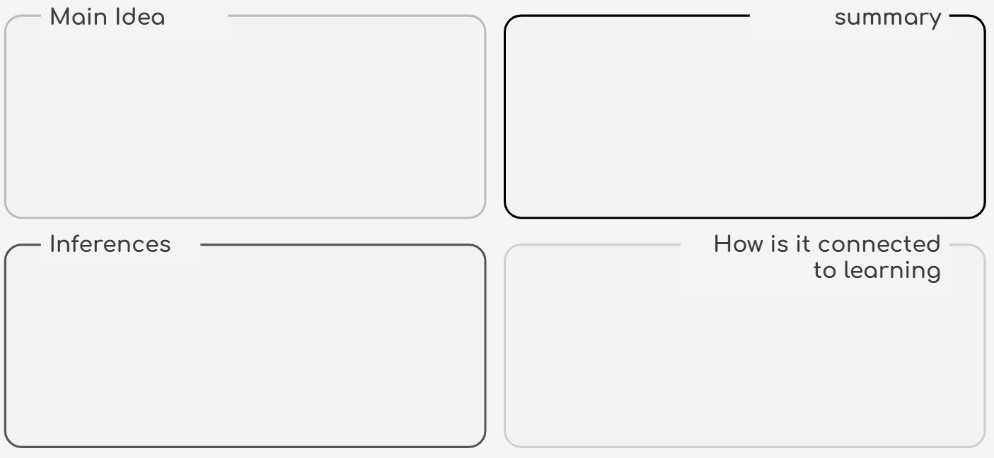


Station 8 - Evaluate it

