Unit 13 - Genetics: Grinch Family Tree
INSTRUCTOR:
no_reply@example.com

Background Information
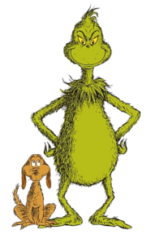
https://en.wikipedia.org/wiki/Grinch
The Grinch is depicted as a green, pot-bellied, furry, pear-shaped, snub-nosed creature with a cat-like face and cynical personality. In full-color adaptations, he is typically colored yellow-green. He has spent the past 53 years living in seclusion on a cliff, overlooking the town of Whoville.
In contrast to the cheerful Whos, the Grinch is misanthropic, ill-natured, and mean-tempered. The reason for this is a source of speculation; the consensus among the Whos is that he was born with a heart that they say was "two sizes too small". He especially hates the Holiday season, making particular note of how disturbing the various noises of Christmas time are to him, including the singing of carols. Unable to stand the holiday any longer, he decides to destroy it once and for all.
Aided by his pet dog, Max, he meticulously designs a red suit to disguise himself as Santa Claus and breaks into the Whos' homes on Christmas Eve while they sleep to steal everything they own, right down to the last crumb of food they have, and dump it off of a nearby mountain. Although he pulls off the theft successfully, on Christmas morning, he is shocked to hear the Whos still singing cheerfully, happy simply to have each other. He then realizes that the holiday has a deeper meaning that he never considered. Inspired, he stops the Whos' belongings from falling off the edge of the mountain, and in the process, his heart grows "three sizes". He returns all the gifts he stole and gladly takes part in the Whos' Holiday celebration.

Taking a look at the Family Grinch Genetics:

Genes | Skin Color |  | Height |  | Width |  | Heart Size
Phenotype | Red | Green | Tall | Short | Wide | Thin | Normal | 2x’s too small
Allele | R | r | T | t | W | w | H | h
Genotype | RR / Rr | rr | TT / Tt | tt | WW / Ww | ww | HH / Hh | hh

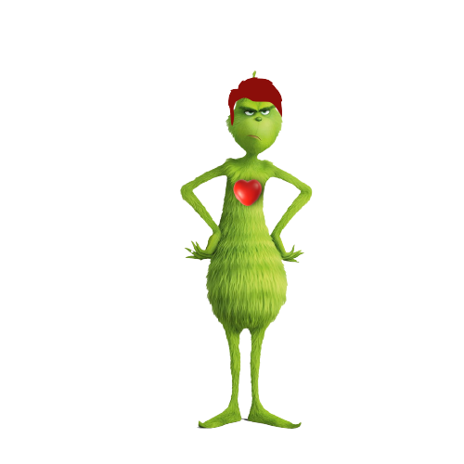

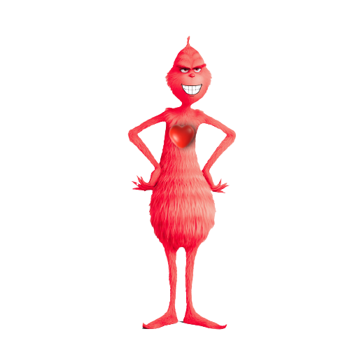
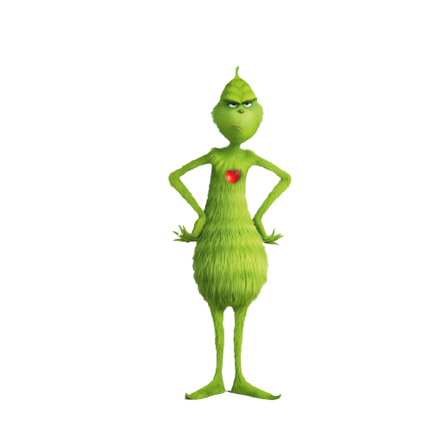
Grinch’s Family:

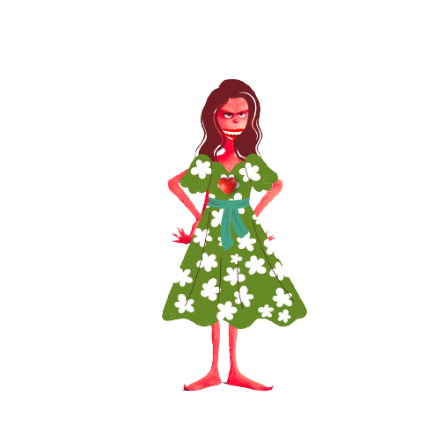

Grinch Grouch (dad) Griselda (sister) Graycen (brother) Grimmeria (mom)
Directions: Part 1
- Determine the Family’s Phenotype & Genotypes Below:

Family Member | Phenotype |  |  |  | Genotype
 | Skin Color | Height | Width | Heart | Skin Color | Height | Width | Heart
Grinch
Grouch (dad)
Griselda (sister)
Graycen (brother)
Grimmeria (mom)

- Perform a punnet square / Monohybrid Cross for each trait listed above. Determine the parent's genotypes to produce their offspring.
- Calculate the probabilities of being able to produce each trait within the F1 / offspring generation.

Skin Color

Skin Color |  |  |  |  |  |  | Height
Red | Green |  |  |  |  |  | Tall | Short
R | r |  |  |  |  |  | T | t

Probability: P: / G: Probability: P: / G:

Width |  |  |  |  |  |  | Heart Size
Wide | Thin |  |  |  |  |  | Normal | 2x’s too small
W | w |  |  |  |  |  | H | h

Probability: P: / G: Probability: P: / G:
Part 2: Dihybrid Cross
Using the Genotypes of the Parents above, perform a Punnett square / Dihybrid cross (Using Skin color and Heart Size) to determine the probability of each phenotype able to be produced.
Option 1
Probability Phenotypes:
Option 2

Probability Phenotypes:

Part 3: Pedigree
Using what you have learned, attempt a pedigree to show 3 Generations of the Grinch’s Family Tree. Use only one trait. Show the Allele combinations. Color and signify male/female the grinch below
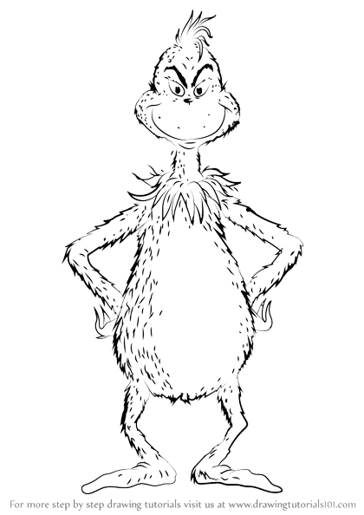

I
II
III

