UNIT 10: Central Dogma & Protein Synthesis - Transcription / Translation Practice
INSTRUCTOR:
instructor@email.com

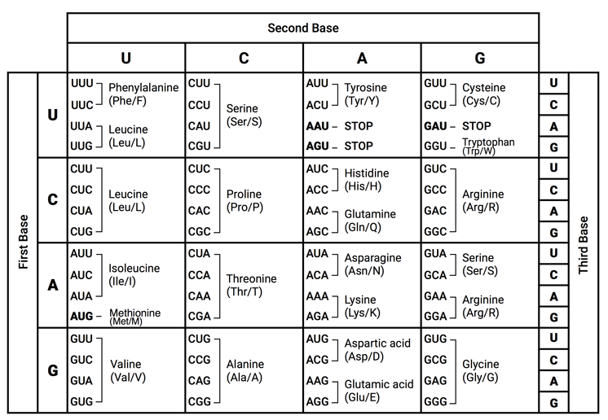
Replicate, Transcribe, and/or translate the following sequences.
- mRNA is synthesized in: ______________
- mRNA has _______ while tRNA has _______
- How many codons does it take to code for 1 amino acid?
- tRNA brings amino acids to the : ___________
- A polypeptide is a sequences of _____ that makes up a __________
- tRNA transfers amino acids during _______________.
- Ribosomes are the site of __________ while _________ takes place in the nucleus.
C
A
G
G
A
A
T
T
G
C
T
G
A
T
C
A
A
c

A

Original Strand - DNA
Complementary Strand - DNA
mRNA
Transcription
tRNA
Translation
Amino Acid
Sequence - Polypeptide
Peptide Bonds

c

C
C
A
U
U
A
U
G
U
A
A
C
C
A
A
C
G

C

Original Strand - DNA
Complementary Strand - DNA
mRNA
Transcription
tRNA
Translation
Amino Acid
Sequence - Polypeptide
Peptide Bonds

c

Methionine
Tryptophan
Serine
Arginine
Lysine
Glycine
Original Strand - DNA
Complementary Strand - DNA
mRNA
Transcription
tRNA
Translation
Amino Acid
Sequence - Polypeptide
Peptide Bonds

