Understanding Composition

In photography, composition refers to the placement of the subject within the frame of your photograph. Composition also deals with lightness, darkness, lines and balance of the image. There are no fixed rules in photography, but there are guidelines which can often help you to enhance the impact of your photos.

- Rule of Thirds (Nine Zone Grid) One basic rule is the rule of thirds. Images with the subject aligned with the intersection of the horizontal and vertical thirds are usually more appealing.

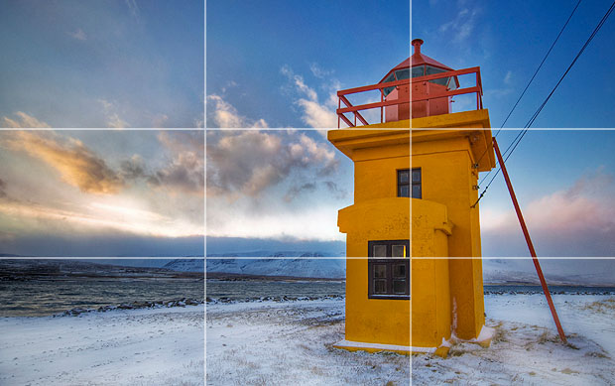

- Framing can give the viewer the impression of looking through something to the subject. The frame directs the eye's gaze.
- Framing that surrounds the subject
- Framing that adds depth to the image by establishing a foreground or background.

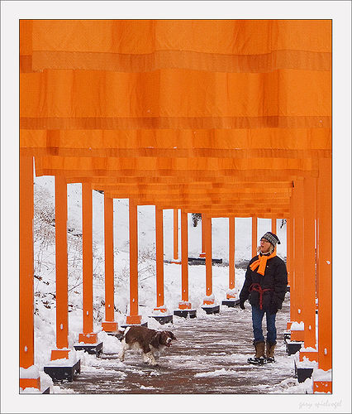


- Lighting Photography is all about light. Direction, color, hardness, it's all about light. To control what happens in your photograph you must control the light.
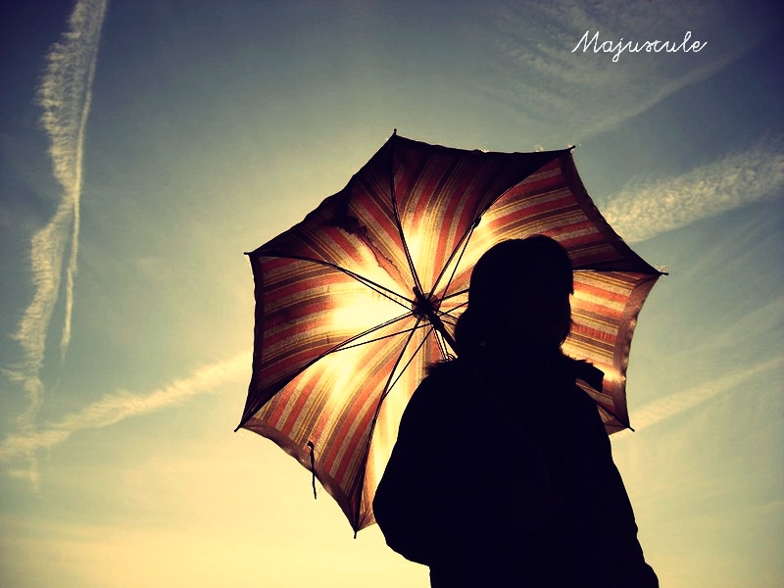

Lighting options can include Shadow, Sun & Reflection, Silhouette and Backlit (Flickr)

- Use of elements and principles of design – Line, shape, value (contrast), color (rgb or black/white), texture, depth and space(form), movement (visual and literal), emphasis, balance (radial/asymmetrical/symmetrical), harmony, repetition, rhythm, variety



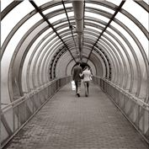
- Viewpoint: Before photographing your subject, take time to think about where you will shoot it from. Our viewpoint has a massive impact on the composition of our photo, and as a result it can greatly affect the message that the shot conveys. Rather than just shooting from eye level, consider photographing from high above, down at ground level, from the side, from the back, from a long way away, from very close up, etc.



Sources:
http://www.photographymad.com/pages/view/10-top-photography-composition-rules
http://photok12.org

