PS Unit 5: Motion Notes Packet

Unit Goals
By the end of this unit, you should be able to
- Compare and contrast position, distance, and displacement.
- Explain the similarities and difference between speed and velocity.
- Calculate velocity, change in position, and time using the velocity formula.
- Calculate acceleration, initial velocity, final velocity, and time using the acceleration formula.
- Create and interpret position-time and velocity-time graphs.
- Calculate momentum, mass, and velocity using the momentum formula.

Unit Vocabulary
U5Q1: Position, Distance, Displacement, Speed, Velocity, and Acceleration Quiz

- Position
- Distance
- Displacement
- Speed
- Average Velocity
- Acceleration
- Initial Velocity
- Final Velocity

Other Vocab

- Momentum

Unit Formulas
Formula | Rearranged Formula  or Triangle | Variables | Units
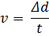 |  | v:  d:  t: | v:  d:  t:
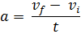 |  | a:  v_{f}:  v_{i}:  t: | a:  v_{f}:  v_{i}:  t:
 |  | ρ:  m:  v: | ρ:  m:  v:

Unit Assignments

- U5Q1 _____
- U5Q2 _____
- U5T _____
- Packet Due _____

Motion
- In this unit we will be describing how objects move
- Scalar vs Vector
  - Scalar quantities provide only magnitude (size)
    - Examples: length, area, volume, speed, mass, density, pressure, temperature, energy, work, power
  - Vector quantities provide both magnitude and direction
    - Examples include displacement, velocity, acceleration, momentum, force, and weight

Position, Distance, and Displacement
- Position is ____________________________________________________________________
  - Can be positive or negative
- Distance is ____________________________________________________________________
  - Always positive
  - The whole journey
- Displacement is ________________________________________________________________
  - Can be positive or negative
  - Initial position → Final position only, don’t worry about the journey
  - If final position = initial position, then displacement = ______

Speed and Velocity
- Speed is ______________________________________________________________________
  - Scalar quantity
  - Variable is ____
  - Unit is ________
    - Any distance unit divided by any time unit will work
Formula | Triangle | Rearranged Formulas

- Velocity is _____________________________________________________________________
  - Vector quantity
  - Variable is ____
  - Unit is ________
    - Any displacement unit divided by any time unit will work
Formula | Triangle | Rearranged Formulas
- Example Problems

Position-Time Graphs
- ____________ goes on the x-axis
- ____________ goes on the y-axis
- This graph will be a line graph since the data is taken continuously over time
  - Line graph means the dots __________ connected
- The slope of the line gives you the ________________ of the object
  - If the line is horizontal, the object is __________________________________________
  - If the line is straight, but not horizontal, the object is _____________________________ _______________________________________________________________________
    - Positive slope = ________________ direction
    - Negative slope = ________________ direction
    - Toward the x-axis = ________________________________________________
    - Away from the x-axis = _____________________________________________
- Interpretation Example
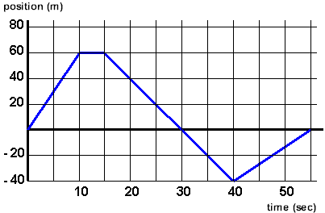
Acceleration
- Definition: _____________________________________________________________________
- 3 ways an object can acceleration: _________________________________________________ _____________________________________________________________________________
- Variable: ________
- Unit: ________
Formula | Triangle | Rearranged Formulas
- Example Problems

- On a position-time graph, acceleration is shown as a ____________ line
  - If the slope is getting steeper, the object is _________________________
  - If the slope is getting flatter, the object is _________________________

Velocity-Time Graphs
- ____________ goes on the x-axis
- ____________ goes on the y-axis
- This graph will be a line graph since the data is taken continuously over time
  - Line graph means the dots __________ connected
- The slope of the line gives you the ________________ of the object
  - If the line is horizontal, the object is __________________________________________ _______________________________________________________________________
    - If the horizontal
  - If the line is straight, but not horizontal, the object is _____________________________
    - Toward the x-axis = _____________________
    - Away from the x-axis = ____________________
- The number of directions comes from the ____________________

- Interpretation Example
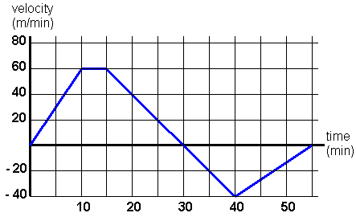

Momentum
- Definition: _____________________________________________________________________ _____________________________________________________________________________
- Law of Conservation of Momentum
__________________________________________________________________________________________________________________________________________________________
- Variable: ____ (Greek letter rho)
- Unit: ________
Formula | Triangle | Rearranged Formulas
- Example Problems

