PS Unit 4: Acids & Bases, Solutions, and Nuclear Chemistry Notes

Unit Goals
By the end of this unit, you should be able to
- Define solute, solvent, solution, suspension, and colloid.
- Explain the factors that determine the rate of dissolving of a solute in a solvent.
- Compare and contrast ionization, dissociation, and dispersion.
- Determine if a solution is saturated, unsaturated, or supersaturated using a graph.
- Identify if a substance is an acid, base, or neutral compound based on its chemical formula and/or properties, including how litmus paper, phenolphthalein, and universal indicator paper react.
- Explain what the pH scale is.
- Compare and contrast nuclear fission and nuclear fusion.
- Differentiate between alpha, beta, and gamma decay.
- Write an equation to illustrate a nuclear reaction.
- Complete calculations involving the half-life of a radioactive substance.

Unit Vocabulary
Acids, Bases, and Solutions

- Acid
- Base
- Neutral Compound
- pH
- Litmus Paper
- Phenolphthalein
- Universal Indicator
- Acid-Base Neutralization

- Solute
- Solvent
- Concentration
- Ionization
- Dissociation
- Dispersion
- Saturated
- Unsaturated
- Supersaturated

Nuclear Chemistry

- Nuclear Fission
- Nuclear Fusion
- Alpha Decay
- Beta Decay
- Gamma Decay
- Half-Life
- Radioactivity
- Stable
- Unstable

Unit Formulas
None

Unit Assessments

- U4Q1 Acids, Bases, and Solutions Quiz: ____________

- U4Q2 Nuclear Chemistry Quiz: ____________

- U4T Unit 4 Test: ____________

Homework
- StudyJams Acids & Bases video and questions on Google Classroom

Acids & Bases
- An acid is a substance that gives off ____________________ ions in solution
- Acids have a pH of ____ or ________, taste ____________, feel ____________, and ______________________________
- Acids turn litmus paper ____________ and phenolphthalein _____________________________
- Examples of acids include: _______________________________________________________
- A base is a substance that gives off ____________________ ions in solution
- Bases have a pH of ____ or ________, taste ____________, feel _____________, and _______________________________
- Bases turn litmus paper ____________ and phenolphthalein _____________________________
- Examples of bases include: _______________________________________________________
- Compounds that have a pH of ____ are said to be neutral
- Neutral compounds produce both ____________________________________ ions in solution
  - This is why pure water is neutral
- The pH scale measures __________________________________________________________
  - The more ________________________________________, the lower the pH value is
  - It is a log-based scale, which means that each value is ______ times more or less than the next value
- There is also a pOH scale that measures _________________________________ concentration, and is the exact opposite of the pH scale
- When an acid and base are reacted together, the result is pure water and a neutral compound called a ________________
  - Acid-base neutralization reactions are a special type of double replacement reaction
  - Examples

Solutions
- A solution is a _________________________ mixture with one substance is dissolved in another
  - The substance that does the dissolving is called the _________________
  - The substance that gets dissolved is called the __________________
- “Like Dissolves Like”
  - In order for a solution to form, both components must be similar in polarity
    - Polar dissolves polar covalent or ionic
    - Non-polar dissolves non-polar
- Methods of Dissolving
  - Ionic compounds ________________________, breaking up into their individual ions
    - This is a physical change because it can be reversed
  - Covalent compounds _________________________, breaking into smaller and smaller pieces of themselves, but never breaking up into individual atoms
    - This is a physical change because it can be reversed
  - Unlike the other two methods of dissolving, ________________________ is a chemical change and is how ions form in the first place
- Rates of Dissolving
  - The rate at which dissolving occurs depends on three things: ______________________ _______________________________________________________________________
    - Increasing any of these will speed up the rate of dissolving
- Solubility & Concentration
  - Solubility is a measure of how soluble a substance is at a given temperature
  - Concentration is the amount of ________________ dissolved in the _______________
    - If the solution is unsaturated then _____________________________________ ________________________________________________________________
    - If the solution is saturated then _______________________________________ ________________________________________________________________
    - If the solution is supersaturated then __________________________________ ________________________________________________________________
- Solubility Curves
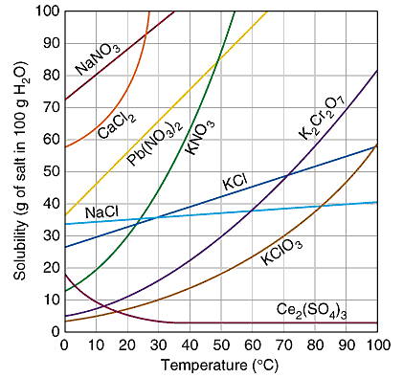
Nuclear Chemistry
- Nuclear reactions are when changes are made to the ________________ of the atom
  - When these changes occur spontaneously, it is called ________________________
- The amount of time it takes for half of a radioactive substance to decay into a stable daughter product is called ________________
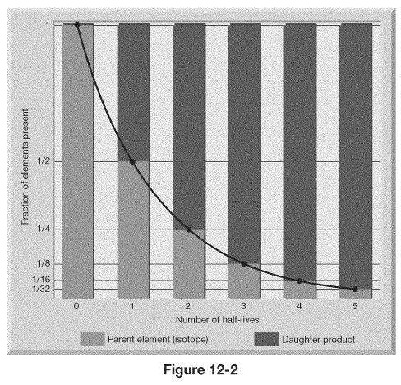
  - Half-Life Calculation Examples

- Radioactive Decay
  - Alpha decay is the emission of an alpha particle, which is basically a ________________ nucleus. Alpha particles have a ________________ charge and are attracted to _________________ electric fields. Although they travel ____________ than other forms of radioactive decay, alpha particles can cause ________________________________.

    - Greek Symbol
    - Atomic Symbol

  - Beta decay is the emission of a beta particle, which is basically an __________________. Beta particles have a _________________ charge. Because of their tiny size, they are relatively ________ to stop.

    - Greek Symbol
    - Atomic Symbol

  - Unlike the other forms of decay, gamma decay ________________ emit a particle. Gamma radiation is a very ________ energy emission that is very __________________ to stop; only thick sheets of ____________ are effective. Gamma decay usually occurs ____________ other forms of radioactive decay.

    - Greek Symbol
    - Atomic Symbol

- Balancing Nuclear Equations
  - Similar to balancing chemical equations, except that now you are looking at balancing making the mass and protons in the atomic symbols balance.
  - Examples

- Nuclear Fission and Fusion
  - Nuclear fission is _________________________________________________________
    - This is what we do in our power plants
    - Problems: finding/making fissionable materials, constructing safe facilities, and storing radioactive waste
  - Nuclear fusion is _________________________________________________________
    - This is what happens in stars
    - Problems: it requires extremely high temperatures

