Work Lab
Materials

- 4 Textbooks
- Self

Procedure
Part A
- Stand with your arms out in front of you at waist level, palms up.
- Have your partner put a book on each of your hands.
- Lift the books to about shoulder level, then lower them.
- From waist height, lift the books over your head, and then lower the books.
- When did you do more work: when lifting the books from waist height to shoulder height or when lifting the books from waist height to over your head? Explain using complete sentences.

Part B
- Stand with your arms out in front of you at waist level, palms up.
- Have your partner put 2 books on each of your hands.
- Lift the books to about shoulder level, then lower them.
- From waist height, lift the books over your head, and then lower them.
- Are you using more force when lifting 2 books than when you were holding only one book? Explain using complete sentences.

Part C
- Stand with your arms stretched out to the sides (like you are showing your wing span).
- Have your partner put 2 books on each hand.
- Hold the books at shoulder level until your arms get tired.
- Are you exerting a force on the books?

- Are you doing work in this situation? Explain using complete sentences.

Post-Lab Questions
- Using a force of 50N, you push a cart 10m across a classroom floor. How much work did you do?
Variables | Formula/Triangle | Work | Answer
W = ______J

F = ______N

d =______m

- A person pushes a block 4m with a force of 24N. How much work was done?
Variables | Formula/Triangle | Work | Answer
W = ______J

F = ______N

d =______m

- A person does 15J of work moving a couch 1.3m. How much force was used?
Variables | Formula/Triangle | Work | Answer
W = ______J

F = ______N

d =______m

- Paul Konerko hit a 125m grand slam in Game 2 of the World Series. He did 3000J of work. With what force did he hit the ball?
Variables | Formula/Triangle | Work | Answer
W = ______J

F = ______N

d =______m

- Ms. Herlacher holds two 10kg above her head for 5seconds. What work was done on the weights?
Variables | Formula/Triangle | Work | Answer
W = ______J

F = ______N

d =______m

- A 55kg student does 1650J walking up the stairs. How tall are the stairs? (2 step problem)
Variables | Formula/Triangle | Work | Answer
W = ______J

F = ______N

d =______m

- If 100J of work are done lifting a 2.5kg box, how far was the box lifted?
Variables | Formula/Triangle | Work | Answer
W = ______J

F = ______N

d =______m

Power Lab
Materials

- Staircase
- Meter Stick
- Stopwatch

Procedure
- Measure the height of one step. Multiple this measurement by the number of steps.
  - 1 Step = _____m x _____ steps = _____m total
- Student 1 will carefully walk up the stairs at a normal pace while another student times them and records the time.
- Repeat for 2 additional trials.
- Repeat for students 2, 3, and 4.
- Student 1 will carefully run up the stairs as fast as possible while another student times them and records the time.
- Repeat for 2 additional trials.
- Repeat for students 2, 3, and 4.
- Determine each student’s weight in Newtons by multiplying their weight, in pounds, by 4.4.

Student | Weight  (N) | Walking Trial Times (s) |  |  | Walk Ave. Time (s) | Running Trial Times (s) |  |  | Run Ave. Time (s)
1.
2.
3.
4.

Post-Lab Questions
- How much work did each student do climbing the stairs? Show your work.

  - Student 1

  - Student 2

  - Student 3

  - Student 4

- How much power did each student use to walk up the stairs? Show your work.

  - Student 1

  - Student 2

  - Student 3

  - Student 4

- How much power did each student use to run up the stairs? Show your work.

  - Student 1

  - Student 2

  - Student 3

  - Student 4

- Does it take more work to run up the stairs than it does to walk up the stairs?

- Does it take more power to run up the stairs than it does to walk up the stairs?

Post-Lab Questions
- Dante uses 14J of work to lift a weight for 30s. How much power did he use?
Variables | Formula/Triangle | Work | Answer
P = ______W

W = ______J

t =______s

- Darth Vader unleashed the power of the dark side (1225W) on an unsuspecting Jedi. If he did 727J of work, how much time did it take?
Variables | Formula/Triangle | Work | Answer
P = ______W

W = ______J

t =______s

- Jessi used 5W of power to do work for 6s. How much work was done?
Variables | Formula/Triangle | Work | Answer
P = ______W

W = ______J

t =______s

- Alisha can bench press 150kg from 0.7m from the ground to 1.5m above the ground in 5s. How much weight does Alisha lift? How much work does she do? How much power is used? (3 step)
Variables | Formula/Triangle | Work | Answer
F = ______N

m = ______kg

a =______m/s²

Variables | Formula/Triangle | Work | Answer
W = ______J

F = ______N

d =______m

Variables | Formula/Triangle | Work | Answer
P = ______W

W = ______J

t =______s

- A 50kg student walks up a 10m flight of stairs in 10s. How much power did the student use?

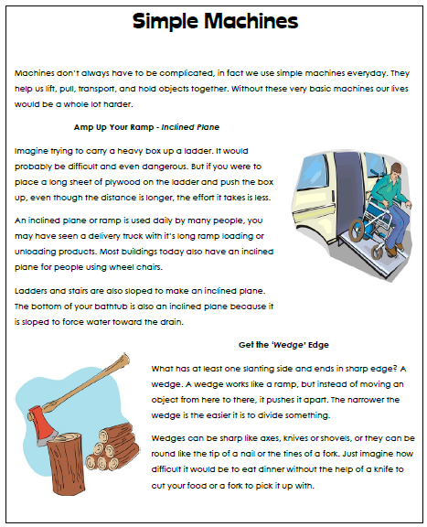
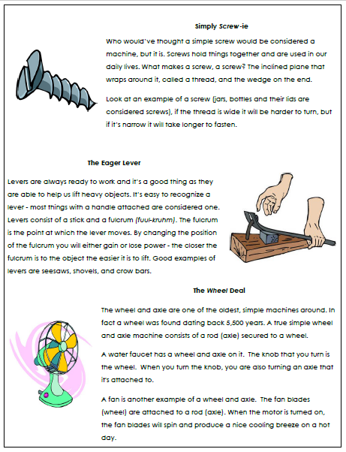
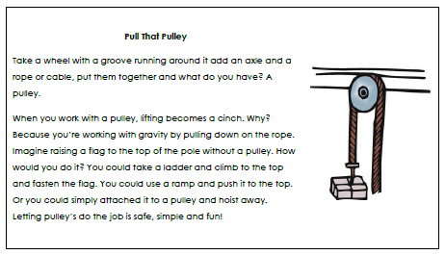
- What type of simple machine is found on a water bottle cap?

- How is a wedge similar to an inclined plane? How is it different?
Similar:
Different:
- On which type of simple machine would you find a fulcrum? Explain what a fulcrum is.
- Which is an example of a wheel and axle?

  - Shovel
  - Seesaw
  - Water faucet knob
  - Crow bar

- What type of simple machine is a slide?

- Which is NOT a type of simple machine?

  - Spring
  - Pulley
  - Screw
  - Wedge

- Which type of simple machine is found on the floor of a bathtub?

- Which of these is an example of a wedge?

  - Skateboard
  - Stairs
  - Broom
  - Butter knife

- Which is an example of someone using a simple machine to do work?
  - A boy runs across a football field
  - A banker counts money
  - A mother pushes a strolled up a ramp into a building
  - A girl eats a sandwich
- A student is using a screwdriver to pry open a paint can. The screwdriver is being used as

  - a pulley.
  - a screw.
  - an inclined plane.
  - a lever.

- Which type of simple machine would be found on the bottom of a wagon?

- An ax is used to chop wood. The metal part, called the head) chops through the wood, pushing it apart into two smaller sections. Which type of simple machine is found in the head of the ax?

- A wheel with a rope is used to hoist a flag up to the top of a tall flagpole. This simple machine can also be used to lift objects with less force. What type of simple machine is this?

- What type of simple machine is a shovel used for digging?

- How do simple machines make work easier?
Mechanical Advantage & Efficiency Practice
- A force of 30N is applied to a screwdriver to pry the lid off of a can of paint. The screwdriver applies a 75N force to the lid. What is the actual mechanical advantage of the screwdriver?

- A force of 75N is applied to a nutcracker to crack open a walnut. If the actual mechanical advantage of the nutcracker is 3.5, what is the force the nutcracker applies to the walnut?

- A lever is used to lift a heavy rock. The actual mechanical advantage of the lever is 4 and the lever applies a force of 800N to the rock. What is the force applied to the lever?

- To open a soda bottle, a force of 55N is applied to the bottle opener. If the bottle opener applies a force of 675N to the cap, what is the actual mechanical advantage of the bottle opener?

- What is the ideal mechanical advantage of a lever with an effort arm that is 8m long and a resistance arm that is 2m long?

- A 6m long ramp has an ideal mechanical advantage of 4. What is the height of the ramp? (Remember, the ramp length is the effort distance and its height is the resistance distance)

- A lever with a resistance arm that is 20cm long has an ideal mechanical advantage of 5. How long is the effort arm of the lever?

- What is the ideal mechanical advantage of an inclined plane that has a length of 40cm and a height of 5cm?

- A stage crew member uses a pulley to lift scenery for the school play. If he does 750J of work and the pulley system does 600J of work, what is the efficiency of the pulley system?

- To pull a nail out of a wood board a carpenter does 100J of work. The hammer he uses does 95J of work. What is the efficiency of the hammer?

- A ramp is used to load furniture onto a moving truck. The person does 1240J of work pushing the furniture up the ramp, and the ramp does 822J of work. Calculate the efficiency of the ramp.

- A lever does 765J of work and the person using the lever applies 890J of work. What is the efficiency of the lever?

- A machine is 75% efficient and the work put into it is 4800J. What is the work output?

- Why can the work output be LESS than the work input, but NEVER be more?

- The raised end of a board is 1.0 meter above the ground. A 300N crate is pushed up the board for a distance of 5.0 meters with an 80N force.
  - Draw a picture of this problem. Label the effort force, effort distance, resistance force, and resistance distance.

  - What is the ideal mechanical advantage?

  - What is the actual mechanical advantage?

  - What is the work input?

  - What is the work output?

  - What is the efficiency of the machine?

  - Why is the efficiency not 100%? (Where did the energy go?)

- A person using a machine applies a force of 100N over a distance of 10m to raise a 500N object 1.5m.
  - What is the ideal mechanical advantage?

  - What is the actual mechanical advantage?

  - What is the work input?

  - What is the work output?

  - What is the efficiency of the machine?

Unit 6 Study Guide
- If the force is kept constant, and the distance is increased, what will happen to the amount of work done?

- If the distance is held constant, and the amount of force is increased, what will happen to the amount of work done?

- A 5000N force is used to move a boulder 8m. How much work was done? Show your work.

- The engine of a car produces 3000N of force. If 60,000J of work were done by the engine, how far did the car go? Show your work.

- A student applies a force to do 30J of work pushing a desk 2m. How much force did they use? Show your work.

- A motor does 30,000J of work to lifting an elevator 4m in 20s.
  - How much force did the motor use? Show your work.

  - How much power does the motor in #6 use to lift the elevator? Show your work.

- How much work must be done to keep a 60W light bulb running for 1hr? Show your work.

- How long will it take a 20W motor to do 400J of work?

- A crane lifts a 200kg steel beam 20m into the air in 60s.
  - What is the weight of the beam? Show your work.

  - How much work is done by the crane? Show your work.

  - How much power does the crane require? Show your work.

- Explain two ways in which you can increase the amount of power generated. (Hint: look at the pieces of the formula)

- Renatta Gass is out with her friends. Misfortune occurs and Renatta and her friends find themselves getting a workout. They apply a cumulative force of 1080 N to push the car 218 m to the nearest fuel station. Determine the work done on the car. Show your work.

- Lamar Gant, U.S. powerlifting star, became the first man to deadlift five times his own body weight in 1985. Deadlifting involves raising a loaded barbell from the floor to a position above the head with outstretched arms. Determine the work done by Lamar in deadlifting 300 kg to a height of 0.90 m above the ground. Show your work.

- During the Powerhouse lab, Jerome runs up the stairs, elevating his 102 kg body a vertical distance of 2.29 meters in a time of 1.32 seconds at a constant speed.
  - Determine the work done by Jerome in climbing the stair case. Show your work.

  - Determine the power generated by Jerome. Show your work.

- A new conveyor system at the local packaging plan will utilize a motor-powered mechanical arm to exert an average force of 890 N to push large crates a distance of 12 meters in 22 seconds. Determine the power output required of such a motor. Show your work.

- The Taipei 101 in Taiwan is a 508 meter tall, 101-story skyscraper. The skyscraper is the home of the world’s fastest elevator. The elevators transport visitors from the ground floor to the Observation Deck on the 89th floor at speeds up to 16.8 m/s. Determine the power delivered by the motor to lift the 10 passengers at this speed. The combined mass of the passengers and cabin is 1250 kg. Show your work.

- From which two simple machines are all other simple machines created?

- A 600.0N barrel needs to be put in the back of a truck that is 0.6m above the ground. The person moving the barrel uses a 3.0m long board to roll the barrel into the truck using 141.2N of force.

  - What is the effort force? ________

  - What is the effort distance? ________
  - What is the work input? Show your work.

  - What is the resistance force? ________

  - What is the resistance distance? ________
  - What is the work output? Show your work.

  - What type of simple machine is the board? ____________________
  - What is the IMA of the machine? Show your work.

  - What is the AMA of the machine? Show your work.

  - What is the efficiency of the machine? Show your work.

