Position, Distance, and Displacement Worksheet
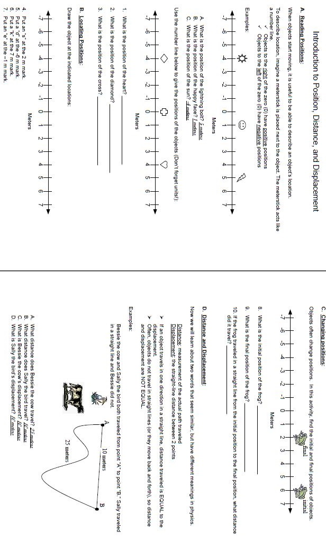
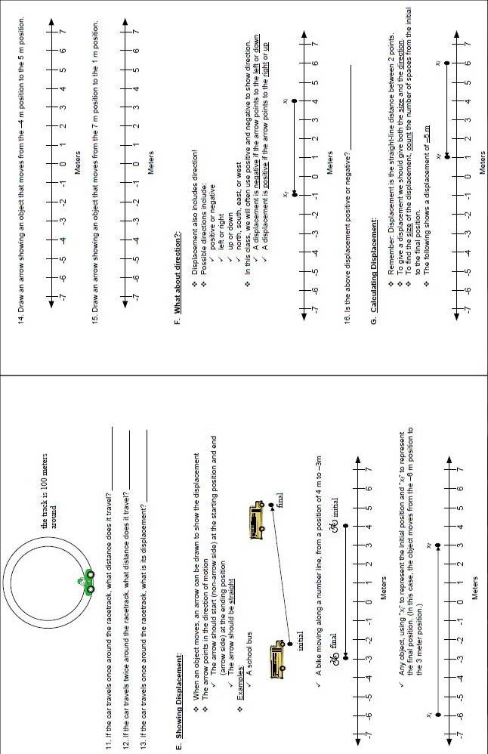
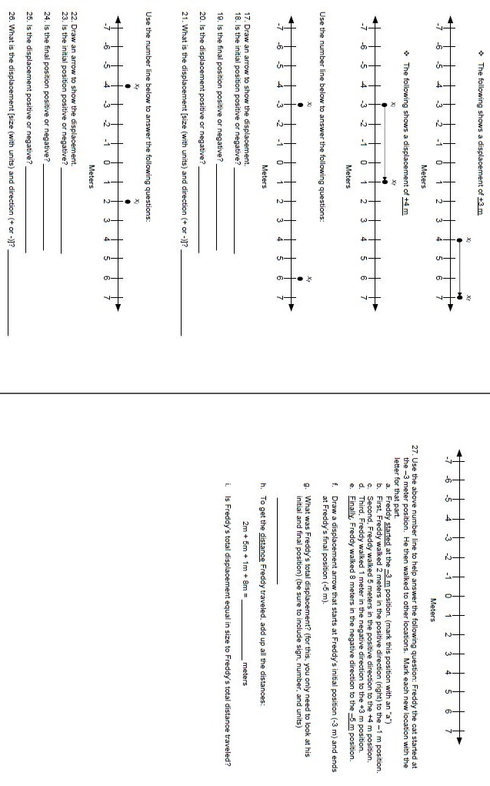
Buggy Lab
Purpose
- To graphically determine where two battery buggies will meet based on their speeds.
Materials

- Green Buggy
- Yellow Buggy
- 2 Meter Sticks
- Stopwatch

Word of Note
- To determine speed, we should actually be controlling the time instead of the position, but we are choosing to control position instead of time because it is easier.
- You will only be allowed access to one of your battery buggies at a time until you are ready to test your meeting point.
Procedure
- Place the two meter stick end to end with the meters side up.
- Place the front of the green battery buggy at the zero mark.
- Start the green battery buggy and the stopwatch at the same time.
- When the front of the green battery buggy gets to the 0.5m mark, stop the stopwatch. Record the time in the data table below. Repeat for two additional trials.
- Repeat steps 2-4 for the remaining positions.
- Take your green buggy to the teacher to exchange for the yellow one.
- Start the yellow buggy at the 2.00m end.
- Place the front of the yellow battery buggy at the 2.00m mark.
- Start the yellow battery buggy and the stopwatch at the same time.
- When the front of the yellow battery buggy gets to the 1.5m mark, stop the stopwatch. Record the time in the data table below. Repeat for two additional trials.
- Repeat steps 2-4 for the remaining positions.
- Average your trial times.
- Create one graph with the data from both buggies. You will need to include a key to show which buggy is represented by which points. Remember to place time on the x-axis and position on the y-axis. When plotting the points remember to only use the average time, not each trial.
Data
Green Buggy  Position (m) | Trial 1 Time (s) | Trial 2 Time (s) | Trial 3 Time (s) | Ave. Time (s)
0.00 | 0.0 | 0.0 | 0.0 | 0.0
0.50
1.00
1.50
2.00
Yellow Buggy  Position (m) | Trial 1 Time (s) | Trial 2 Time (s) | Trial 3 Time (s) | Ave. Time (s)
2.00 | 0.0 | 0.0 | 0.0 | 0.0
1.50
1.00
0.50
0.00

Post-Lab Questions
- If your lines are straight, find the slope of the line using the simple slope formula (). If your lines are not straight, add a line of best fit for each buggy, then calculate the slope of the line using the formula above. Remember to show ALL of your work.
Green Buggy Yellow Buggy

- Find the point on the graph where the two line cross. This is the point where your buggies should meet. What point will is this? When you feel confident of your answer, ask your teacher for your original buggy back to test your hypothesis.

I think the two buggies will meet at position = ________ m and at time = ________ s.

What your hypothesis correct? Why do you think that is?

- How would your graph have looked different if both buggies had been going in the same directions? (Hint: What part of your graph shows the direction the buggy is traveling?)

Buggy Lab Graph

Position-Time Graphs Practice
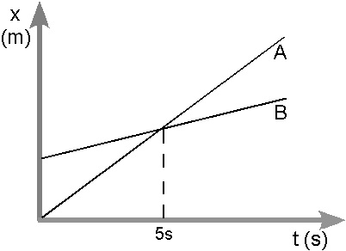
- Consider the position vs. time graph on the right for cyclists A and B.
  - Do the cyclists start at the same point? How do you know? If not, which is ahead?

  - At t= 7s, which cyclist is ahead? How do you know?

  - Which cyclist is travelling faster at t = 3s? How do you know?

  - Are their velocities equal at any time? How do you know?

  - What is happening at the intersection of lines A and B?
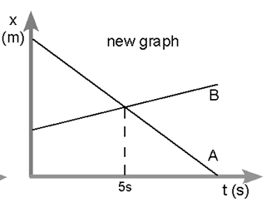
- Consider the new position vs. time graph on the right for cyclists A and B.
  - How does the motion of the cyclist A in the new graph compare to that of A in the previous graph from page one?

  - How does the motion of cyclist B in the new graph compare to that of B in the previous graph?

  - Which cyclist has the greater speed? How do you know?

  - Describe what is happening at the intersection of lines A and B.

  - Which cyclist traveled a greater distance during the first 5 seconds? How do you know?
Velocity Practice
- Jose drives to work with an average speed of 40km/h, how far away does he work if it takes him 30 minutes to get to work? [HINT: watch your time units!]
They Gave | They Want | Formula/Triangle | Work | Answer

- Shaniqua walks 1400m to school in 15 minutes. What is Shaniqua’s speed in meters per second? [HINT: watch your time units!]
They Gave | They Want | Formula/Triangle | Work | Answer

- Yuzu is riding her bike to her friend’s house. If she maintains an average speed of 6m/s, how long will it take her to travel the 12km?
They Gave | They Want | Formula/Triangle | Work | Answer

- A 250g bird is flying south at a rate of 1.5m/s. If the bird flies for 30s, what will be the bird’s displacement?
They Gave | They Want | Formula/Triangle | Work | Answer

- A 0.5kg ball rolled 5.0m down the hall in 2.0s. What was the ball’s velocity?
They Gave | They Want | Formula/Triangle | Work | Answer

- An 1800kg car is driving north on Creedmoor Rd at 20 m/s. How long will it take the driver of the car to drive the 3700 m from Lynn Rd to Strickland Rd, assuming they are able to maintain their velocity and not hit any red lights.
They Gave | They Want | Formula/Triangle | Work | Answer

Matchbox Car Lab
Purpose
- To determine the acceleration of a matchbox car.
Materials

- Matchbox Car
- 4 Textbooks
- 2 Meter Sticks
- Stopwatch

Word of Note
- To determine acceleration, we should actually be controlling the time instead of the position, but we are choosing to control position instead of time because it is easier.
Procedure
- Stack three of the textbooks.
- Place the two meter sticks side by side and tape them together. Lean the meter sticks against the stack of textbooks with the zero at the high end. Place the other textbook at the end of your meter sticks to act as a stop.
- Place the back of the matchbox car at the zero mark.
- Release the car and start the stopwatch at the same time.
- Stop the stopwatch when the back of the car gets to the 0.20m mark. Record the time in the data table. Repeat for two more trials.
- Repeat steps 3-5 for the remaining positions.
- Create a graph of the data. Remember to put time on the x-axis and position on the y-axis. When plotting the points remember to only use the average time, not each trial.
Data
Position (m) | Trial 1 Time (s) | Trial 2 Time (s) | Trial 3 Time (s) | Ave. Time (s)
0.00 | 0.0 | 0.0 | 0.0 | 0.0
0.20
0.30
0.40
0.50
0.60
0.70
0.80

Post-Lab Questions
- Add a line of best fit. (Hint: A line of best fit does not have to be straight; it just needs to be smooth). Is it possible to calculate the slope of this line? Why or why not?

- Calculate the speed for each segment. Remember to show your work

  - 0.00m to 0.20m

  - 0.20m to 0.30m

  - 0.40m to 0.50m

  - 0.50m to 0.60m

  - 0.60m to 0.70m

  - 0.70m to 0.80m

- Create a new graph of velocity vs. time. Time will still go on the x-axis, but velocity (in m/s) will now do on the y-axis. If you line is straight, calculate the slope of the line using the simple slope formula (). If your lines are not straight, add a line of best fit and then calculate its slope to determine the acceleration of the matchbox car. Remember to show ALL of your work.

Matchbox Car Lab Position-Time Graph

Matchbox Car Lab Velocity-Time Graph

Acceleration Practice
- A toy car is rolled down a ramp. If the car started from rest and took 2s to achieve a speed of 0.5m/s, at what rate did the car accelerate?
They Gave | They Want | Formula/Triangle | Work | Answer

- An airplane goes from 0km/h to 750km/h in 5 minutes during launch. At what rate does the airplane accelerate?
They Gave | They Want | Formula/Triangle | Work | Answer

- Rodney is drive west on HWY 40 at 113km/h. As he approaches Durham, were the speed limit drops, he slows down to 97km/h over the course of 1 minute. At what rate did Rodney decelerate his car?
They Gave | They Want | Formula/Triangle | Work | Answer

- How long will it take a bird to increase its flying speed from 0.5m/s to 2m/s if it accelerates at a rate of 0.25m/s/s?
They Gave | They Want | Formula/Triangle | Work | Answer

- What is the final velocity of a dog that started out walking at a speed of 0.75m/s accelerated at a rate of 0.5m/s/s for 5s?
They Gave | They Want | Formula/Triangle | Work | Answer

- What is the initial velocity of a car that took 5s to come to a complete stop if it decelerated at a rate of -10m/s/s?
They Gave | They Want | Formula/Triangle | Work | Answer

Momentum Virtual Lab
Visit the website http://phet.colorado.edu/en/simulation/collision-lab & complete the following:
- Click on the advanced tab. In the green box on the right side of the screen, select the following settings: 1 dimension, velocity vectors ON, momentum vectors ON, reflecting borders ON, momenta diagram ON, elasticity 0%. Look at the red and green balls on the screen and the vectors that represent their motion.
  - Which ball has the greater velocity?

  - Which has the greater momentum?

- Explain why the green ball has more momentum but less velocity than the red ball (HINT: what is the definition of momentum?).

- Push “play” and let the balls collide. After they collide and you see the vectors change, click “pause”. Click “rewind” and watch the momenta box during the collision. Watch it more than once if needed by using “play”, “rewind”, and “pause”. Zoom in on the vectors in the momenta box with the control on the right of the box to make it easier to see if necessary.
  - What happens to the momentum of the red ball after the collision?

  - What about the green ball?

  - What about the total momentum of both the red and green ball?

- Change the mass of the red ball to match that of the green ball.
  - Which ball has greater momentum now?

  - How has the total momentum changed?

  - Predict what will happen to the motion of the balls after they collide.

- Watch the simulation, and then pause it once the vectors have changed.
  - What happens to the momentum of the red ball after the collision?

  - What about the green ball?

  - What about the total momentum of both the red and green ball?

- Now change the elasticity to 100%. Predict the motion of the balls after the collision.

- Watch the simulation, and then pause it once the vectors have changed.
  - What happens to the momentum of the red ball after the collision?

  - What about the green ball?

  - What about the total momentum of both the red and green ball?

Momentum Practice Problems
- How much momentum does a 5000kg elephant traveling at 2.0m/s have?
They Gave | They Want | Formula/Triangle | Work | Answer
- What is the mass of a car traveling at 26m/s with 24570kg·m/s of momentum?
They Gave | They Want | Formula/Triangle | Work | Answer
- What is the speed of a 28kg dog with 504kg·m/s of momentum?
They Gave | They Want | Formula/Triangle | Work | Answer
- A 3.7m 425kg dolphin with 3825kg·m/s of momentum is traveling at what speed?
They Gave | They Want | Formula/Triangle | Work | Answer
- An 8000kg school bus is traveling at 16m/s for 30 minutes. What is the momentum of the bus?
They Gave | They Want | Formula/Triangle | Work | Answer
- A marble is rolls 5m across the floor at 1.5m/s with 4.5kg·m/s of momentum. What is the mass of the marble?
They Gave | They Want | Formula/Triangle | Work | Answer

PS Unit 5 Study Guide
- Little Red Riding Hood lives 1000m west of her grandmother. Red sets off for her grandmother’s house. After 10.0 minutes, Red has travelled 500m when she realizes that she forgot her basket of goodies for her grandmother, so she returns home at the same speed. It takes Red only 2.0 minutes to grab her basket before heading back out. Realizing she is running late, Red increases her speed and it takes her only 10.0 minutes to get to her grandmother’s house.
  - What distance did Little Red Riding Hood travel? Show your work.

  - What was her displacement? Show your work.

  - Create a position-time graph to represent Red’s journey.
X-axis = Time (min), count by 2’s
Y-axis = Position (m), count by 250’s

  - Calculate Red’s velocity for each segment of her journey. Round to the nearest whole number if necessary
Home to 500m | 500m to Home | Getting the Basket | Home to Grandma
  - Create a velocity-time graph to represent Red’s journey.
X-axis = Time (min), count by 2’s
Y-axis = Velocity (m/min), place 0 in the middle so that you have + & -, count by 25’s

- What is the velocity of a bullet that travels 1600m in 4.0s?
They Gave | They Want | Formula | Work | Answer
- An ant is walking at 0.05m/s. How long will it take the ant to travel 2.5m?
They Gave | They Want | Formula | Work | Answer

- How far can a Manuel go in 10 minutes if he is walking 1.4m/s?
They Gave | They Want | Formula | Work | Answer

- Lightening McQueen is driving up HWY-50 at 26m/s when the light at Mount Vernon Church Rd. turns red. Since McQueen is law abiding, he slows down and comes to a stop after 3.0s. What is McQueen’s deceleration?
They Gave | They Want | Formula | Work | Answer

- Khalil is participating in the 400m dash at a track meet. When the starting gun fairs, how long will it take Khalil to reach his running speed of 3.5m/s if he accelerates at a rate of 2.0m/s/s?
They Gave | They Want | Formula | Work | Answer

- Alyssa is riding her skateboard on a flat stretch of her neighborhood road at 3.0m/s. As Alyssa approaches an intersection, she slows down to check if it is safe to cross, but she does not stop because she sees that it will be safe. If Alyssa decelerated at a rate of 0.5m/s/s for 1.5s, what was her final velocity?
They Gave | They Want | Formula | Work | Answer

- Geoffrey is running to try to catch up to his friends. As Geoffrey approaches his friends, he slows down to match their speed of 1.45m/s. If Geoffrey decelerated at a rate of -0.5m/s/s for 1.5s, what was his initial velocity?
They Gave | They Want | Formula | Work | Answer

- What is the momentum of a 2200kg truck traveling at 30m/s?
They Gave | They Want | Formula | Work | Answer

- What is the mass of a ball with 500kg·m/s of momentum traveling at 4.0m/s.
They Gave | They Want | Formula | Work | Answer

- What is the velocity of a 60kg bicyclist traveling east with 900kg·m/s of momentum?
They Gave | They Want | Formula | Work | Answer

- State the Law of Conservation of Momentum.

