UNIT 8: Energy & Waves CLASSWORK PACKET

Types of Energy
Each pair/trio will be assigned one type of energy to research and create a mini poster with the following pieces of information: A one sentence definition that a 5th grade student could understand, two examples, and at least one picture. We will then do a poster walk to fill out the chart below.

Type of Energy | Basic Definition | 2 Examples | 1 Picture
Thermal
Gravitational Potential
Elastic Potential
Kinetic
Mechanical
Chemical
Electrical
Electromagnetic
Nuclear
Energy Conversions Lab
Carefully follow the directions.
Safety Concerns: Flying objects – you MUST wear your safety glasses or goggles until EVERYONE is finished with the lab!
- Rub your hands together 10 seconds and touch them to your cheeks.
  - What did you observe?

  - What form of energy did you start with? _________________________
  - What form of energy did you end with? _________________________
- Wind up the toy and left it walk across the table.
  - What did you observe?

  - What form of energy did you start with? __________________________
  - What form of energy did you end with? __________________________
- Spin the top and let it go until it falls.
  - What did you observe?

  - What form of energy did you start with? _________________________
  - What form of energy did you end with? _________________________
- Open the film canister and drop in the alka seltzer tablet. Tightly close the top.
  - What did you observe?

  - What form of energy did you start with? _________________________
  - What form of energy did you end with? _________________________
  - Clean up any mess.
- Invert the popper and place it on the desk.
  - What did you observe?

  - What form of energy did you start with? _________________________
  - What form of energy did you end with? _________________________
- Pull back the race car and let it roll across the table.
  - What did you observe?

  - What form of energy did you start with? _________________________
  - What form of energy did you end with? _________________________
- Gently hang the mass from the spring and pull the mass down.
  - What did you observe?

  - What form of energy did you start with? _________________________
  - What form of energy did you end with? _________________________
- Drop the bouncy ball onto the floor from table height.
  - What did you observe?

  - What form of energy did you start with? _________________________
  - What form of energy did you end with? _________________________

Thermal Energy Practice
For each scenario, identify the hot object and the cold object. Then create an energy diagram showing the flow of energy.
- Ice is placed in a glass of lemonade.

- A child is holding a mug of hot cocoa.

- A spoon is placed in a bowl of soup.

- A student grabs a metal handrail on a cold February morning.

- A chef bumps his arm on rack while pulling a tray from the oven.

For each pair of substances, circle the substance with more thermal energy and explain why.
- 500 g of water at 35°C vs. 500 g of water at 85°C

- 500 g of water at 35°C vs. 250 g of water at 35°C

For each pair of substances, circle the substance that will take more energy to heat from 20°C to 100°C and explain why.
- 30 g of water vs. 300 g of water

- 500 g of aluminum vs. 500 g of plastic

- Explain why a can of soda from the refrigerator feels cold in your hand.

Determine which method(s) of energy transfer are described in each scenario.
- The earth is heated by energy from the sun.

- Cookies bake in the oven.

- Water boils on the stove to make pasta.

- A fire is lit in the fireplace to warm the house on a cold January day.

- A thermometer is placed under a child’s tongue to take her temperature.

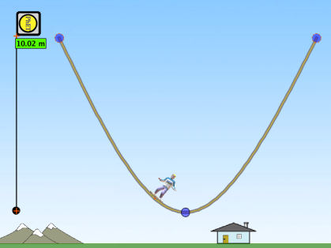
Energy Skate Park
http://phet.colorado.edu/en/simulation/energy-skate-park
Create a ramp like the one shown that is 10 meters tall. Make sure the ramp does not touch the ground.

Drop the skater from the top of the ramp so that he reaches the top of the ramp on the other side and comes back again.

Open the ‘Energy vs. Position’ graph and wait until a full set of data has been collected. Use this graph to fill in the information in the table below.

 | PhET Skater | Star Skater | Bulldog | Bug
Maximum potential energy
Minimum potential energy
Maximum kinetic energy

1. Which of the skaters had the most energy?

2. Why did this skater have the most energy?

3. Why does the total energy line remain flat?
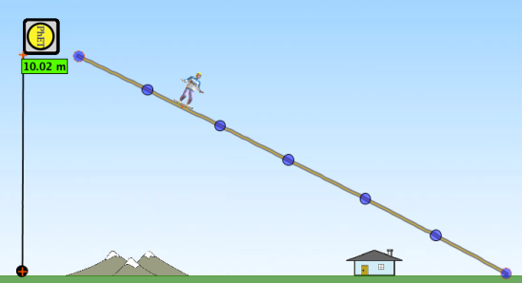

Set up your ramp so that it looks like the one shown.

Drop the skater from each of the dots on the ramp, starting from the top, and complete the table below.

Dot | 1 | 2 | 3 | 4 | 5 | 6
Max. potential energy
Max. kinetic energy

4. What was the effect on the skater’s maximum potential energy when he was placed further down the ramp?
5. Explain why this happened.

6. What was the effect on the skater’s maximum kinetic energy when he was placed further down the ramp?

7. Explain why this happened. (Note: it is not because of the height)
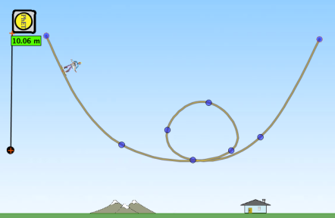

Set up your ramp so that it looks like the one shown.

In the table below record the maximum potential energy for each of the skaters at the top of the loop. Repeat this on the Moon, and on Jupiter. You will need to place the skater at the top of the ramp each time you change location.

 | PhET Skater | Star Skater | Bulldog | Bug
Earth
Moon
Jupiter

8. Explain why the maximum potential energy of the skaters was different at each location.

9. What are the values of gravity on Earth, on the Moon and on Jupiter?

10. a) Increase the friction on the track and explain what effect this has on the total energy of the skater.

b) What type of energy is the friction causing the other energy to transform into?

Kinetic & Potential Energy Practice
- What is the kinetic energy of an 1800kg car traveling at 26m/s?
They Gave | They Want | Formula | Calculation | Answer

- What is the mass of a rabbit with 12J of kinetic energy traveling at 6m/s?
They Gave | They Want | Formula | Calculation | Answer

- How fast is a 23kg tortoise with 6J of kinetic energy traveling?
They Gave | They Want | Formula | Calculation | Answer

- What is the gravitational potential energy of a 20kg box that is 2m above the floor?
They Gave | They Want | Formula | Calculation | Answer

- How high do you need to lift a 6kg box to gain 120J of gravitational potential energy?
They Gave | They Want | Formula | Calculation | Answer

- What is the mass of a ball that is 1.5m above the floor with 30J of gravitational potential energy?
They Gave | They Want | Formula | Calculation | Answer

- A 70kg probe is sent to Jupiter’s moon Io. When the probe is 200m above the surface it has 24766J of gravitational potential energy. What is the acceleration due to gravity on Io?
They Gave | They Want | Formula | Calculation | Answer

- What is the velocity of a 0.75kg bird that is flying 5.0m above the ground?
They Gave | They Want | Formula | Calculation | Answer

Waves
1. The highest point on a wave is the __________, while the lowest point is the __________.

2. The __________ of a wave is a measure of the amount of energy it carries.

3. The distance from one crest to the next crest is the __________.

4. The __________ is a measure of the number of waves that pass a point in a given amount of time.

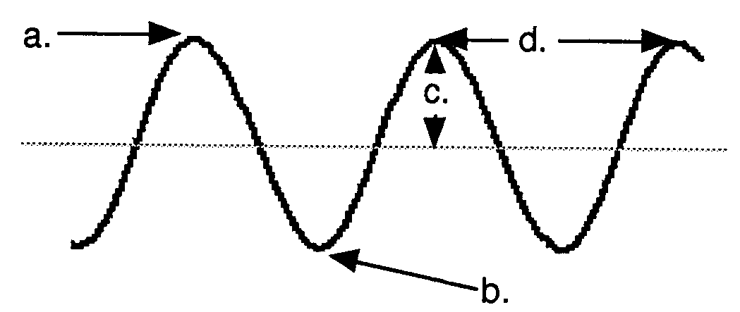
5. The illustration to the right shows a wave. Label each part in the space below:

a. ____________________

b. ____________________

c. ____________________

d. ____________________

6. Use the five illustrations of waves drawn below to answer the following questions:

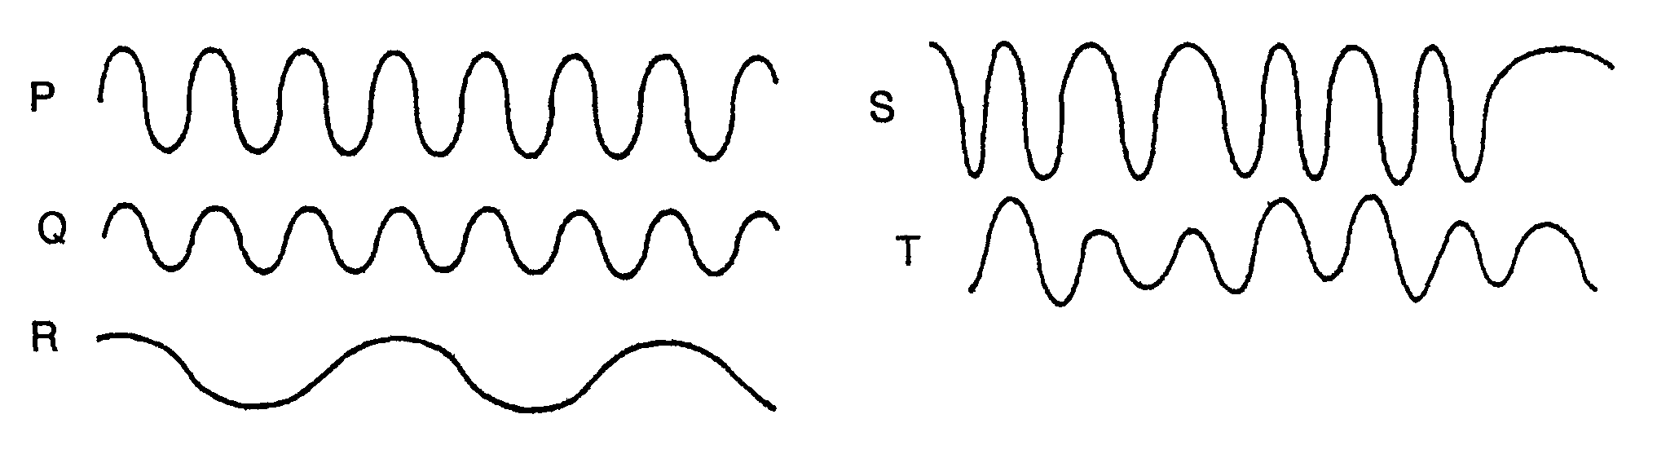

- Waves P and Q have the same __________, but wave P has twice the __________ of wave Q.

- Waves Q and R have the same __________, but wave R has twice the __________ of wave Q.

- Wave __________ shows a steady frequency but changing amplitude.

- Wave __________ shows steady amplitude but a changing frequency.

- Waves __________ and __________ have a low amplitude and a steady frequency.

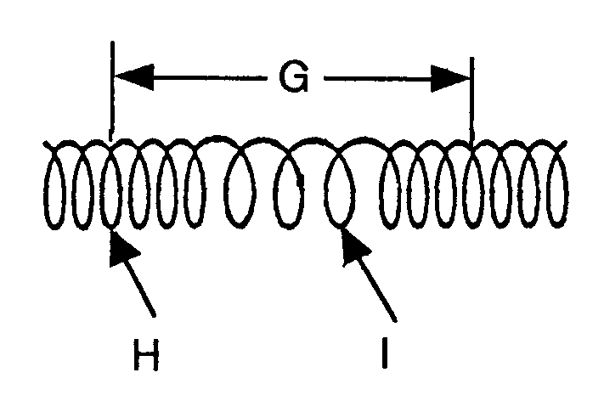
7. The following questions refer to the diagram to the right:

- Is this wave transverse or longitudinal?

- Letter H represents a _______________ and
letter I represents a _______________.

- Letter G represents a ______________.

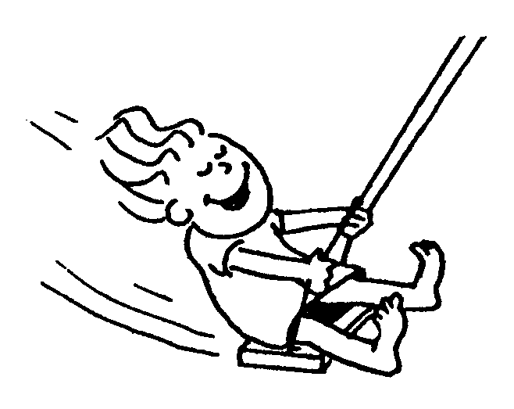
8. A kid on a playground swing makes 6 complete to-and-fro swings each 30 seconds.

- The frequency of the swinging is __________.

- The period of the swinging is __________.

9. Complete the statements in the diagrams below:

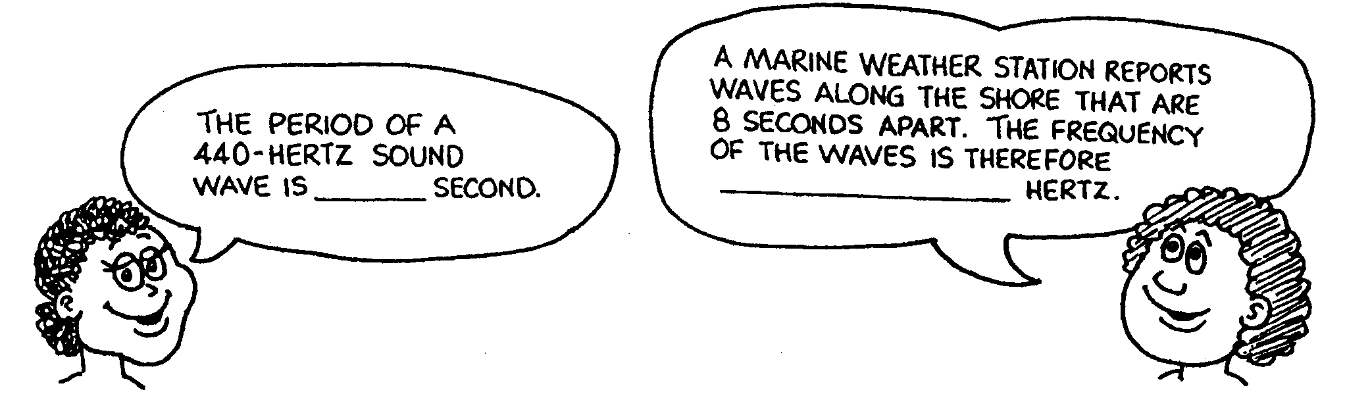

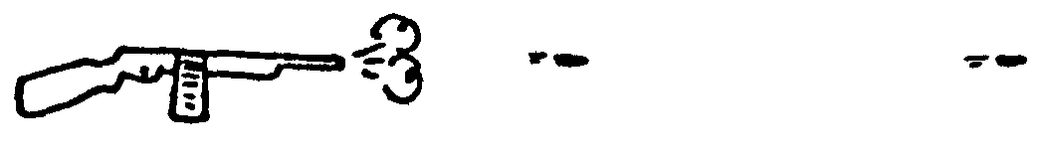
10. A machine gun fires 10 rounds per second.
The speed of the bullets is 300 m/s.

What is the distance in the air between the flying bullets? __________
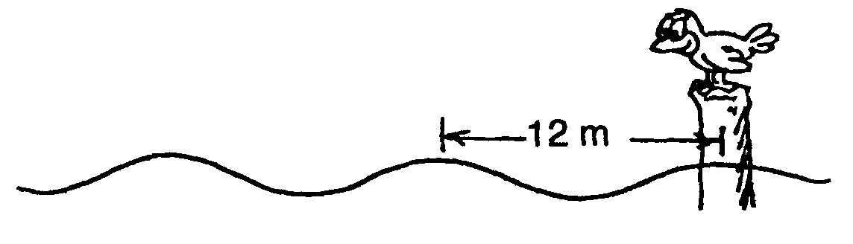
11. The bird below watches the wave crests.
- If four crests pass the pole each second, what is the speed of the wave? __________

- What is its period? __________

12. In what type of wave is the vibration perpendicular to the direction of travel of the wave? ____________________

13. What type of wave vibrates parallel to the direction of travel? ____________________

14. What type of wave contains compressions and rarefactions? ____________________

15. What type of wave is produced when you move one end of a horizontal spring up and down?
____________________

16. What type of wave has a wavelength? ____________________

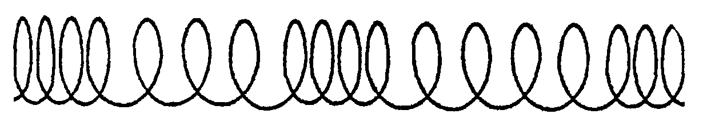
17. Obtain a ruler and determine the wavelength of the wave to the right.

Wavelength = __________
- A wave along a guitar string has a frequency of 540 Hz and a wavelength of 2.5 meters. Calculate the speed of the wave.
Variables | Formula/Triangle | Work | Final Answer

- The speed of sound in air is about 340 m/s. What is the wavelength of sound waves produced by a guitar string vibrating at 490 Hz?
Variables | Formula/Triangle | Work | Final Answer

- The speed of light is 300,000,000 m/s. What is the frequency of microwaves with a wavelength of 0.01 meter?
Variables | Formula/Triangle | Work | Final Answer

- What is the period of the microwaves in the above question?
Variables | Formula/Triangle | Work | Final Answer

- The string on a piano that produces an A sharp vibrates with a frequency of 235 Hz. If the sound waves produced by this string have a wavelength in air of 1.49 meters, what is the speed of sound in air?
Variables | Formula/Triangle | Work | Final Answer

- The average wavelength in a series of ocean waves is 15.0 meters. A wave crest arrives at the shore on an average of every 10.0 seconds, so the frequency is 0.100 Hz. What is the average speed of the waves?
Variables | Formula/Triangle | Work | Final Answer

- An FM radio station broadcasts electromagnetic waves at a frequency of 94.5 MHz (equal to 94,500,000 Hz). These radio waves have a wavelength of 3.17 meters. What is the speed of the waves?
Variables | Formula/Triangle | Work | Final Answer

- Green light has a wavelength of 0.00000052 meters. The speed of light is 300,000,000 m/s. Calculate the frequency of green light waves with this wavelength.
Variables | Formula/Triangle | Work | Final Answer

- Calculate the period of the green light waves in the question above.
Variables | Formula/Triangle | Work | Final Answer

- What is the wavelength of a sound wave with a frequency of 220 Hz if its speed is 340 m/s?
Variables | Formula/Triangle | Work | Final Answer

- What is the period of the sound wave above?
Variables | Formula/Triangle | Work | Final Answer

- Ocean waves are hitting a beach at a rate of 3.5 Hz.
  - What is the period of the waves?
  - Calculate the speed of the waves if the distance between wave crests is 1.3 meters.
Variables | Formula/Triangle | Work | Final Answer

- The note A above middle C on a piano emits a sound wave with a wavelength of 0.77 meters.
  - What is the frequency of the wave? Use 340 m/s as the speed of the sound wave.
  - What is the period of the sound wave?
Variables | Formula/Triangle | Work | Final Answer

Study Guide
- How are work and energy related?

- How much kinetic energy does a 35.0kg dog have if it is running at 17.5m/s? Show your work.

- The world’s fastest train can travel at 100m/s. If it has 75000000J of kinetic energy when traveling at this speed, what is its mass? Show your work.

- At what speed would a 1.5kg rabbit be traveling if it has 60.8J of kinetic energy? Show your work.

- How much gravitational potential energy does an 8.5kg box have when sitting on a shelf that is 1.5m high? Show your work.

- What is the mass of a doll with 144J of gravitational potential energy that is sitting on a bed 0.75m above the ground? Show your work.

- A 2.2kg ball is thrown into the air. Just before it begins to fall back down, it has 44J of gravitational potential energy. What is the height of the ball just before it begins to fall back down? Show your work.

- A 135.0kg probe is sent to Jupiter’s moon Europa. When the probe is 50.0m above the surface it has 8876.3J of gravitational potential energy. What is the acceleration due to gravity on Europa? Show your work.

- A 2.5g penny is dropped from the top of a 10m tall building. How much kinetic energy will it have the instant before it strikes the ground? Show your work.

- Where is the kinetic energy of a roller coaster the greatest?

- A 350kg roller coaster cart is traveling a 13m/s at its fastest point. What is the height of the cart at this point? Show your work.

- How does ice cool a warm drink? You may use a picture to explain your answer, but the final answer must be in words.

- Which method of energy transfer does not require a medium?

- Which method of energy transfer is most effective in solids?

- Which method of energy transfer only applies to fluids?

- What is the velocity of a wave with a frequency of 20Hz and a wavelength of 0.25m?

- What is the frequency of a wave that has a wavelength of 2.5m and travels a 375m/s?

- What is the wavelength of a wave with a frequency of 97Hz traveling at 400m/s?

- How are the period and frequency of a wave related?

- Which type of electromagnetic wave has the highest amount of energy?

- What do the prefixes “infra” and “ultra” mean?

- In which medium (solid, liquid, gas, or a vacuum) do sound waves travel the fastest?

- In which medium, solid, liquid, gas, or a vacuum) do light waves travel the fastest?

- Two waves collide, and the amplitude is temporarily greater. What term describes this?

- Draw and label a transverse wave.

- Draw and label a longitudinal wave.

- Why does a leaf look green?

- Why do waves refract?

