PS Unit 9: Electricity and Magnetism

Unit Goals
By the end of this unit, you should be able to
- Compare and contrast direct and alternating currents.
- Construct simple series and parallel circuits.
- Calculate the current, potential difference (voltage), resistance, and power of a series circuit.
- Diagram a magnetic field.
- Define magnetic domain.

Unit Vocabulary

Electricity

- Direct Current
- Alternating Current
- Series Circuit
- Parallel Circuit
- Current
- Voltage
- Resistance
- Electrical Power
- Transformer

Magnetism

- Permanent Magnet
- Temporary Magnet
- Magnetic Field
- Magnetic Domain

Unit Formulas
Formula | Rearranged Formula  or Triangle | Variables | Units
 |  | V:  I:  R: | V:  I:  R:
 |  | P:  I:  V: | P:  I:  V:

Unit Assignments

- U9 Packet due ______

StudyJams: Electricity

- ______
- ______
- ______
- ______
- ______
- ______
- ______

Electricity Practice

____ 1. Most of the circuits in your home are
a. | series circuits. | c. | reversible circuits.
b. | parallel circuits. | d. | closed circuits.

____ 2. How many volts are required to light a light bulb with a resistance of 15 Ω by an 8 A current?
a. | 120 V | b. | 1.9 V | c. | 0.53 V

____ 3. What voltage is required to keep a 60 W light bulb lit with 0.5 A of current?
a. | 30 V | b. | 120 V | c. | 0.008 V

____ 4. If a neutral metal comb is held near an object with a negative charge, the comb will become charged by
a. | induction. | c. | friction.
b. | contact. | d. | static discharge.

____ 5. An electrical insulator has
a. | electrons that freely move. | c. | negatively charged ions.
b. | more protons than electrons. | d. | electrons tightly bound to its atoms.

____ 6. Which of the following would reduce the resistance of a metal wire?
a. | increasing its thickness | c. | increasing its length
b. | increasing its temperature | d. | all of the above

____ 7. Which of the following materials allows charges to flow easily?
a. | glass | c. | an electrical conductor
b. | wood | d. | an electrical insulator

____ 8. The type of current in your school is mostly
a. | direct current. | c. | series current.
b. | alternating current. | d. | produced by batteries.

____ 9. How many paths through which charge can flow would be shown in a circuit diagram of a series circuit?
a. | one | c. | none
b. | two or more | d. | more information is needed

____ 10. How much power is contained in a circuit with 20 Ohms of resistance and 10 amps of current?
a. | 2000 Watts | b. | 20 Watts | c. | 0.05 Watts

____ 11. What is the current in a circuit containing a 12 V battery and two 30 Ω resistors?
a. | 720 A | b. | 0.2 A | c. | 5 A

____ 12. What type of current is produced by a battery?
a. | parallel current | c. | direct current
b. | alternating current | d. | potential current

____ 13. What is the current in a circuit containing four 1.5 V batteries and a 24 W light bulb?
a. | 144 A | b. | 0.25 A | c. | 4 A

____ 14. What is the resistance in a circuit containing two 1.5 V batteries with a current of 30 A?
a. | 90 Ω | b. | 0.1 Ω | c. | 10 Ω

____ 15. The current in a hair dryer measures 15.0 amps. The resistance of the hair dryer is 8 ohms. What is the voltage?
a. | 120 V | c. | 7 V
b. | 0.5 V | d. | 1800 V

____ 16. Walking across a carpet is an example of charge being transferred by
a. | contact. | c. | static electricity.
b. | induction. | d. | friction.

____ 17. What is the power contained in a circuit with a current 50 A and 200 V of potential difference?
a. | 10000 W | b. | 0.25 W | c. | 4.0 W

____ 18. What is the potential difference in a circuit with 10 A of current and 20 W of power?
a. | 200 V | b. | 0.5 V | c. | 2.0 V

____ 19. What is the current in a ciruit with a 12 W light bulb connected to four 1.5 V batteries?
a. | 72 A | b. | 2 A | c. | 0.5 A

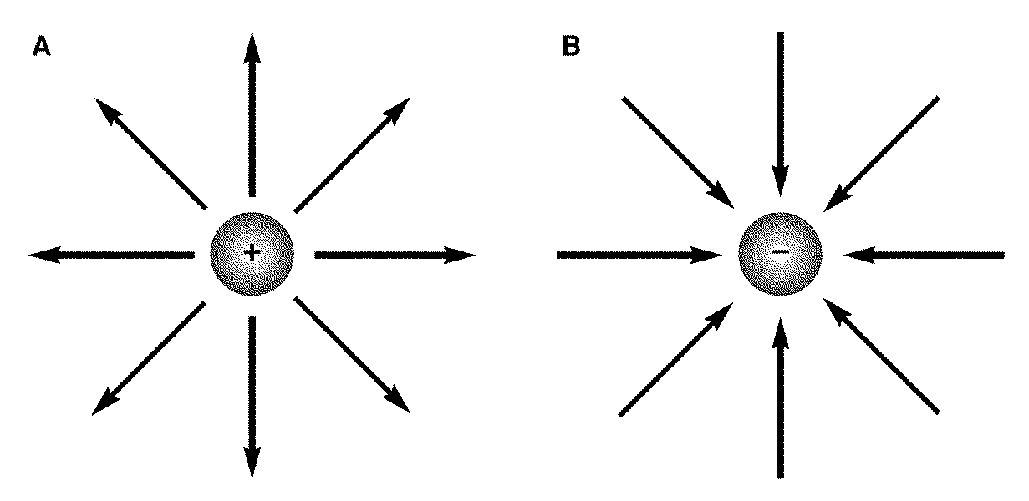

Figure 20-1

____ 20. If the two charges represented in Figure 20-1 were brought near each other, they would
a. | attract each other. | c. | cause static discharge.
b. | repel each other. | d. | have no effect on each other.

____ 21. Resistance is affected by a material’s
a. | thickness. | c. | temperature.
b. | length. | d. | all of the above

____ 22. What do transistors do in a mobile phone?
a. | store electric charge | c. | store data
b. | maintain proper voltage | d. | amplify the phone’s incoming signal

Bill Nye the Science Guy – Magnetism
Answer the following questions using the information in Bill Nye’s Magnetism video. Use complete sentences when appropriate.
1. What are the only three elements that can be picked up using a magnet?

2. What were the steps for making an electromagnet using a nail?

3. What is special about the direction of the movement of electrons in a magnet?

4. What happens when you break a magnet in half?

5. What are five common, everyday, items that use magnets to work?

6. How does the earth’s core produce magnetism?

7. What happens to a compass when it is exposed to a magnet?

8. How are the northern lights and magnets related?

