Distance Learning Photo 1
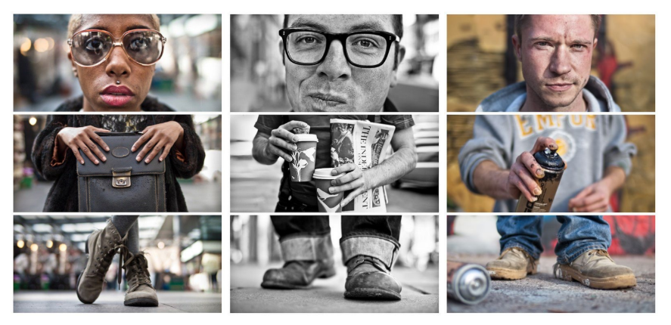
Triptych Portrait of a Person- Like Adde Adesokan
To see more examples of Adesokan's work, CLICK HERE
Goal: We are going to continue to photograph during this time to practice your skills with the resources available to you. (camera or phone) Use imagination to plan and capture creative images.
Product Goal: Develop creative portraits
Monday | Research PhotographerAdde Adesoan  Adde Adesokan Article 1 Adde Adesokan Article 2
Tuesday | Take pictures, edit and make 3 triptychs
Wednesday/Thursday  Block | Take pictures, edit and make 6 triptychs
Friday | Complete weekly Photo journal. Catch up on anything that is missing.
Instructions:
Monday- Research Adde Adesokan. There is not a ton of information about him. But there is enough to fill a page if you use facts, a photo of him, and 3 examples of his work (only 1 triptych. Hand write (300 words or more) the information about him and photograph it. Do not copy and paste in a word doc. You can upload the images you use though in case you don’t have printer.
Tuesday- You can use your camera or your photo. You will create 3 triptychs today and turn in. When taking the photos, here’s what you need to keep in mind- the head (take close up) the body (include something personal or that tells a story) the feet (get down low and close to the floor) You decide on the editing or collage software/APP. You can use photoshop, photojet or APPS like photoshop or pic collage, its free. You decide color or black and white. Post these in the google folder I sent you also. If using the same person, have them change things around- different hair styles, hats, beanies, shirts, props they are holding, shoes…
Wednesday- You should have worked out the kinks by now. So you will make 6 more of these. I realize you will be using the same family members and that’s ok. These should be better than Tuesdays. Turn in all 6.
Friday- Complete and turn in your photo journal, handwritten- photo and upload, you can upload images only. Catch up on anything that is missing.
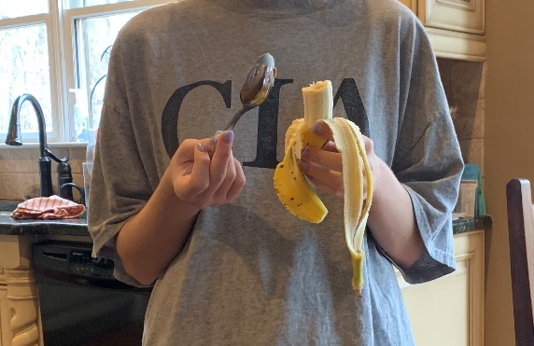
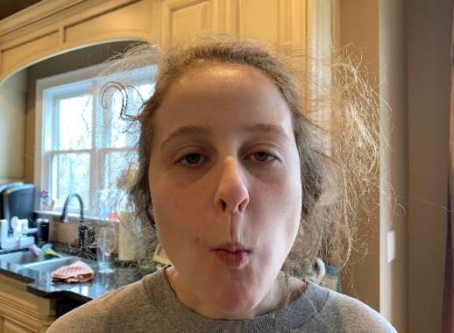
When taking the photos, here’s what you need to keep in mind-
head (take close up)
body (include something personal or that tells a story)
feet (get down low and close to the floor)
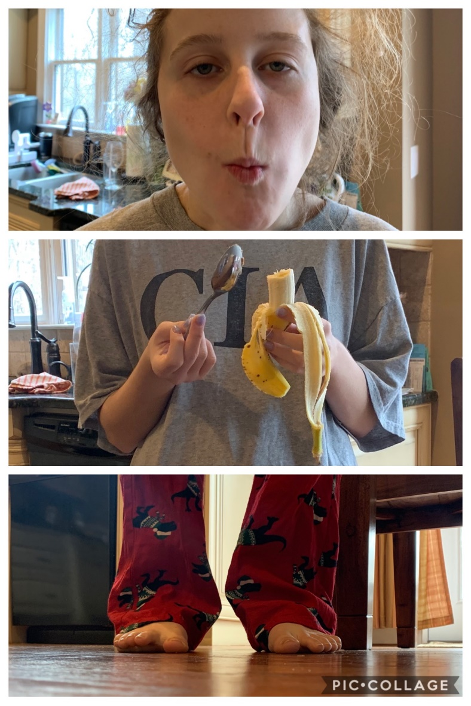
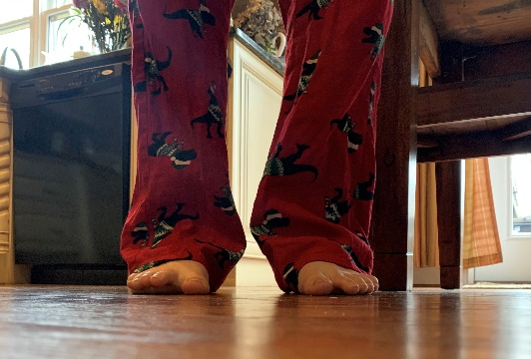
You decide on the editing or collage software/APP. You can use photoshop, photojet.com or APPS like photoshop or pic collage, its free. You decide color or black and white.

