AP Physics – Don’t get me Torqued lab
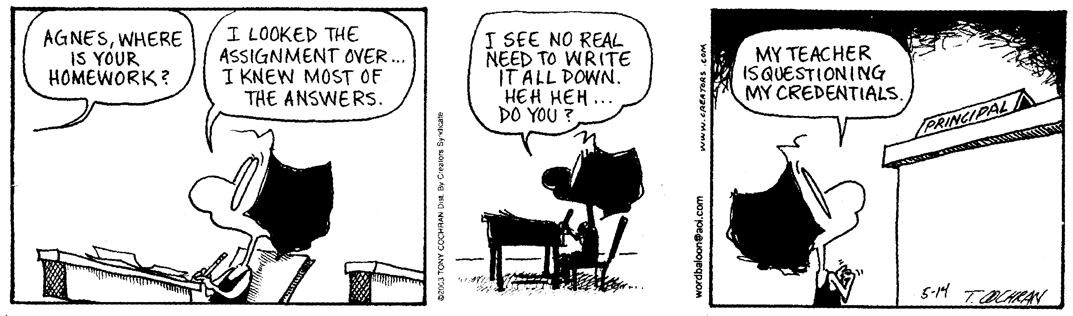
Green Eggs and Hamlet - Would you kill him in his bed? Thrust a dagger through his head? I would not, could not, kill the king. I could not do that evil thing. I would not wed this girl, you see. Now get her to a nunnery. -- Washington Post’s “Style Invitational”

Here's the deal. In a stationary system, one that is not rotating, the sum of the torques must equal zero. Remember?

Okay, your mission. . . . . prove it.

Craft you an experiment that will prove that the sum of the torques of a non rotating system is zero.

May the torque be with you.

