
Tooth Tunes

Background Information:
A miniature electric motor and a speaker have the same basic components: a coil and a permanent magnet. When electrical impulses pas through the voice coil of a speaker, it interacts with the magnet and moves back and forth. When a current passes through the coil of a motor, it interacts with the magnet and spins. When sound is passed to a motor, it causes a slight vibration of the arm of the motor. These vibrations produce sounds.
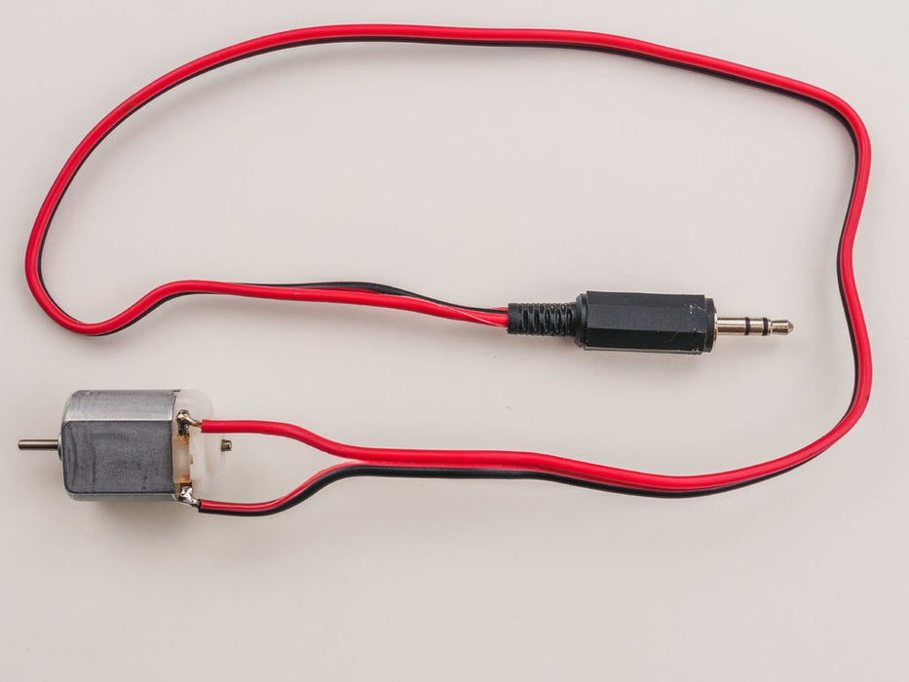
Materials:
- 1.5 Volt motor
- Earphones
- Straws
- Scissors
- Music source (cellphone works well)

Procedure:
  - Cut the earphones from its cord. We only need the plug and the wire leading up to the earphones.
  - Separate the 2 wires that make up the cord for a distance of a few centimeters.
  - Remove about 2 cm of the insulation from the end of each wire.
  - Tightly connect the wires to an electric motor.
  - Place a straw over the tip of the motor (for sanitary purposes)
  - Plug the cord into a music source such as your cellphone and turn the volume on high.
  - You should feel the motor vibrating. If not, check your connections. Also, try switching your connections.
  - Clamp your teeth loosely over the the straw.
  - Use your fingers to close your ears.
  - You should hear the music clearly. The motor is conducting the sound to your teeth, thru the bones of your skull, and to your inner ear.

Conclusion:
- Describe what you experienced?

- Why do you hear the music when you clamp with your teeth?

- What happens if you turn up the music or down the music? Why do you think this is?

- Explain how and where the sound is traveling.

