AP Physics – Thermo Test’O

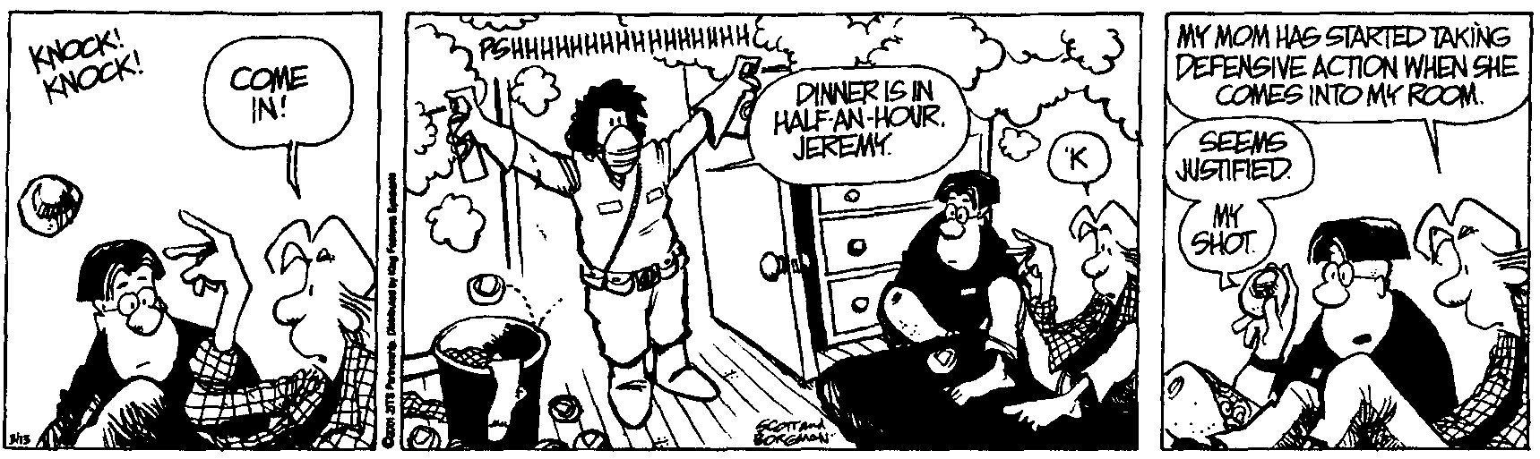
Zingo!________________________________________________________________Per___
The true test of character is not how much we know how to do, but how we behave
when we don't know what to do. -- John Holt
- (20) How much heat is required to raise the temperature of 387 g of silver from 21.5°C to 344°C?

- (20) You attend a birthday party and cram an enormous amount of cake and ice cream into your stressed digestive system. You find out that this little snack amounted to over 1 750 food Calories. To work this food off, how much equivalent mechanical work would you have to do (in Joules please)?

- (20) A 25.0 Ω resistor is placed into 525 g of water. It is hooked up to a 24.0 V battery. If the current flows for 12.0 minutes, we ignore the mass of the resistor, it is entirely immersed in the H₂O, by how many degrees would the water temperature increase?

- (20) A 345 g chunk of gold at 235°C is dropped into 826 g of H₂O at 20.5°. What will the final temperature of the gold be after the system reaches equilibrium?

- (20) How much heat is required to melt 455 g of silver that is at a temperature of 25.9°C?

- (20) A scuba tank holds 2.85 L of air at 22.1°C and 235 atm. How many moles of air does the tank contain?

- (20) What is the average kinetic energy per molecule for a tank of oxygen gas at 25.0 °C? Molar mass of oxygen is 32.00 g/mole.

- (20) In a thermodynamic process, a system absorbs 755 kJ of heat and does 117 kJ of work on its surroundings. By what amount did the system’s internal energy increase?

- (20) A steam engine operates on a warm 28.0 °C day. The saturated steam operates at a temperature of 100.0 °C. What is the ideal efficiency for this engine?

- (20) A gas undergoes a thermodynamic process as shown. Process ab represents the output work, process bc represents input work, all three processes involve heat transfer. (a) what is the work accomplished along path ca? (b) What is the work along path ab, (c) What is the work along path bc? (d) What is the net work for the entire thermo cycle?

