AP Physics – Thermo Quiz’O
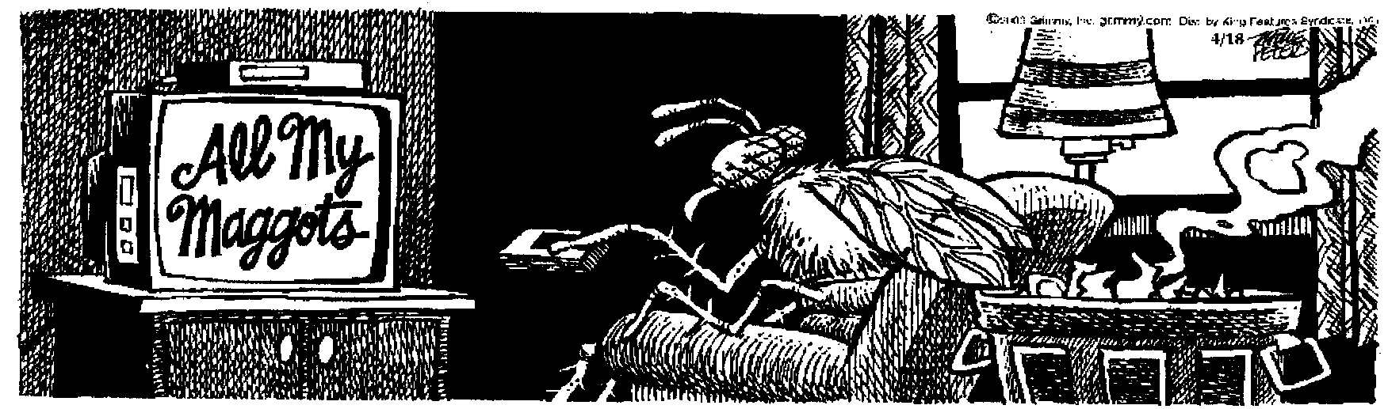
Zingo!________________________________________________________________Per___
The true test of character is not how much we know how to do, but how we behave
when we don't know what to do. -- John Holt
- A very small mass 15.0 resistor is placed into 455 g of water. The resistor is in the circuit shown below. The battery is connected to the circuit for 38.0 minutes. The initial temperature of the water is 24.0 degrees C. It is in an insulated container. What is the final temperature of the water after the 38.0 minutes?

- (20) A 525 g chunk of gold at 235°C is dropped into 826 g of H₂O at 20.5°. What will the final temperature of the gold be after the system reaches equilibrium?

- (20) A tank holds 2.85 L of oxygen at 22.1°C and 235 atm. (a) How many moles of gas does the tank contain? (b) What is the average kinetic energy per molecule?

