AP Physics – Thermo - 1
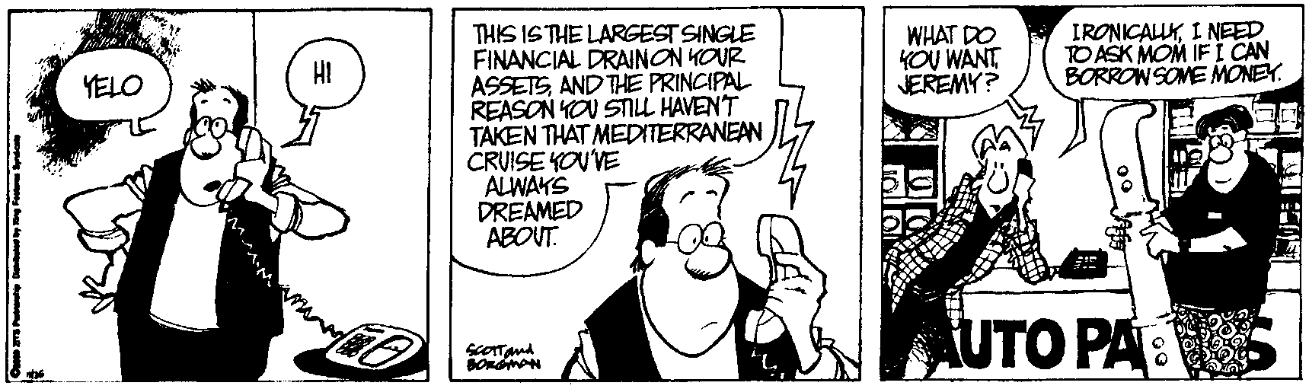
Who’sa you’sa?_________________________________________________________________
But I canna change the laws of physics, Captain! -- Scotty, to Kirk
- A pigeon flying horizontally at a speed of 16.0 m/s drops a stolen Rolex watch. The timepiece falls to the ground in 2.90 s. (a) What was the watch’s altitude when it was dropped? (b) how far horizontally did it travel before it smashed into the deck?

- How much heat is required to raise the temperature of 235 g of iron from 22.5°C to 234°C?

- You attend a birthday party and cram an enormous amount of cake and ice cream into your stressed digestive system. You find out that this little snack amounted to over 1500 food Calories. To work this food off, how much equivalent mechanical work would you have to do (in Joules please)?

- A 56.0 Ω resistor is placed into 350 g of water. It is hooked up to a 12 V battery. If the current flows for 15 minutes, we ignore the mass of the resistor, it is entirely immersed in the H₂O, by how many degrees would the water temperature increase?

- A 345 g chunk of gold at 98.5°C is dropped into 656 g of H₂O at 22.5°. (a) What will the final temperature of the gold be after the system reaches equilibrium? (b) What is the apparent weight of the gold in the water?

- Buffy the Vampire slayer is, as a change of pace, after a werewolf. Her weapon? A 9 mm Glock firing silver bullets! Anyway she spots one of the fearsome beasts and fires off a round, but misses! The bullet drills into a thick slab of insulating material. If the bullet has a mass of 3.50 g and a speed of 225 m/s, what is its final temperature when it comes to rest?

- How much heat is required to melt 455 g of silver that is at a temperature of 25.9°C?

- You have two samples of water at different temperatures. The 265 g sample is at 22.5°C. It is mixed with 385 g of water at 87.0°C. What is the final equilibrium temperature of the system after it is mixed?

