
AP Physics – Thermo – 1 Ans
- A pigeon flying horizontally at a speed of 16.0 m/s drops a stolen Rolex watch. The timepiece falls to the ground in 2.90 s. (a) What was the watch’s altitude when it was dropped? (b) how far horizontally did it travel before it smashed into the deck?
(a)
- How much heat is required to raise the temperature of 235 g of iron from 22.5°C to 234°C?
- You attend a birthday party and cram an enormous amount of cake and ice cream into your stressed digestive system. You find out that this little snack amounted to over 1500 food Calories. To work this food off, how much equivalent mechanical work would you have to do (in Joules please)?

- A 56.0 Ω resistor is placed into 350 g of water. It is hooked up to a 12 V battery. If the current flows for 15 s, we ignore the mass of the resistor, it is entirely immersed in the H₂O, by how many degrees would the water temperature increase?

- A 345 g chunk of gold at 98.5°C is dropped into 656 g of H₂O at 22.5°. What will the final temperature of the gold be after the system reaches equilibrium?
- Buffy the Vampire slayer is, as a change of pace, after a werewolf. Her weapon? A 9 mm Glock firing silver bullets! Anyway she spots one of the fearsome beasts and fires off a round, but misses! The bullet drills into a thick slab of insulating material. If the bullet has a mass of 3.50 g and a speed of 225 m/s, what is the temperature change for the slug?
- How much heat is required to melt 455 g of silver that is at a temperature of 25.9°C?
- You have two samples of water at different temperatures. The 265 g sample is at 22.5°C. It is mixed with 385 g of water at 87.0°C. What is the final equalibrium temperature of the system after it is mixed?

- Students are designing an experiment to demonstrate the conversion of mechanical energy into thermal energy. They have designed the apparatus shown in the figures below. Small lead beads of total mass M and specific heat c fill the lower hollow sphere. The valves between the spheres and the hollow tube can be opened or closed to control the flow of the lead beads. Initially both valves are open.
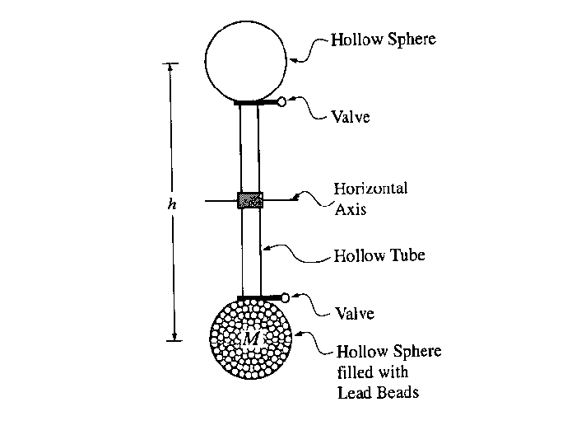
  - The lower valve is closed and a student turns the apparatus 180º about a horizontal axis, so that the filled sphere is now on top. This elevates the center of mass of the lead beads by a vertical distance h. What minimum amount of work must the student do to accomplish this?
  - The valve is now opened and the lead beads tumble down the hollow tube into the other hollow sphere. If all of the gravitational potential energy is converted into thermal energy in the lead beads, what is the temperature increase of the lead?
  - The values of M, h, and c for the student’s apparatus are M = 3.0 kg, h = 2.00 m and c = 128 J/(kg·K). The students measure the initial temperature of the lead beads and then conduct 100 repetitions of the “elevate and drain” process. Again, assume that all of the gravitational potential energy is converted into thermal energy in the lead beads. Calculate the theoretical cumulative temperature increase after the 100 repetitions.
  - Suppose that the experiment were conducted using smaller reservoirs, so that M was one-tenth as large (but h was unchanged). Would your answers to parts (b) and (c) be changed? If so, in what way, and why? If not, why not?
  - When the experiment is actually done, the temperature increase is less than calculated in part (c). Identify a physical effect that might account for this discrepancy and explain why it lowers the temperature.
a.
b.
c.
d. No change, the masses cancel out, so the temp change does not depend on mass.
e. Glass and equipment absorb some of the heat.
Friction with air slows beads, so KE less.
Beads make noise, this energy loss results in lower temperature.

