Pre-Construction Phase
- Form a company with other students.
- Conduct and graph a survey that assists your company in your design. Due_____
- Discuss and decide the overall ideas and concepts for the theme park.
- Write a argumentative essay as to why your group’s theme park will be successful. Due_____

Construction Phase
- Review price sheet and how to design using symbols.
- Design layout of park adhering to health and safety rules. Due_____
- Calculate a running total of construction expenses using a spreadsheet program. Due_____

Post-Construction Phase
- Complete Sales and Profit worksheet for a Snack Stand in your park. Due_____
- Write a descriptive essay or narrative essay about the theme park. Due______
- Create a video or radio commercial for your theme park. Due______
- Present all of your work from the project on a display board. Due_____

Standards Alignment for Project

English Language Arts
- R 1.5 - Understand and explain the figurative and metaphorical use of words in context.
- R 2.1 - Understand how format, graphics, charts, maps, etc. make information accessible.
- R 3.5 - Describe function and effect of literacy devices such as imagery and metaphor.
- W 2.4 - Write persuasive letters or compositions that state a clear position, support it with evidence, address reader concerns.
- W 1.2 - Create multiple-paragraph expository compositions with topic or events in sequence, details and transitions, and closing summary.
- W 1.6 - Edit and revise to improve meaning and focus by adding, deleting, rearranging text.
- W 1.1 - Create multi-paragraph narratives: establish a situation or plot, describe the setting, and present an ending.
- L/S 2.2 - Deliver informative presentations about an important idea, issue, or event.

Math
- NS 1.2 - Interpret percents as part of a hundred, find decimal and percent equivalents for common fractions, and compute a given percent of a whole number.
- NS 2.1 - Add, subtract, multiply, and divide whole numbers and decimals; add with negative integers
- MG 2.1 - Measure, identify, and draw angles, perpendicular and parallel lines, rectangles and triangles by using appropriate rules.
- SDAP 1.2 - Organize and display single-variable data in appropriate graphs and representations (e.g., histogram, circle graphs) and explain which types of graphs are appropriate for various data sets.
- MR 2.1 - Use estimation to verify the reasonableness of calculated results.
- MR 2.2 - Apply strategies and results from simpler problems to more complex problems.
- MR 2.6 - Make precise calculations and check the validity of the results from the context of the problem.

Social Studies
- HAS CST 4. Students use map and globe skills to determine the absolute locations of places and interpret information available through a map’s or globe’s legend, scale, and symbolic representations.
- HAS CST 5. Students judge the significance of the relative location of a place (e.g., proximity to a harbor, on trade routes) and analyze how relative advantages or disadvantages can change over time.

Research: What do people want and like in a theme park?

Directions: Each member of the company will conduct a survey of at least forty people. The survey question should be one that helps the company in determining how to design their park (i.e. rides, theme, food, etc.) The results should be documented. In school, we will graph the results in Microsoft Excel.

Due Date: _______

The Park Proposal
The first writing assignment of the project is for each team member to write a persuasive essay as to why your park will be successful. To receive funding for your theme park, investors want to know your company has a plan for your park to be a success. The paper should be a five paragraph standard essay. Results from the surveys should be utilized in the essay and overall ideas should be common within the company/group. Below is a sample guide you can use in constructing your essay. The amount of investment money will be determined by proposals submitted in on time and how convincing the essays are to the investors.

Please make sure the final draft has been corrected for mistakes (spelling, punctuation, capitalization, grammar, etc.) and clarity.
The paper will be due _____________.

¶ 1 – Introduction – Introduce Park & Include Topic Sentence
Sample Topic Sentence: Our theme park will be successful because Reason1, Reason2 and Reason3.

¶ 2 – Reason 1:
Example/Fact:
Example/Fact:
Example/Fact:

¶ 3 – Reason 2:
Example/Fact:
Example/Fact:
Example/Fact:

¶ 4 – Reason 3:
Example/Fact:
Example/Fact:
Example/Fact:

¶ 5 – Conclusion
Summarize the goal of the paper.

Map & Expenses

Each group will create a map of their theme park using the given graph paper, the Theme Park Catalog, and the Color Coding Table. Using the catalog and table, groups will create and label the selected items with the correct size and color. The Custom Item Order Form is used when groups want to create an item that is not in the catalog. Groups should also read the RRG page and make sure all of the listed specifications are followed.

At the same time, groups need to keep track of which items are used in their park and their quantity. It will be recorded on an Order Form in a spreadsheet where subtotals, tax and the grand total will be calculated. The grand total must be kept below the allotted budget.
Due Date:____________

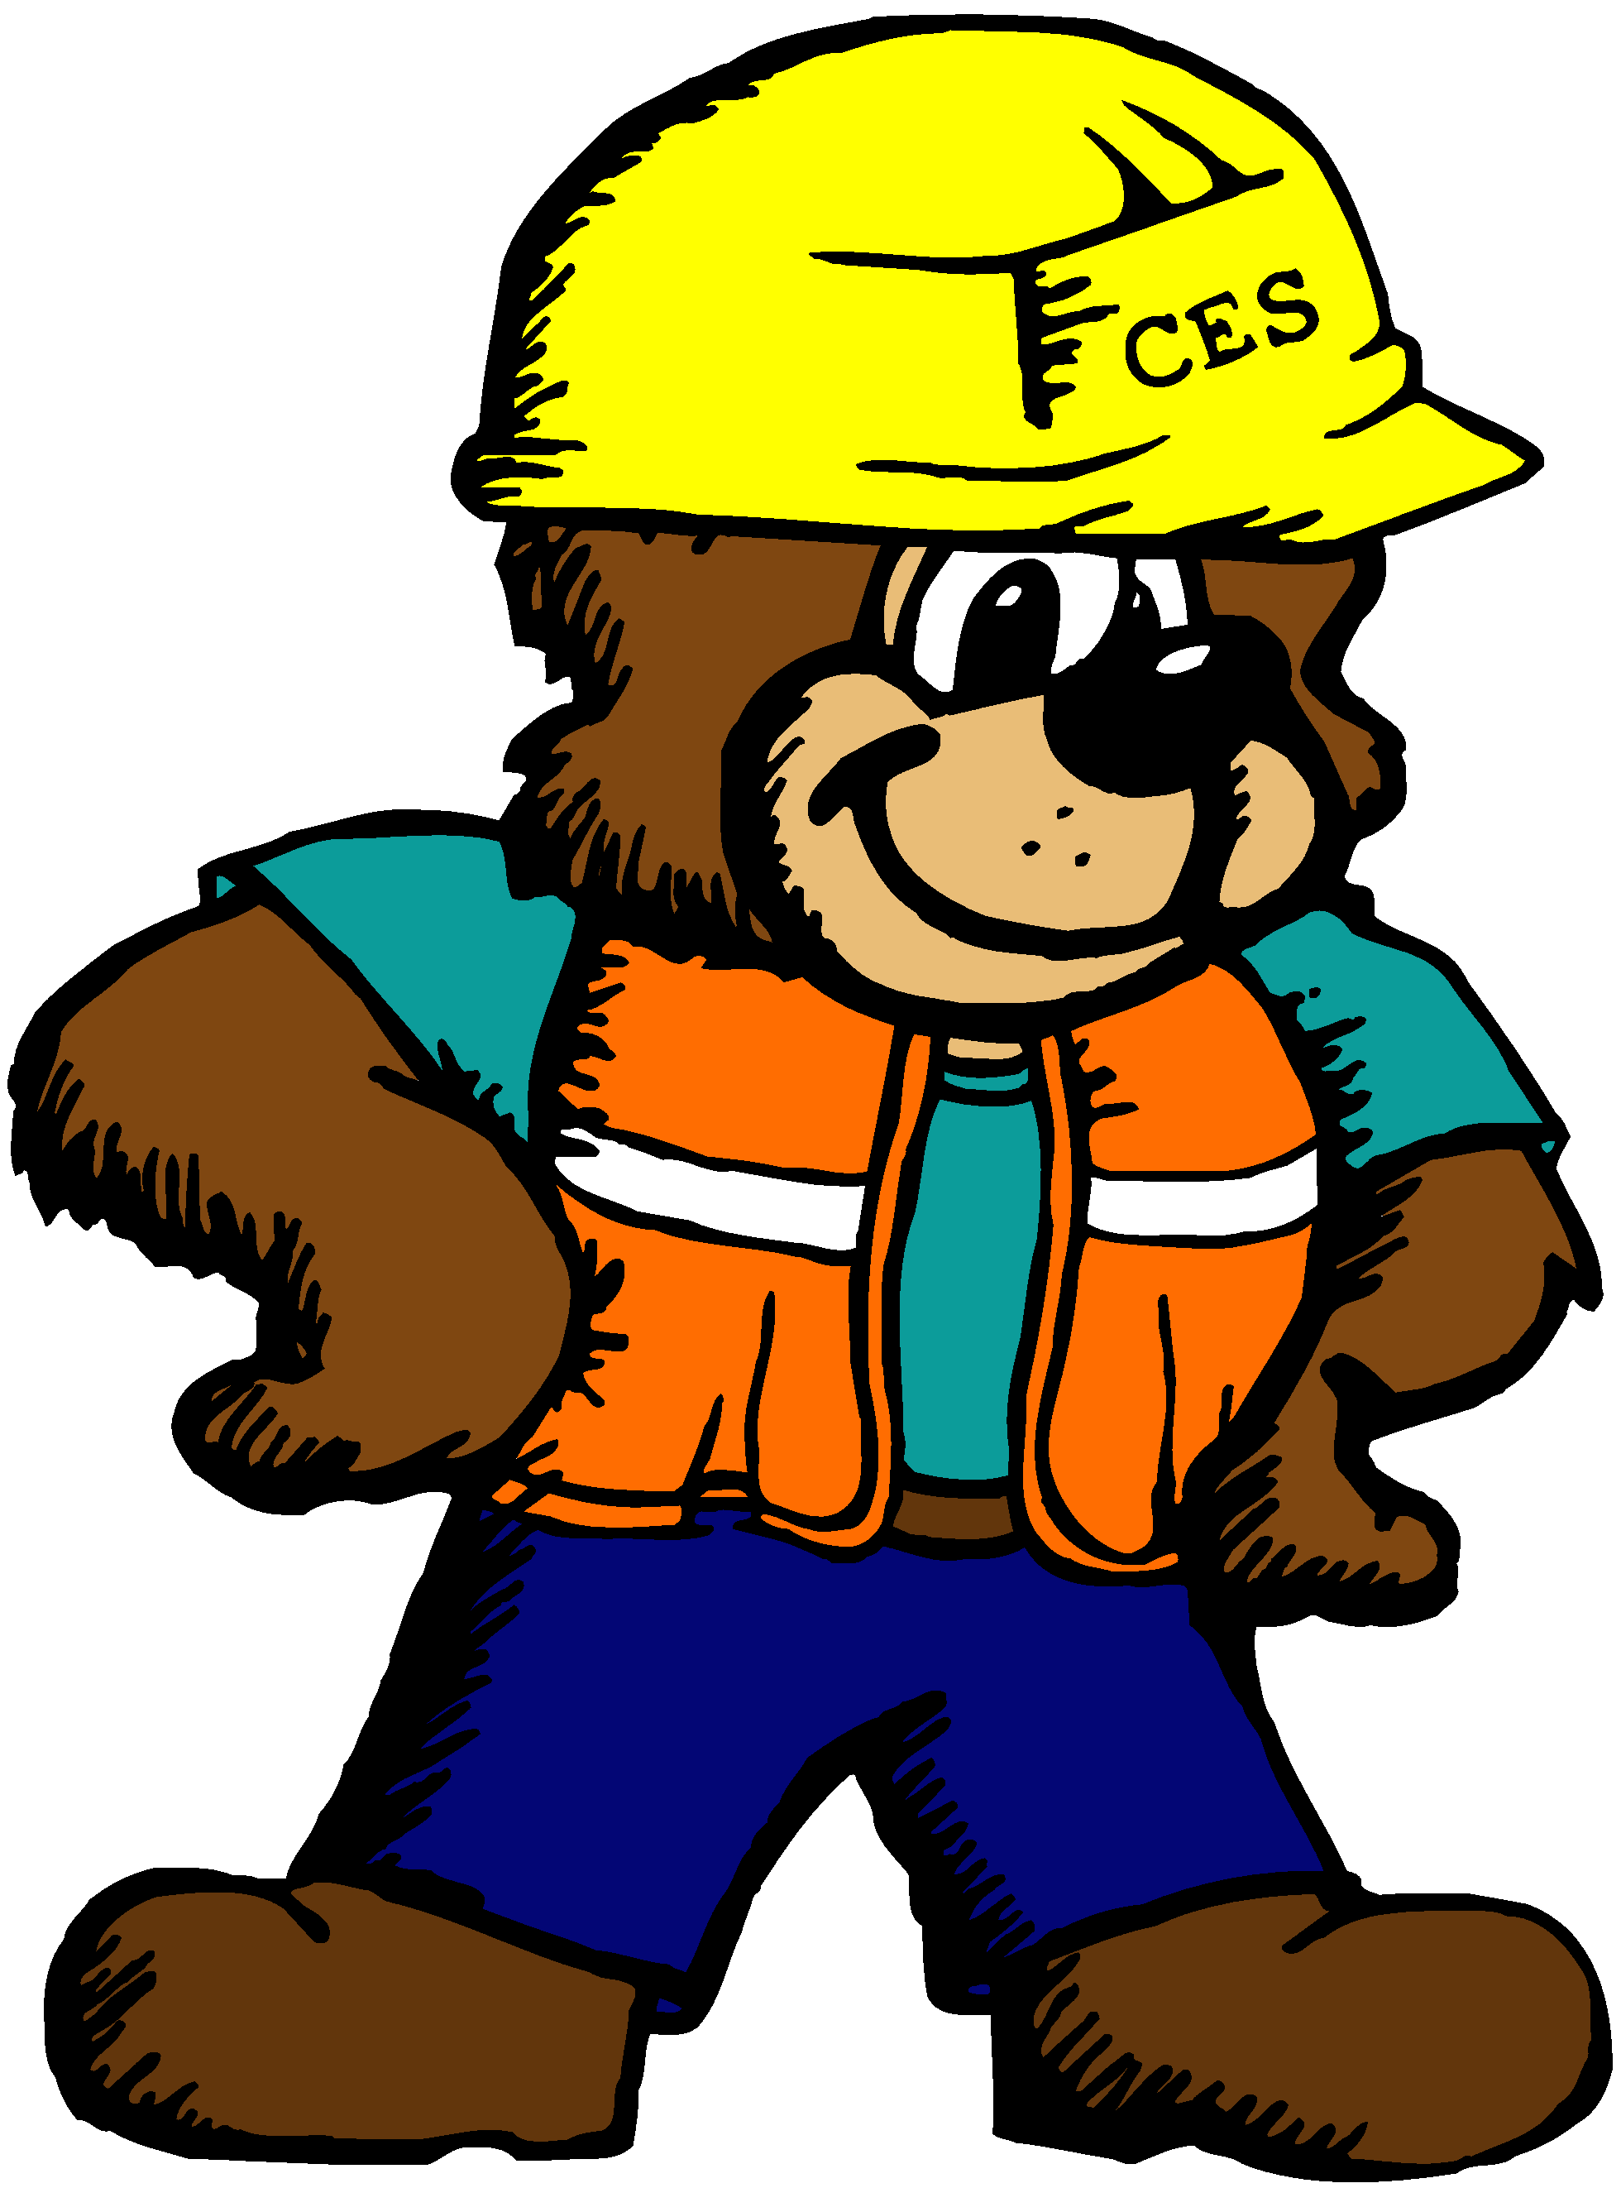
Sales and Profit

Each member of the group will complete a Sales and Profit worksheet to determine the totals of different sales transactions at a snack stand within your theme park. Your group will need to create a list of items sold at the stand and what each item costs. Then you will need to use your addition, subtraction, multiplication and division of decimal skills to find your answers of the given problems. All work must be shown.
Due Date:__________
The Commercial

Each member of the group will create a video or radio advertisement for their theme park. Each person is expected to be part of the commercial. For a radio commercial, students will write a script, record and edit their commercial. The radio commercial can contain singing or talking. For a video commercial, students will draw and describe different attractions, features and highlights of the park. Students will then edit the video together. Both types of commercials should include the theme park name and reasons why someone should go and visit your park. The commercial should be persuasive and very descriptive.
Due Date:____________

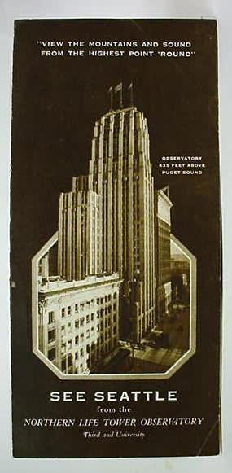
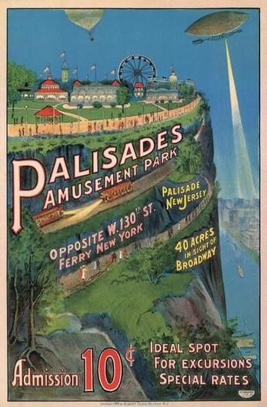


A Visit to Your Park

The second writing assignment of this project is for each team member to write a descriptive essay about your company’s theme park. Using your created theme park map as a guide, each member will write about the experience of visiting your park. The paper can be written in two ways. The first could be an expository essay with content organized by location, category or importance. The essay could also be written in narrative form that describes a visit to the park from your or someone else’s point of view. No matter which method is used, the essay should be highly descriptive making use of more exact nouns (or proper nouns), adjectives, adverbs and figurative language. Utilizing the senses to create imagery is a must. The writing should be about two pages in length. Please also make sure the final draft has been corrected for mistakes (spelling, punctuation, capitalization, grammar, etc.) and clarity.
The paper will be due _____________.

