Name: ________________________________ ____ / 7
The Office: Launch Party

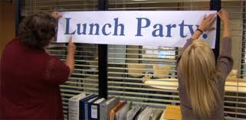
Directions: While viewing the episode of The Office, answer the questions to the best of your ability.

- What accounting concept relates to preparing financial statements with the expectation that the business will remain in operation indefinitely?
  - Adequate disclosure
  - Business entity
  - Consistent reporting
  - Going Concern

- Dunder Mifflin’s stock is publicly traded on the NYSE. What fiscal period do they utilize?
  - Monthly
  - Quarterly
  - Semi-annually
  - Annually

- What event is the “Launch Party” celebrating?

- How will this impact the company AND the employees?

- Reflection: How does this episode involving changing technology relate to you and your education now and in the future? Provide a constructed response (five sentences) to explain your answer using examples to justify your response.

Name: ________________________________ ____ / 7
The Office: Koi Pond

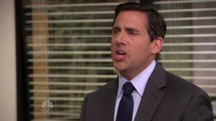
Directions: While viewing the episode of The Office, answer the questions to the best of your ability.

- Since Pam and Andy have the lowest sales, what are they required to do?
  - Work overtime
  - Cold calls
  - Change positions
  - Shadow someone else in sales

- Why would companies require them to do this?

- How does Michael respond to everyone’s reaction to his trip with Jim?
  - Sensitivity training
  - Takes a personal day
  - Dresses up in costume and gives a presentation
  - Drives to New York

- What advice does Jim give Michael about the situation? What is your initial reaction?

- What are the advantages and disadvantages of having 2 managers (co-managers)? Provide a constructed response (five sentences) using examples from your personal life and/or the episode to justify your response.

Name: ________________________________ ____/10
The Office: Doomsday


Directions: While viewing the episode of The Office, answer the questions to the best of your ability.

- Bell ringer: How many mistakes have you made in your simulation thus far?
  - 0-2 c. 6-8
  - 3-5 d. 9+

- Bell ringer: List the types of errors you made:

- What mistake does Robert California share happened in the accounting department?

- How many mistakes trigger Dwight’s Accountability Booster?
  - 1 c. 5
  - 3 d. 7

- What happens if the Office reaches this number of mistakes in one day?

- What mistake does Oscar do on purpose?
  - Sends an order to shipping before payment is received
  - Combines two different orders
  - Writes a check to the wrong vendor
  - Journalizes a transaction in the wrong journal

- What actual (not accidental) mistake does Oscar make? How could he have avoided the mistake?

- How important do you feel accountability is in accounting? Justify and explain your answer in a 5-sentence constructed response. (use the back of this page to write your response)

Name: ________________________________ ____/10
The Office: Broke

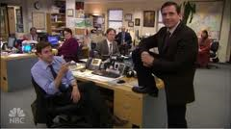
Directions: While viewing the episode of The Office, answer the questions to the best of your ability.

- What form of business ownership is Michael Scott Paper?
  - Sole proprietorship
  - Partnership
  - Corporation
- The van would be classified as which account?
  - Asset
  - Liability
  - Revenue
  - Expense
- What type of account is the paper?
  - Supplies – Office
  - Supplies – Store
  - Purchases
  - Supplies expense
- How does Angela, from Accounting, propose to save the company money?

- What is the primary problem with The Michael Scott Paper Company?

- Which pricing model do they employ?

- Why would Dunder Mifflin buy out The Michael Scott Paper Company?

- How does Michael Scott handle the negotiations? Write a 5-sentence constructed response. Use the back of this page and be sure to reference examples from the episode to justify your response.

Name: ________________________________ ____/10
The Office: The Incentive

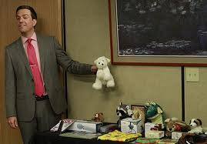
Directions: While viewing the episode of The Office, answer the questions to the best of your ability.

- What does Jim’s first question to Kevin best relate to in accounting?
  - Accounting equation balancing
  - Boring office meetings
  - Capital stock
  - Dividends declared by the company

- How does the economy impact business forecasting?

- What growth does Robert California expect?
  - 2%
  - 4%
  - 6%
  - 8%

- In which section of an income statement would this growth show?

- How does Andy plan to motivate the sales project?

- Do incentives really work? Why or why not? Share your thoughts in a five-sentence constructed response. Be sure to use examples to support your response.

