Name: ________________________________ ____ / 7
Office: Safety Training

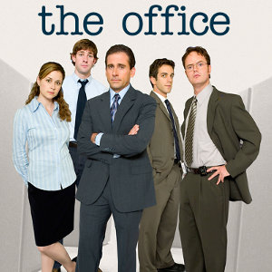
Directions: While viewing the episode of The Office, answer the questions to the best of your ability.

- What is required in order to operate the fork lift?

  - Activation code
  - ID badge
  - License
  - Nothing, just the person to operate it

- Dunder Mifflin Scranton has safety training after every accident reported. They have not made it __________ without having more training.

  - Two months
  - Six months
  - One year
  - Two years

- What are some dangers of working in an office?

- According to Michael, what made the warehouse safety presentation better?

- Constructed response: Using a five-sentence paragraph, explain why safety is important in the workplace. Justify your answer with examples (from class, your work, or the episode).

Name: ________________________________ _____/10
Office: Stress Relief
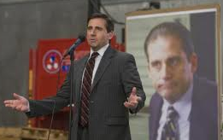
Directions: While viewing the episode of The Office, answer the questions with the best possible answer(s). Remember to pay close attention to the details in the episode.

- List all the topics we discussed in class that are addressed in the episode:

- What was the topic of Dwight’s 3. Why did Dwight use this style of training
emergency action plan training? instead of a PowerPoint
  - Natural disaster
  - Lockdown / bomb scare
  - Fire drill
  - Intruder

- During the Red Cross training, which of the topics 5. Which top 7 life stressor is affecting Pam and
are addressed? Circle all that apply Jim in this episode?
  - Assess the situation (Check) a. Retirement
  - Call / Intervene b. Marital separation
  - Do no further harm c. Death of a spouse
  - ABC’s of an emergency d. Jail term

- Dwight’s excuse for Stanley’s heart attack falls 7. Which part of our wellness compass does
under which piece of the wellness compass? Michael’s roast relate to?
Circle all that apply
  - Increased (instead of without) stress a. Without stress
  - Lack of sleep b. Sleep
  - Minimal exercise c. Exercise
  - Poor nutrition d. Nutrition

- Which stress / anger management technique best 9. What affect does Michael’s roast have on
relates to Michael’s roast? him?
  - Get a pet (birds) a. Michael realizes he has poor health
  - Vent to a friend b. Michael shows signs of depression
  - Time management c. Michael develops anxiety about
workplace safety

- Constructed response: Using five complete sentences, why is workplace safety and your wellness important? Be sure to include examples from your personal life and/or the episode to justify your response.

Name: ________________________________ ____/8

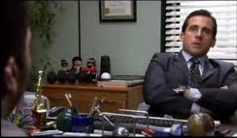
Directions: While viewing the episode of The Office, answer the questions to the best of your ability.

- Before viewing the episode, review: What does total compensation mean?

- Before viewing the episode, what are some things you can negotiate for prior to accepting a position with a company?

- Michael gets his negotiation tips from…
  - Jim c. Wikipedia
  - YouTube d. Dwight

- List which negotiation tactics are mentioned and/or utilized in the episode.

- Reflect: Why is it important to consider your total compensation with a company and not just the pay (salary or hourly rate)?

- Opinion: Which option (hourly, salary, commission) would you prefer to be paid at your dream job when you are working full time – anything more than 36 hours per week? Respond using a 5-sentence paragraph. Be sure to justify why you selected your choice with examples.

Name: ________________________________ _____/8
The Office: The Merger


Directions: While viewing the episode of The Office, answer the questions with the best possible answer. For questions 1-2 circle all that apply. Remember to pay close attention to the details in the episode.

- The handshake between Michael and Tony Gardiner
  - Firm
  - Eye contact
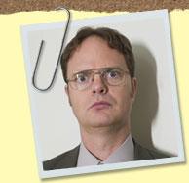
  - Smile

- The handshake between Pam and Karen
  - Firm
  - Eye contact
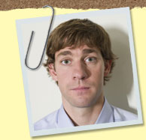
  - Smile

- Which of the following handshakes/greetings takes place between Dwight and Andy?
  - The Enough Already
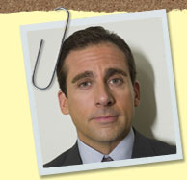
  - The Dead Fish
  - The Bone Crusher
  - The Second Hand Awkward


- Which of the following handshakes/greetings ACTUALLY takes place between Jim and Toby?
  - The Bone Crusher
  - A handshake
  - A high five
  - “Knucks”/fist pump
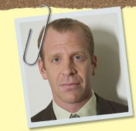
- What other greetings besides the handshake do you see throughout the episode?

- How do you think Michael did at leaving a good first impression with the new employees? Write 5 sentences to explain your answer citing examples from the episode. Use the back to answer this question.

Name: ________________________________ _____/10
The Office: Pilot

Directions: While viewing the episode of The Office, answer the questions with the best possible answer. For questions 1-4 circle all that apply. Remember to pay close attention to the details in the episode.

- What trick to remembering names does Michael use when meeting Ryan?

- The handshake between Michael and Ryan
  - Firm
  - Eye contact Michael
  - Smile


- The introduction between Michael and Ryan
  - Greeting
  - Name
  - Title Ryan

- The handshake between Dwight and Ryan
  - Firm
  - Eye contact
  - Smile Dwight

- The introduction between Dwight and Ryan
  - Greeting
  - Name
  - Title

- What mistake(s) does Dwight make with his introduction? Pam

- Constructed response: Be sure to have an introduction sentence, supporting sentences, and closing sentence. Jim
Would you like Michael Scott as a boss? Explain why or why not?

Andy

