Name: ________________________________ ____/10
Office: Golden Ticket
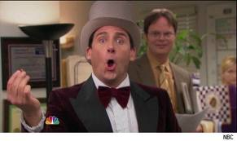
Directions: While viewing the episode of The Office, answer the questions to the best of your ability.

- Before viewing the episode, what are the three types of discounts we defined in Chapter 9?

- Before viewing the episode, what is a person who organizes and runs a business called?

- Which of the following discounts is Michael’s “Golden Ticket” idea?
  - Cash discount
  - Purchases discount
  - Trade discount

- What mistake does Michael make with his “Golden Ticket” idea?

- What other business ideas are revealed during the episode? List as many as you hear.

- There are many different trade discounts stores offer. List as many as you can and then pick one to answer the constructed response question. Use the back if needed.

List What discount is your favorite? Write a constructed response (five
sentence paragraph) justifying your answer.

Name: ________________________________ _____/10
Office: Business Ethics

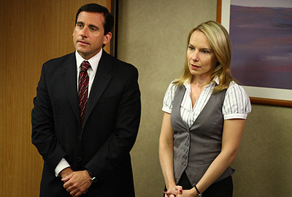
Directions: While viewing the episode of The Office, answer the questions with the best possible answer(s). Remember to pay close attention to the details in the episode.

- What ethical situations arise (either through action or discussion) throughout the episode?

- Do business ethics have an effect on a business? Explain why or why not.

- Constructed response: Use a five sentence paragraph including an introduction, supporting sentences, and closing sentence.
  - Based on this episode, is this business (Dunder Mifflin) ethical? Justify your answer using at least two examples from the episode.

- Reflection: Share a personal ethical dilemma from your work or school experience (EXCLUDING NAMES). Did the person act ethically? How did the situation make you feel?

Name: ________________________________ ____/10
Office: The Surplus

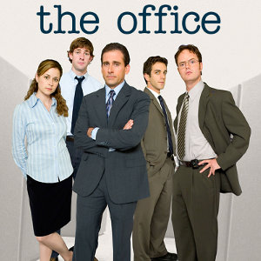
Directions: While viewing the episode of The Office, answer the questions to the best of your ability.

- In the opening of the episode, Oscar attempts to explain the concept of a budget surplus using which analogy?
  - A donut shop
  - Men’s Warehouse
  - A lemonade stand
  - A merry-go-round

- What exactly is a budget surplus?

- Constructed response: Use a 4 – 5 sentence paragraph including an introduction sentence, supporting sentences, and a closing sentence. (4 points)
  - Why would the branch of a business (or department) try and spend a budget surplus?

- What account (i.e. cash, supplies, sales, capital, expenses) do you think is the most important? Why?

- What two items is the primary debate over?
  - A vacation and new ventilation
  - New chairs and new computer
  - New computers and a new copier
  - A new copier and new chairs

- What does Michael find out happens if the branch does not spend the surplus?

- Why do businesses “budget”?

Name: ________________________________ ____/10
Office: Product Recall


Directions: While viewing the episode of The Office, answer the questions to the best of your ability.

- Before viewing the episode, why do customers return products to businesses?

- Do you think Jim did anything wrong in the beginning of the episode? Why or why not?

- Creed’s job title is…
  - Salesman
  - Quality assurance
  - Accountant
  - Customer service representative

- What do you think of Michael’s philosophy with notifying the media?

- What qualities do you think are essential for a customer service representative position?

- Why do businesses accept returns (sometimes without receipts), award sales allowances, and even issue recalls? Write a constructed response (five sentences) justifying your answer.

