AP Physics – Testing, One, Two - 5
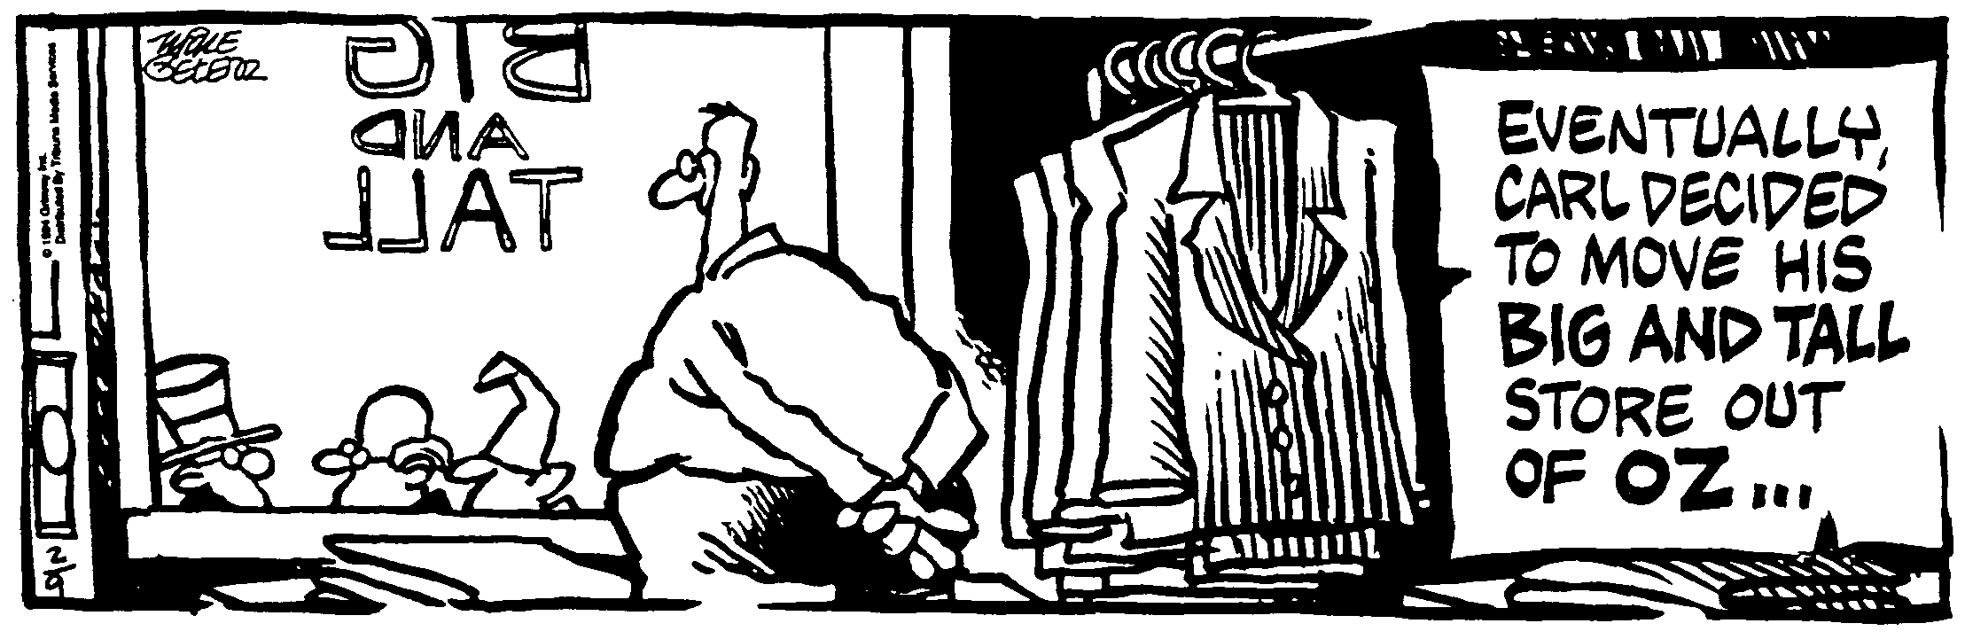
ID Opportunity__________________________________________________________________Per__
If at first you don't succeed, at least find out if the loser gets anything! -- Kristi Derrick
- (20) A planet is attracted to the sun with a certain force. If the distance from the sun to the planet is reduced by one half, what would happen to the force?

- (20) A 1100 kg car negotiates a circular turn. The car is traveling at 95 km/h. The radius of the curve is 345 m. What is the coefficient of kinetic friction for the wheels and the road?

- (20) You weigh 625 N on earth. What would you weigh on Venus? Venus' mass is 4.88 x 1024 kg and it has a radius of 6.07 x 106 m.

- (40) A 75.0 kg man is standing on a 288 N uniform beam that is 5.20 m in length. One end of the beam is attached to a wall, the other end has a cable that supports the outer end of the beam as shown. The angle the cable makes with the beam is 67.0°. (a) What is the weight of the man? (b) What is the tension in the cable?

- (40) Amazingly, a new planet is discovered after all these years in the solar system. The planet has a mass of 4.55 x 1024 m kg. The mass of the sun is 1.99 x 1030 kg. If the planet takes 775 days to go around the sun one time, what is the distance from it to the sun?

