AP Physics – Testing, One, Two - 5
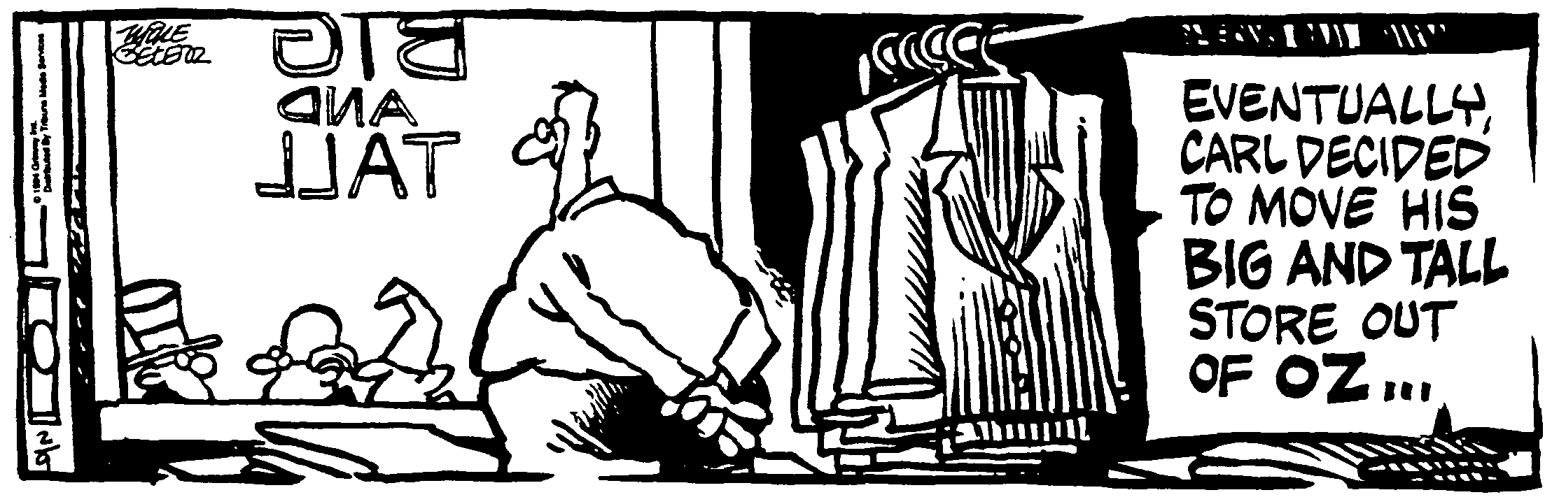
ID Opportunity__________________________________________________________________
If at first you don't succeed, at least find out if the loser gets anything! -- Kristi Derrick
- (20) What is the momentum of a 540g macaw traveling at 18 m/s?

- (20) An 80.0 kg astronaut in space throws a 10.0 kg oxygen tank away from himself. If the recoil speed of the astronaut is 1.52 m/s, what was the velocity given to the oxygen tank?

- (20) A 0.250 kg baseball traveling at 50.0 m/s is caught in a fielder’s mitt. If the ball takes 0.0498 seconds to come to a stop in the mitt, what average force was exerted on the ball?

- (20) A 4.0 kg ball traveling to the right at 7.2 m/s collides with a 6.6 kg ball traveling in the opposite direction at 5.0 m/s. What is the velocity of the second ball (the 6.6 kg one) after the collision?

