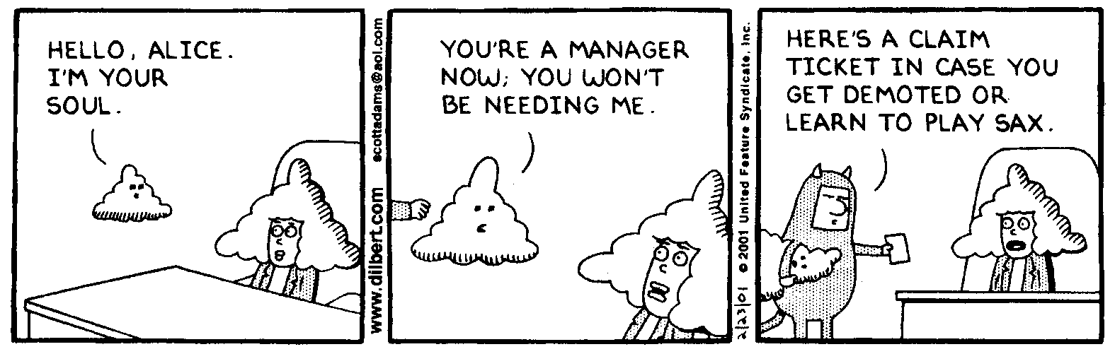
AP Physics – Oh no! It’s a Nuke Test!

You Know Who_______________________________________________________________Per__
I do not know what is wrong with Heisenberg. He seems so sure of himself lately. -- Sydney Harris

- (20) Determine the number of protons, electrons, and neutrons each of these isotopes possesses: , , and

- (20) Complete the following nuclear reactions:

(a)

(b)

- Describe the Compton effect. How does it demonstrate the wave/particle nature of light?

- (20) What is the energy of a photon with a wavelength of 435 nm?

- (60) Light of wavelength 350.0 nm is incident on a metal surface. Electrons are emitted that have a maximum kinetic energy of 5.31 eV. Find (a) the work function of the metal, (b) the cutoff wavelength, and (c) the cutoff frequency.

- (40) In a certain metal, the stopping potential is found to be 4.00 V. (a) What is the maximum kinetic energy given to the electrons in eV and J. (b) What is the de Broglie wavelength of an electron with the maximum kinetic energy?

- (60) A monotomic gas is illuminated with visible light of wavelength 412 nm. The gas is observed to absorb some of the light and subsequently to emit visible light at both 412 nm and 675 nm.
(a) In the box at the side, complete an energy level diagram that would be consistent with these observations. Indicate and label the observed absorption and emissions.

(b) If the initial state of the atoms has energy –5.50 eV, what is the energy of the state to which the atoms were excited by the 412 nm light?

(c) At which other wavelength(s) do these atoms emit radiation after they are excited by the 412 nm light?

